

New Zealand Diploma in System Administration Level 6

# **NET602: Network Services**

# Assessment/Aromatawai - Assessment 2 v2

# Practical

## Credits/Whiwhinga 7



|  |  |  |  |
| --- | --- | --- | --- |
|  | Submission | FER1 | FER2 |
| Result | Click or tap here to enter text. | Click or tap here to enter text. | Click or tap here to enter text. |
| Date | Click or tap to enter a date. | Click or tap to enter a date. | Click or tap to enter a date. |
| Assessor’s Signature |  |  |  |

|  |  |
| --- | --- |
| Student Name | Hui(Spark) ZHENG |
| Student ID | AEU3000774 |
| Student Signature | Spark |
| Assessor | Click or tap here to enter text. |

Contents

Task/Mahi 1: Second Domain Controller Integration & User Authorization 4

Task 1.1 Create a PowerShell script to set up and integrate a second domain controller 4

Task 1.2 Create a PowerShell script to automate user creation in Active Directory 12

Task/Mahi 2: Deploying Print Management Solution via Group Policy Object 17

Task/Mahi 3: Implementing & Managing Multi-Factor Authentication (MFA) for Network Access 29

Task 3.1 Set up the MFA platform on a server and automate the deployment of MFA to the client machines 29

Task 3.2 Troubleshooting the MFA configurations on a client machine and MFA Admin App 32

Task/Mahi 4: Manage the remote access via VPN 43

Task 4.1 Set up and configure a member server of the domain to act as a VPN server 43

Task 4.2 Set up a secure VPN connection 57

Task 4.3 Allow file sharing for a shared folder 61

Task 4.4 Test the VPN connectivity to verify the setup and configuration 65

Task/Mahi 5: Implementing Server Backup 68

Task 5.1 Create a complete backup policy using PowerShell Scripts to automate the backup process 69

Task 5.2 Configure Windows backup using the PowerShell Script 72

Task/Mahi 6: Implementing and Managing Intrusion Detection System(IDS) 83

Task 6.1: IDS Deployment and Configuration 83

Task 6.2: Integration, Testing, and Documentation 92

Task/Mahi 7: Update Existing Network Diagram 101

## Task/Mahi 1: Second Domain Controller Integration & User Authorization

### Task 1.1 Create a PowerShell script to set up and integrate a second domain controller

1. Change Computer Name

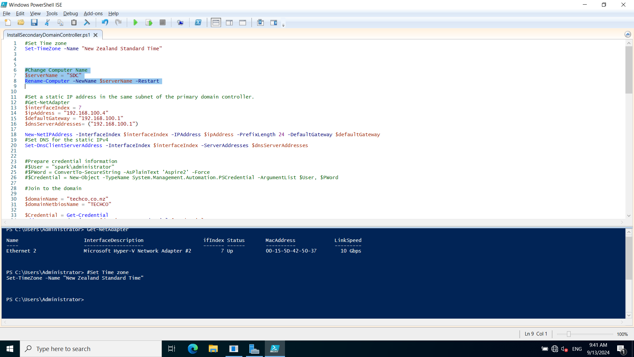

2. Set static IP address

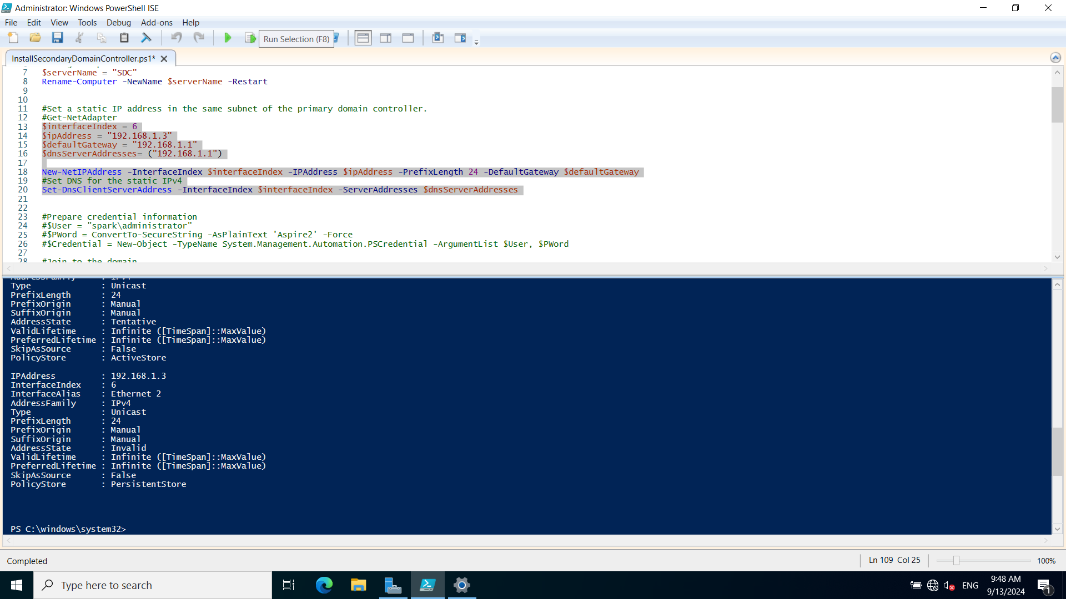

3. Join the domain techco.co.nz

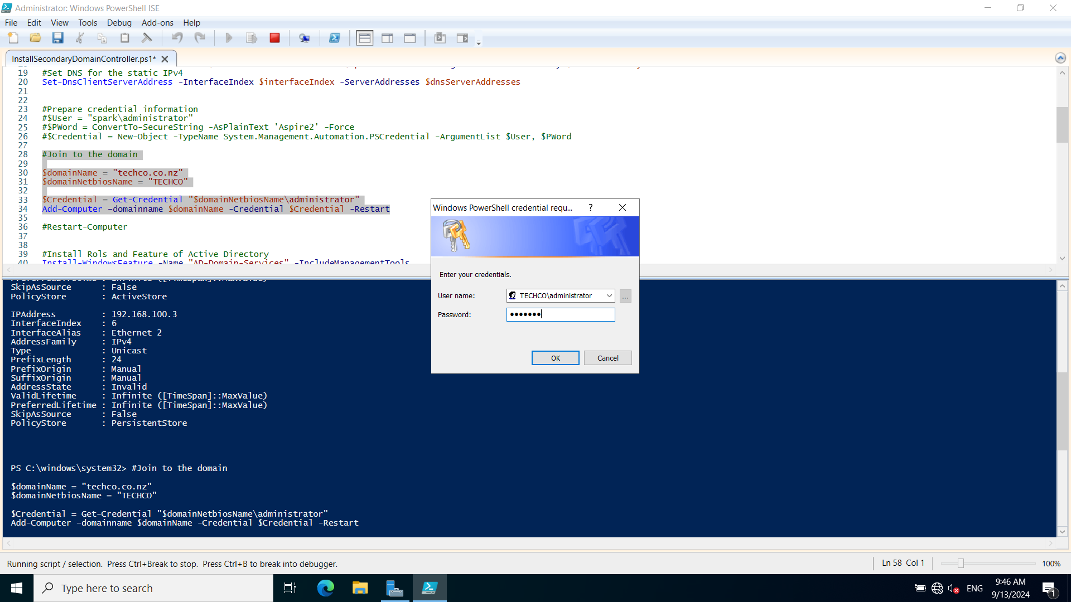

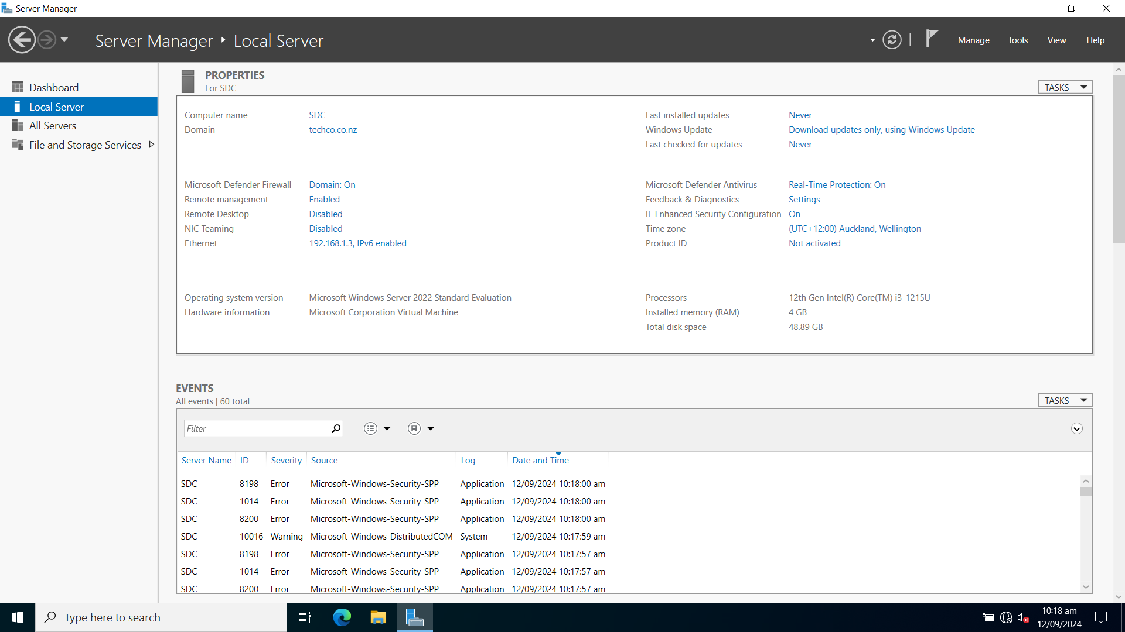

4. Install Rols and Feature of Active Directory

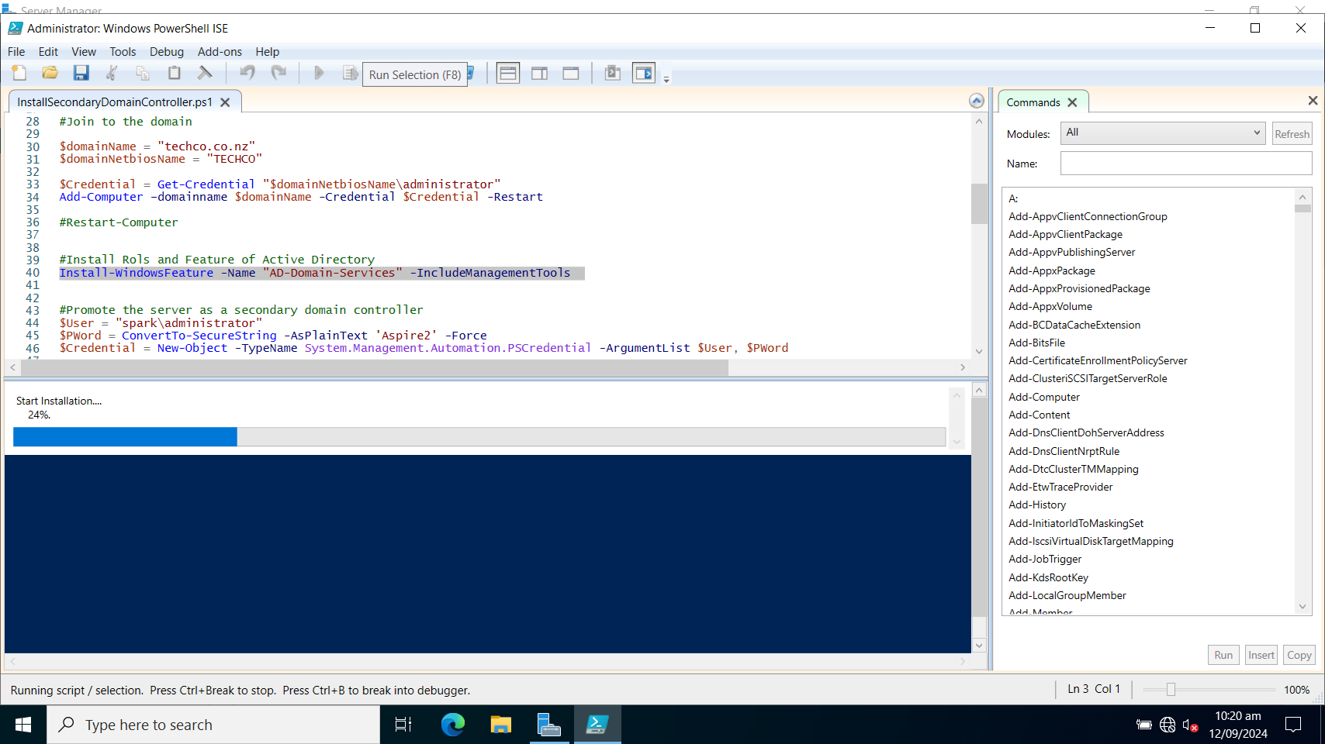

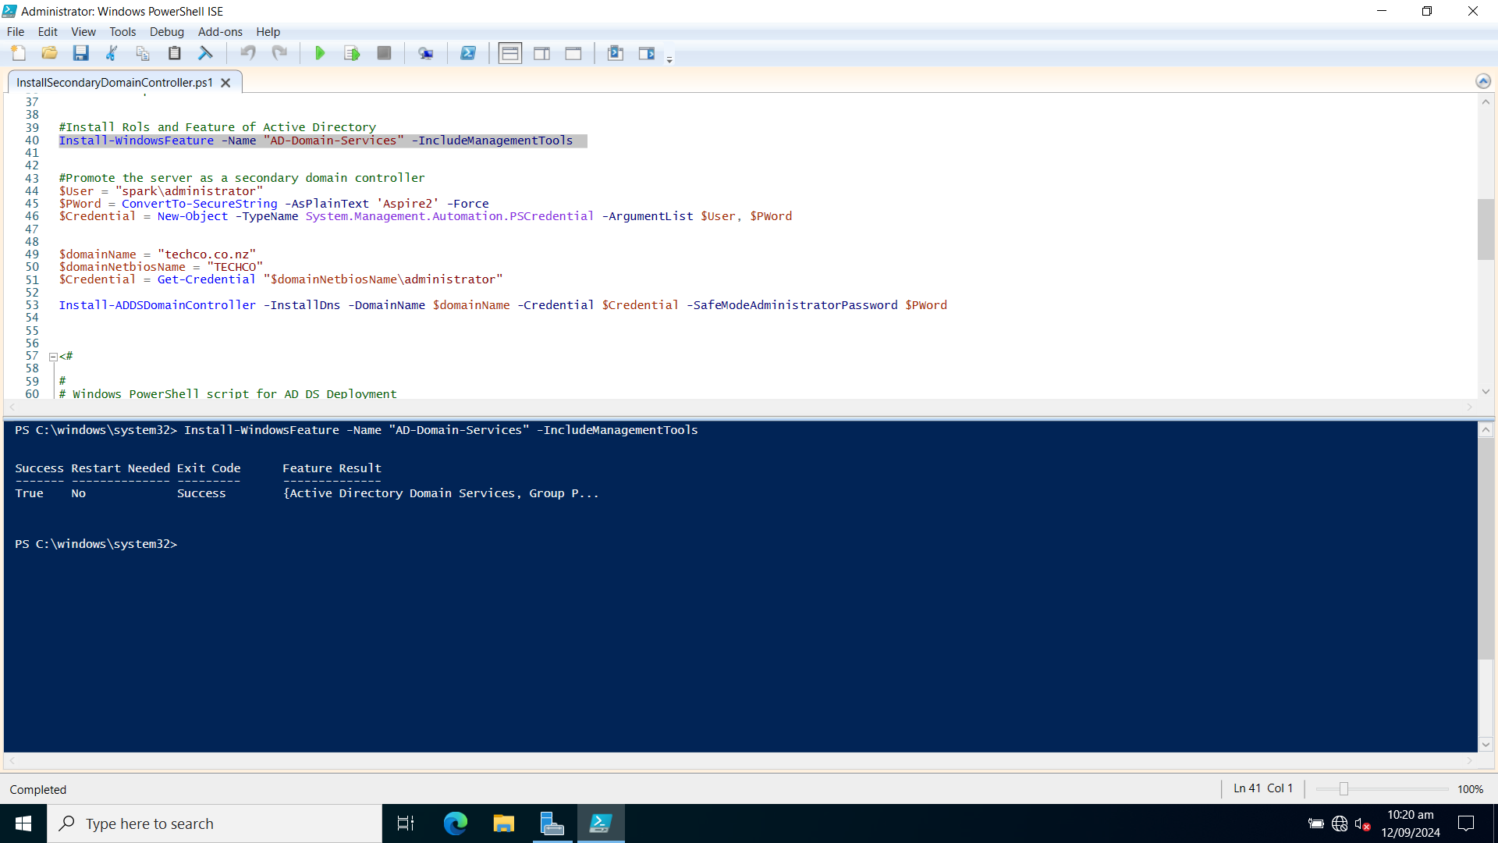

5. Promote the server as a secondary domain controller

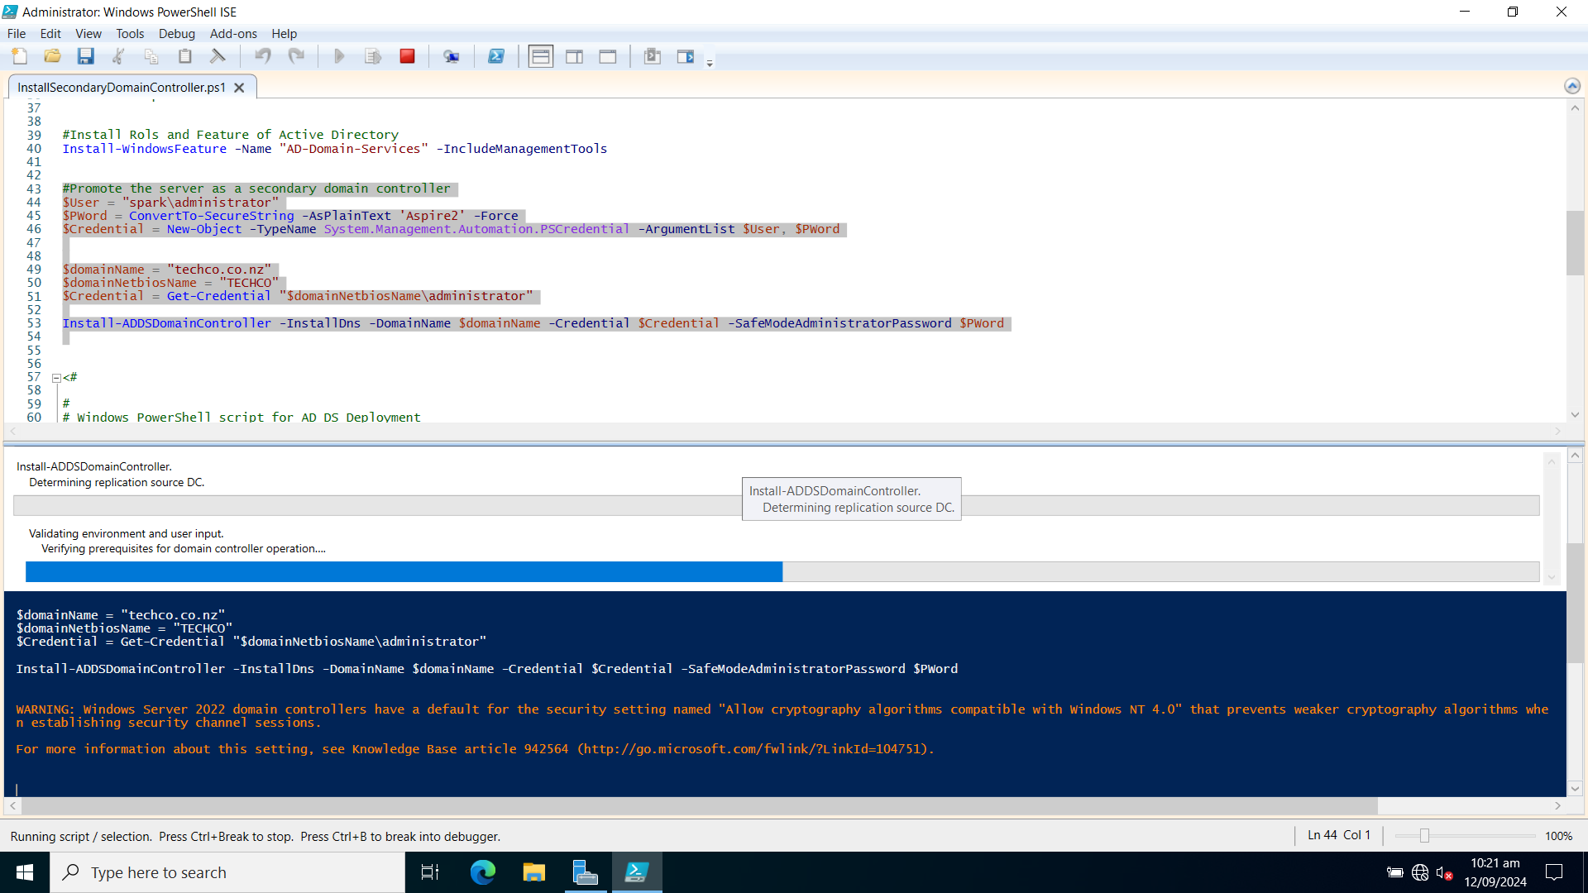

6. Check the user “User1” created on PDC has been synchronized to SDC

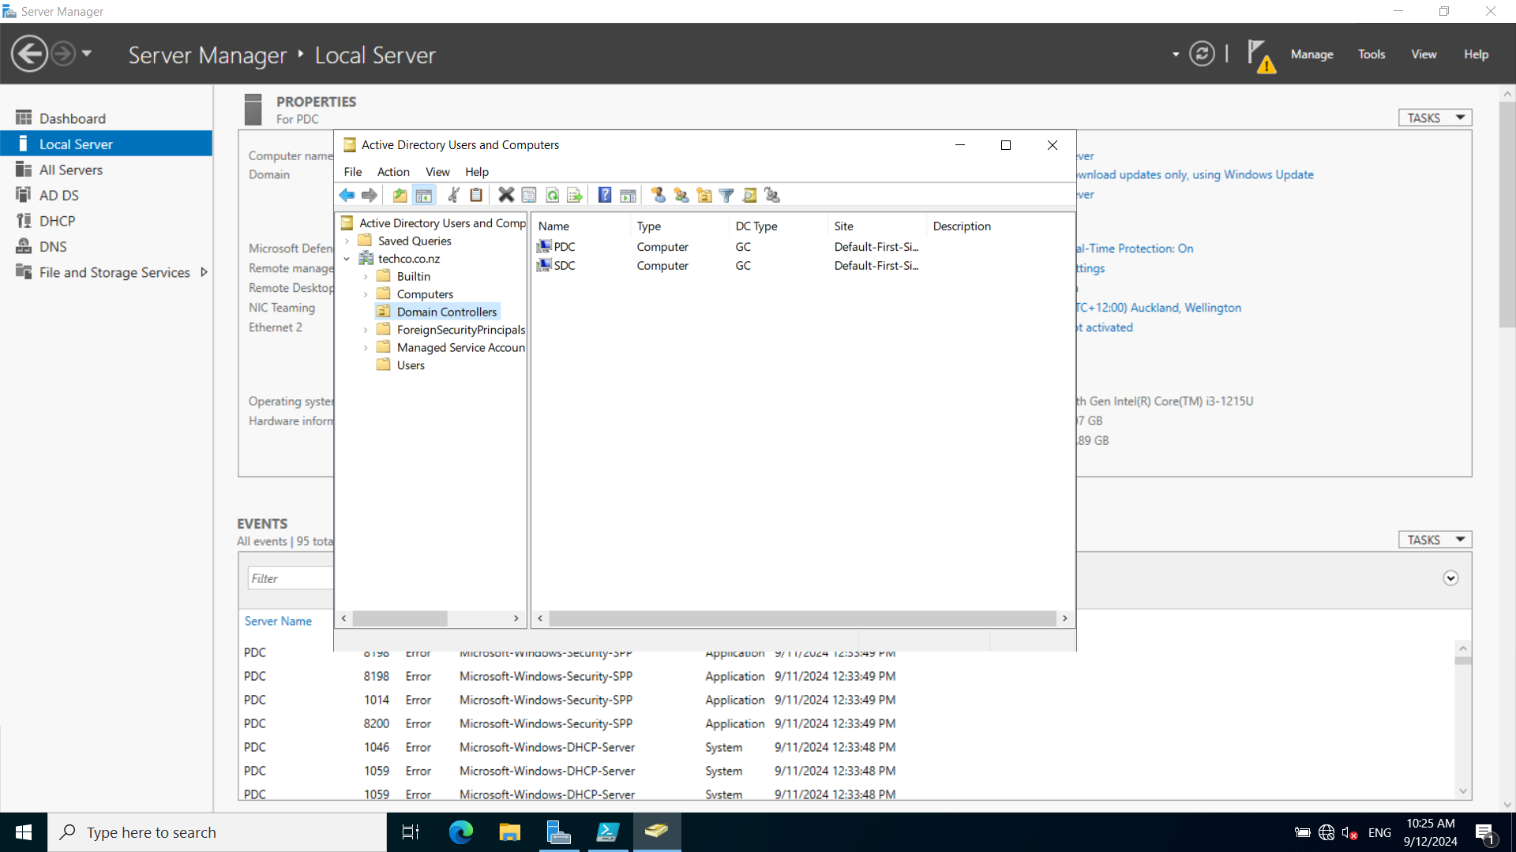

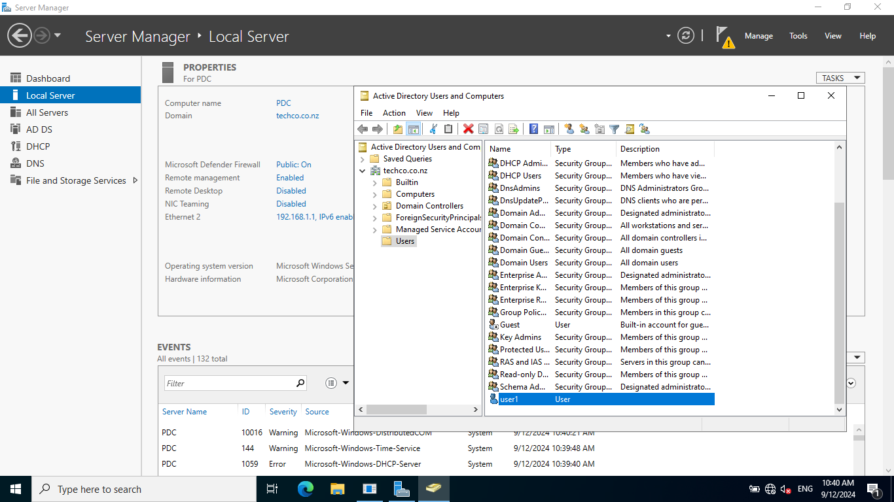

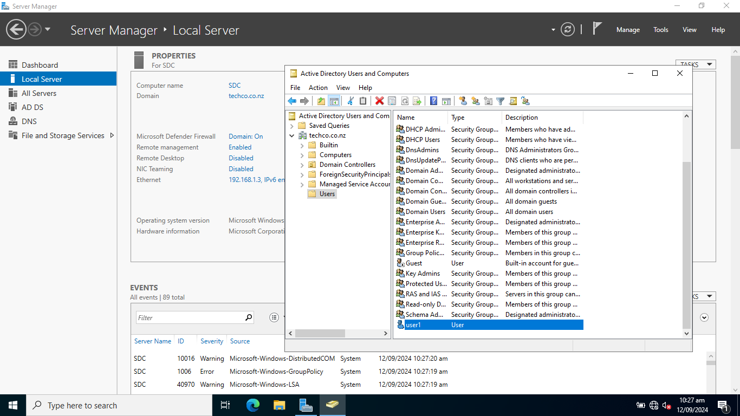

7. Test a client machine to login domain with PDC down.

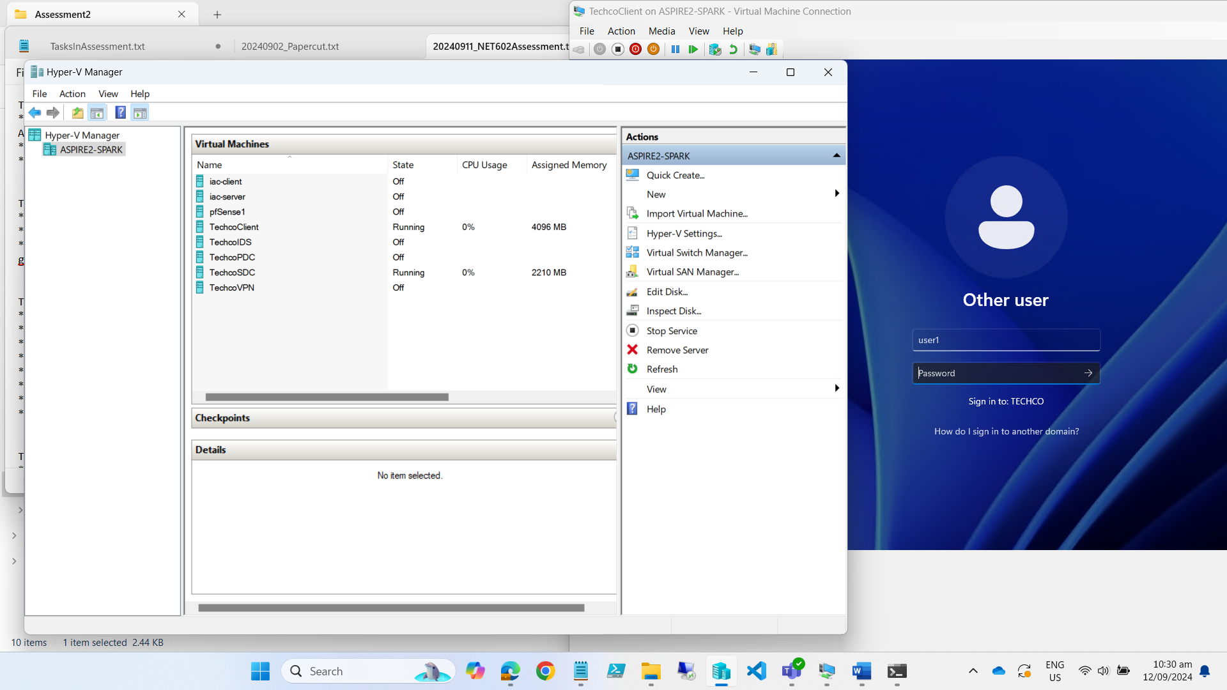

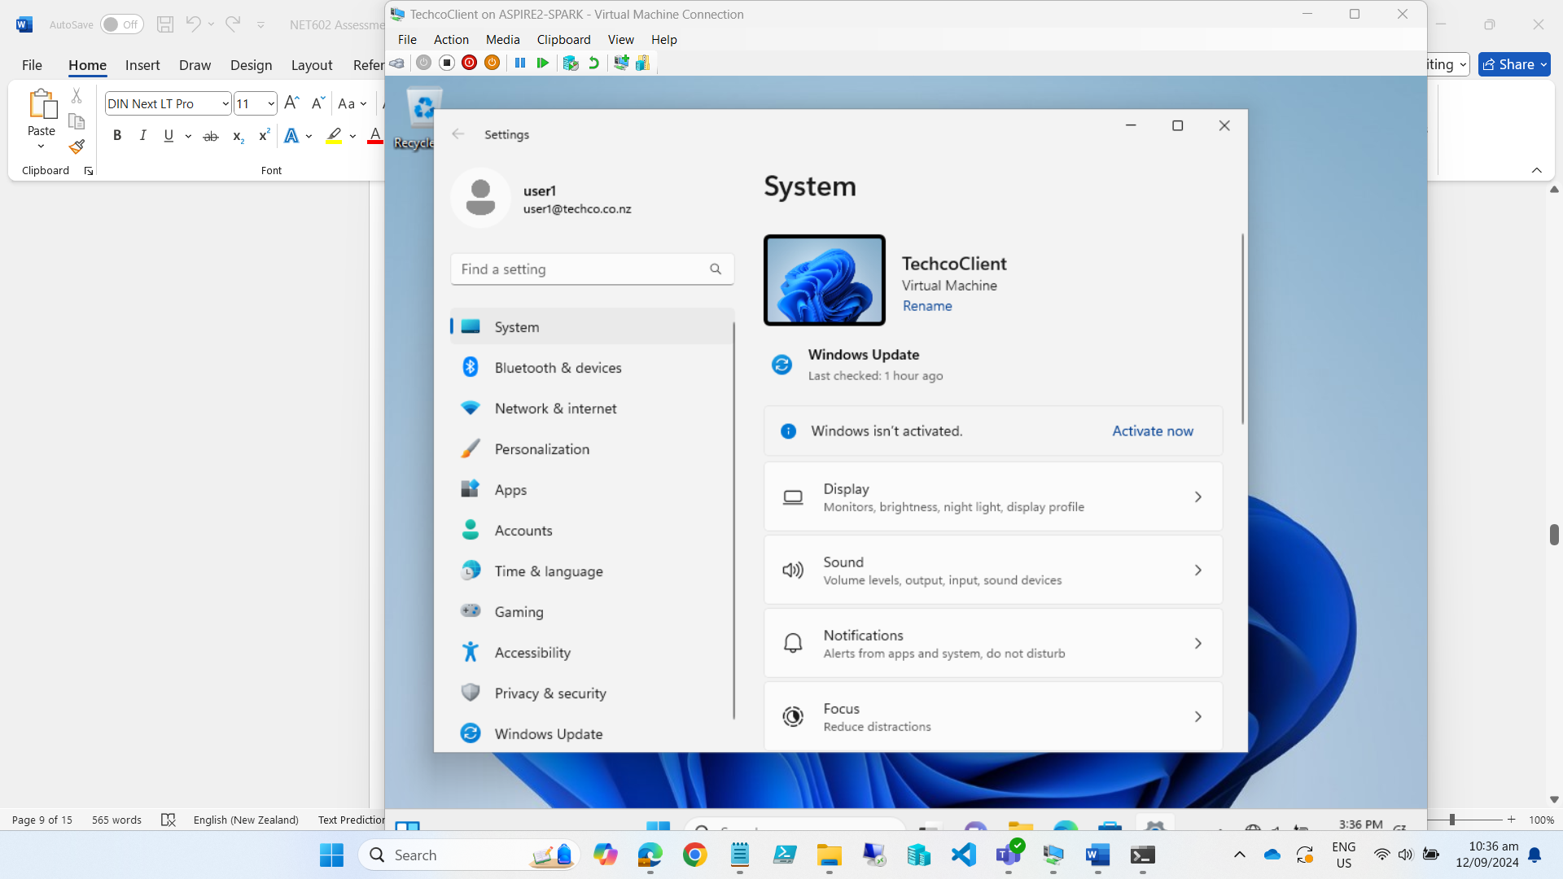

### Task 1.2 Create a PowerShell script to automate user creation in Active Directory

**1. The PowerShell Script to add AD users**

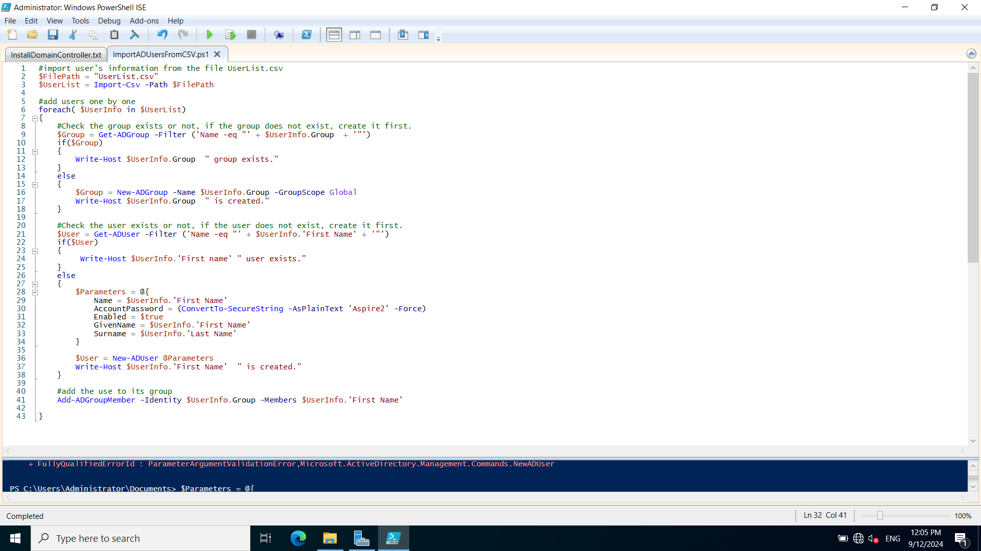

**2. Users in userlist.csv file**

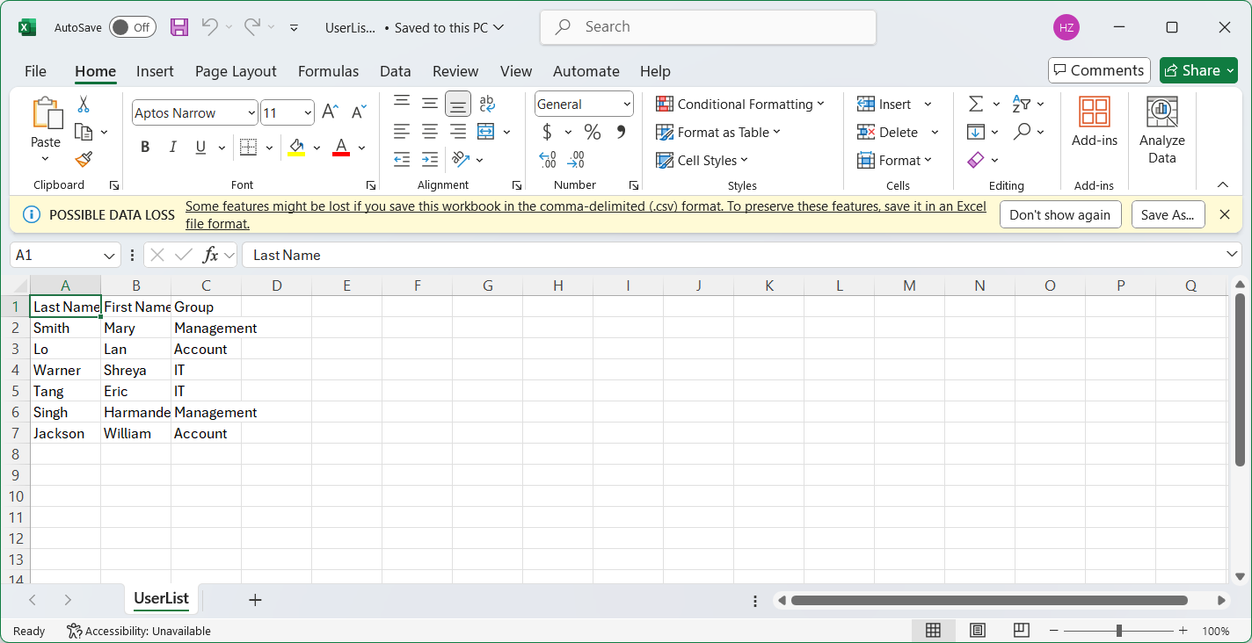

**3. Run the PowerShell script**

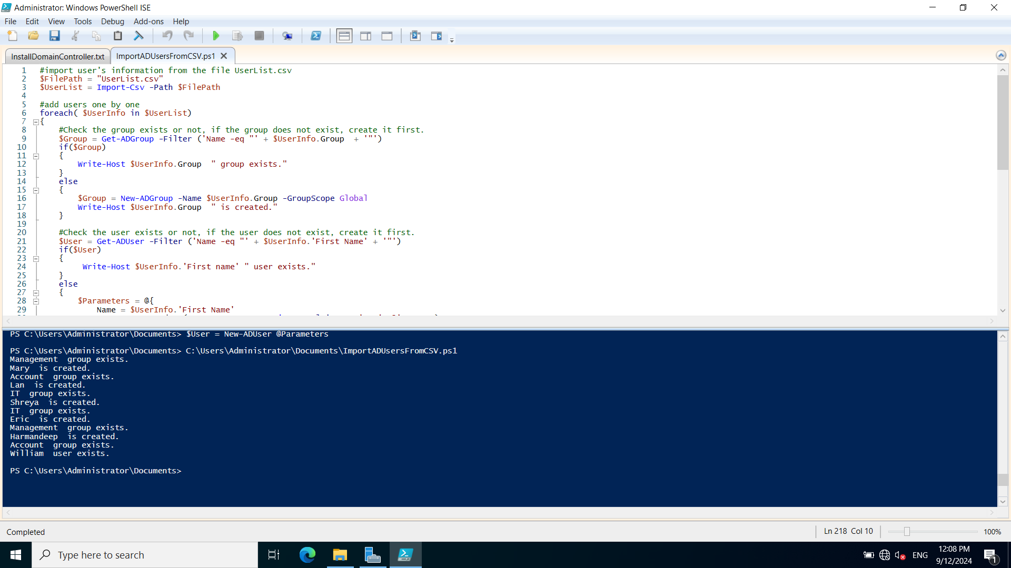

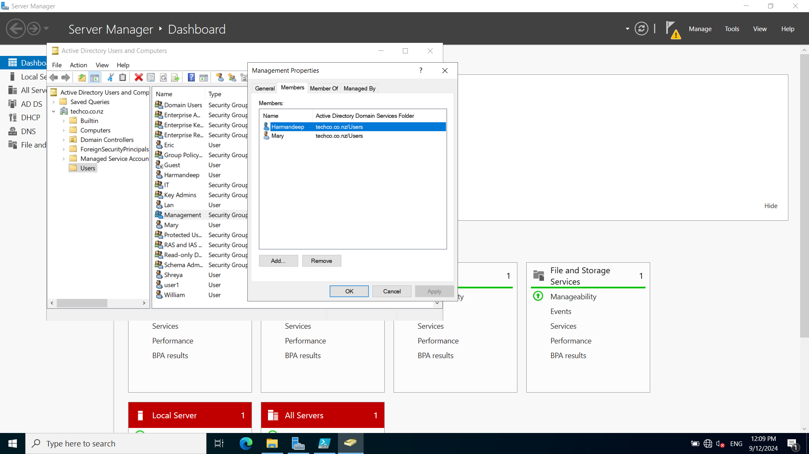

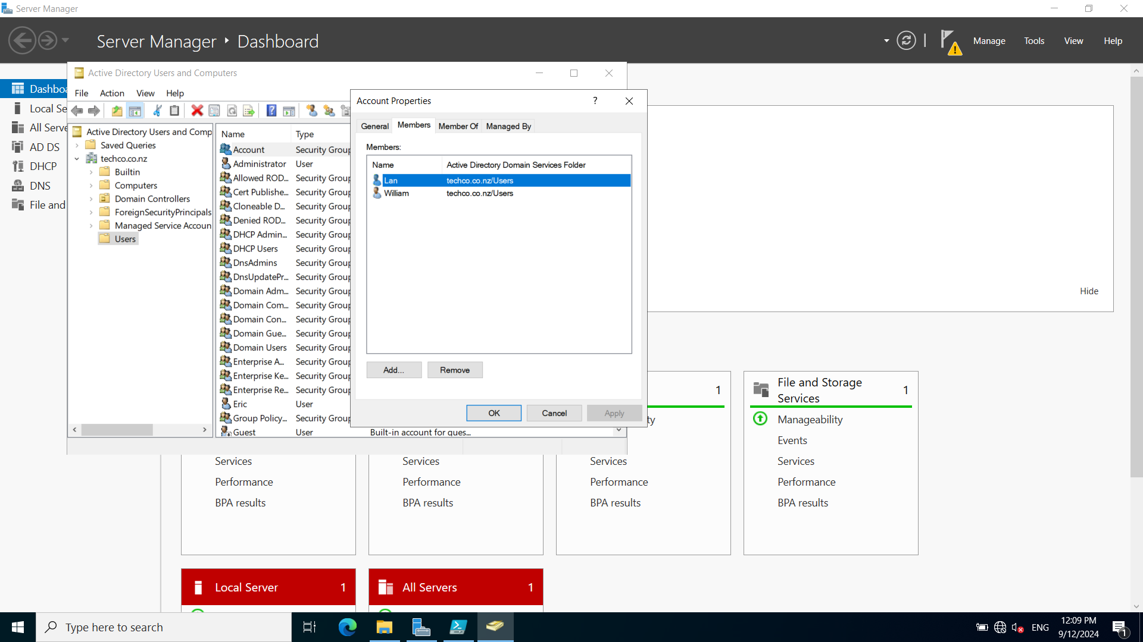

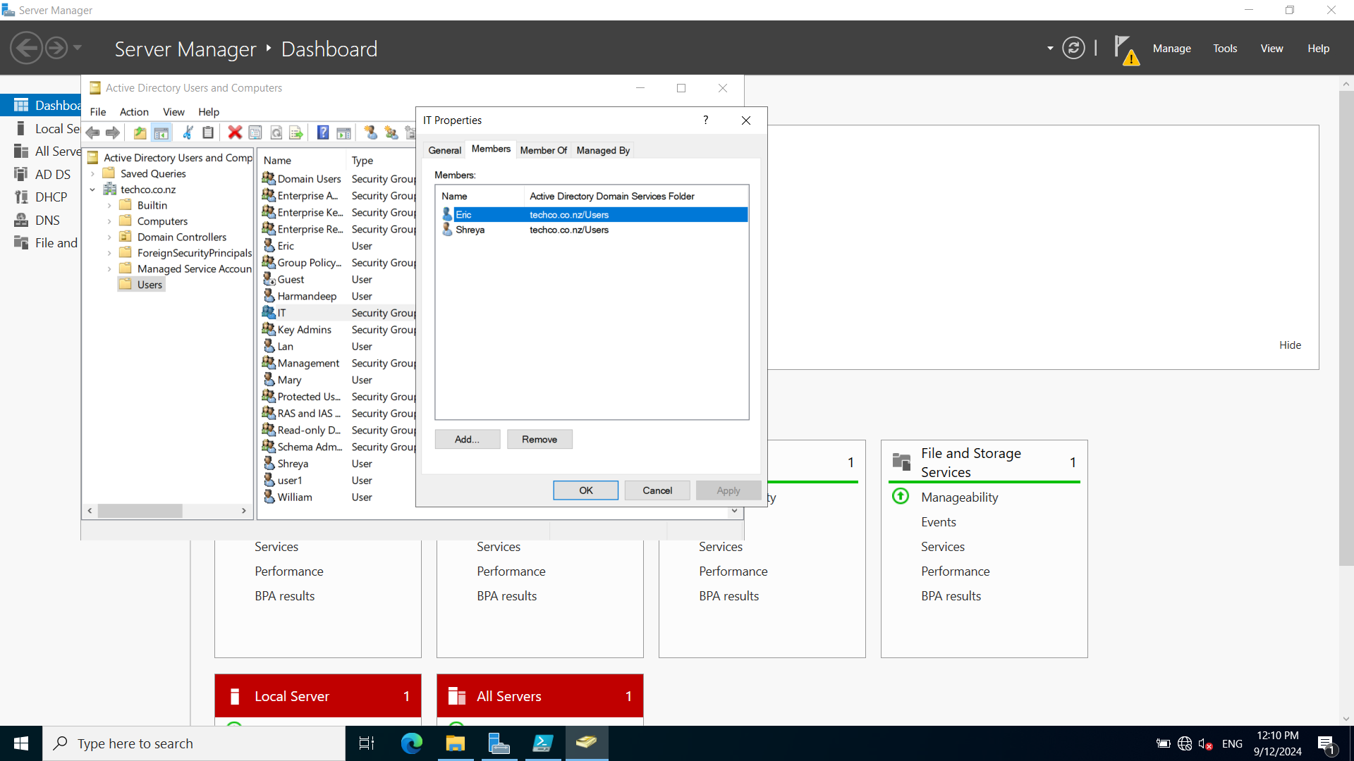

**4. Test users created to login on the client machine**

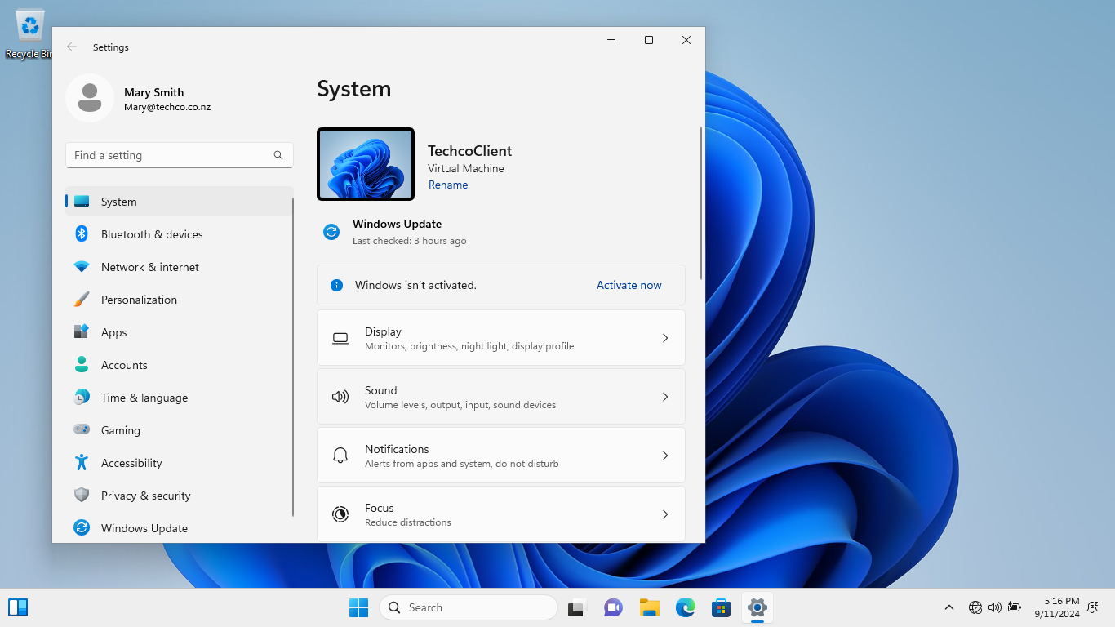

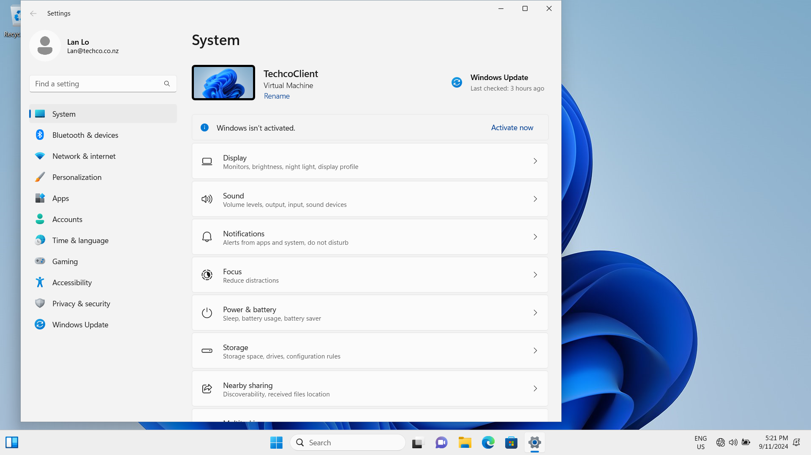

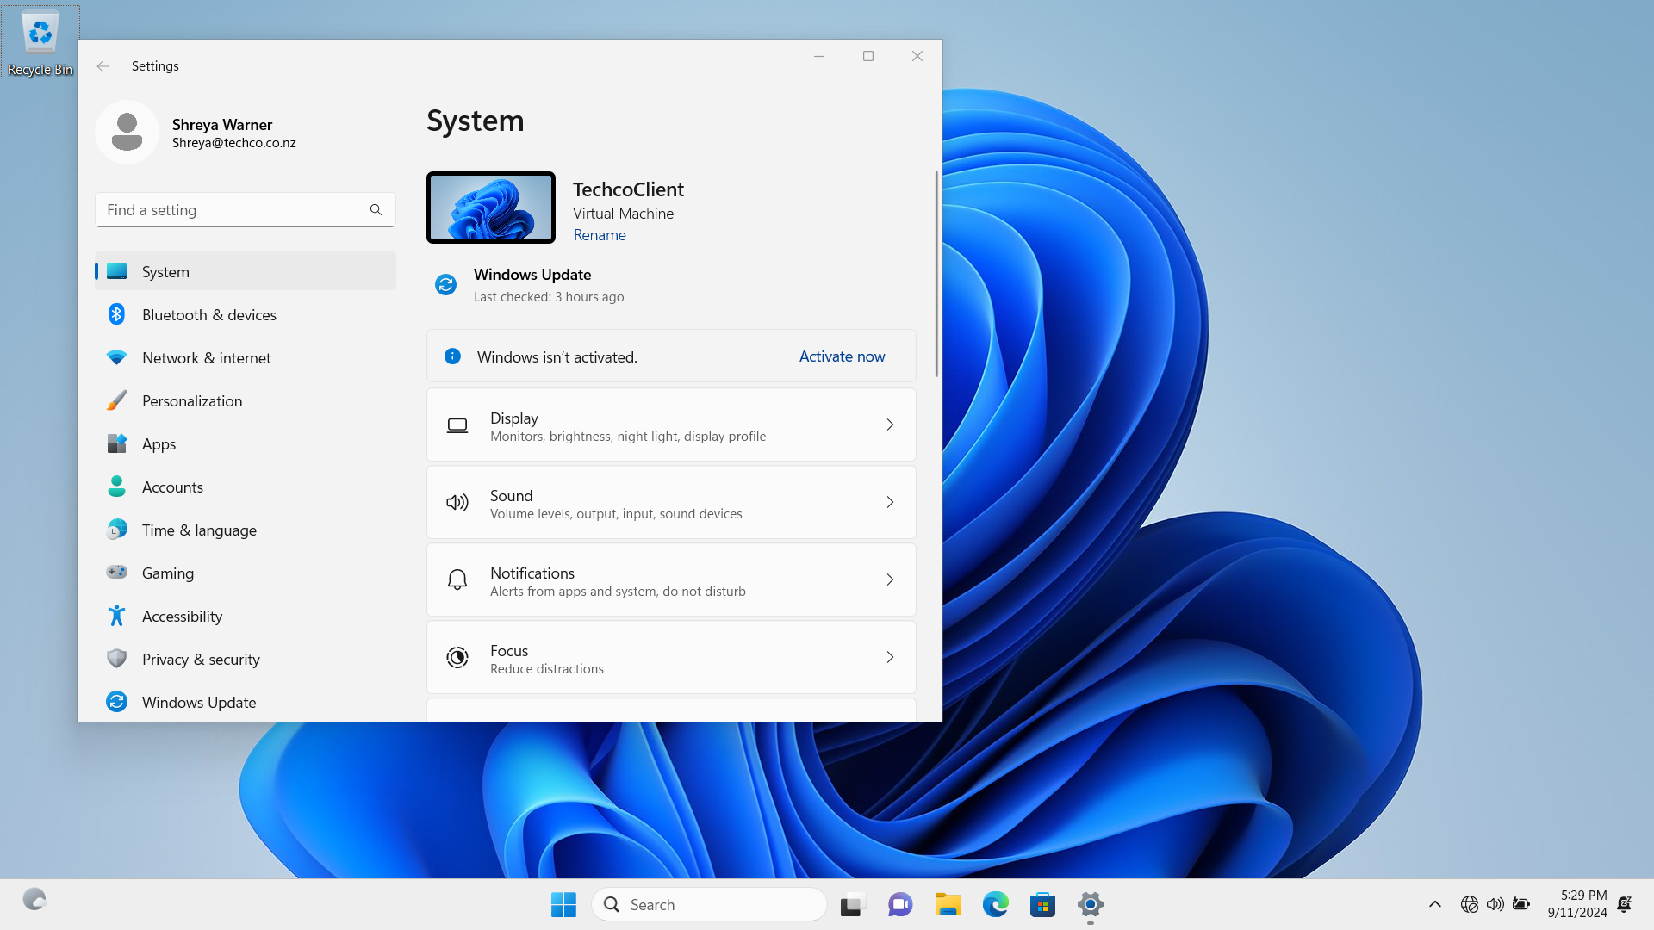

## Task/Mahi 2: Deploying Print Management Solution via Group Policy Object

**1. PaperCut is chosen as our print management solution**

PaperCut provides tools to monitor and control printing activities centrally across the Media Labs network. And PaperCut provides effective ways to manage and reduce printing costs. In our print management solution, PaperCut management system will be deployed on the primary domain controller and PaperCut client software will be deployed to the user client machines through Group Policy Objects (GPO).

**2. Prepare and install Papercut software**

2.1 Install Printer service role on DC

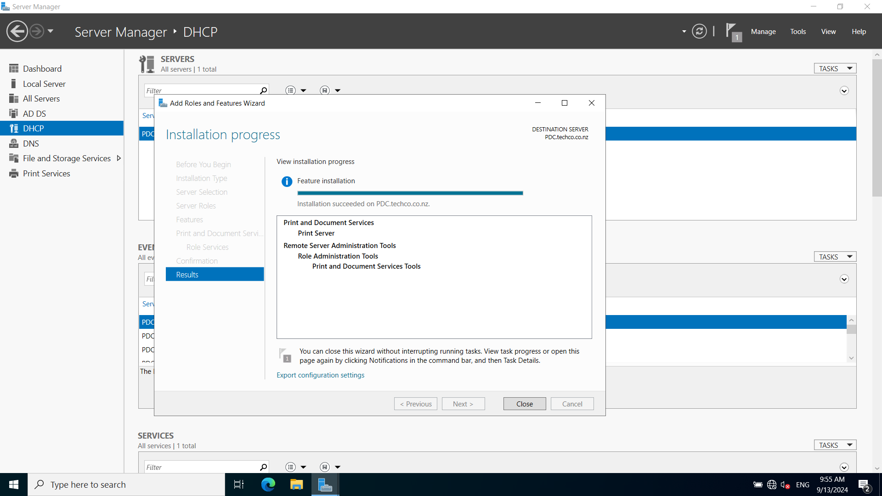

2.2 Install Lexmark printer driver on DC

Download Lexmark Printer Drivers from <https://downloads.lexmark.com/downloads/drivers/Lexmark_Universal_v2_UD1_Installation_Package_02092023.exe>

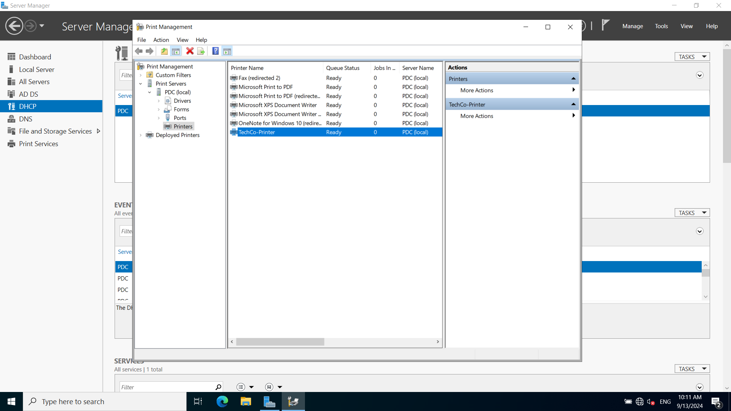

2.3 Download Papercut software.

<https://cdn.papercut.com/web/products/ng-mf/installers/ng/24.x/pcng-setup-24.0.4.70157.exe>

2.4 Install Papercut software on DC. (Admin/Spark@Aspire2)

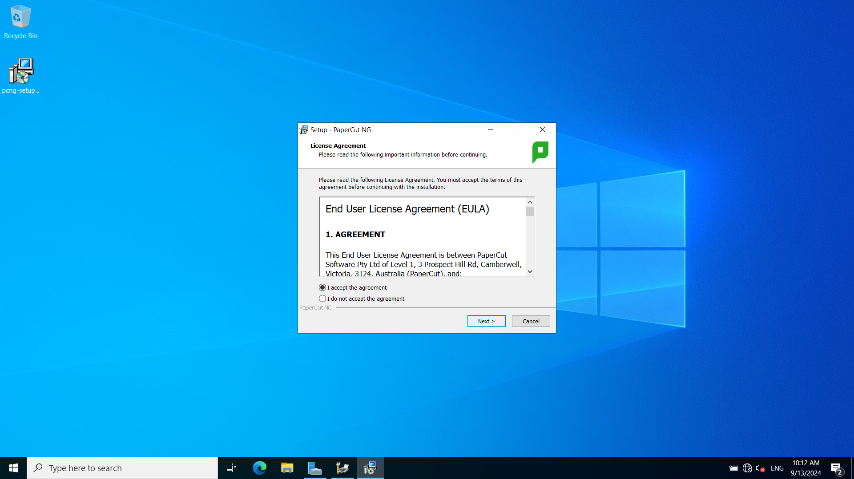

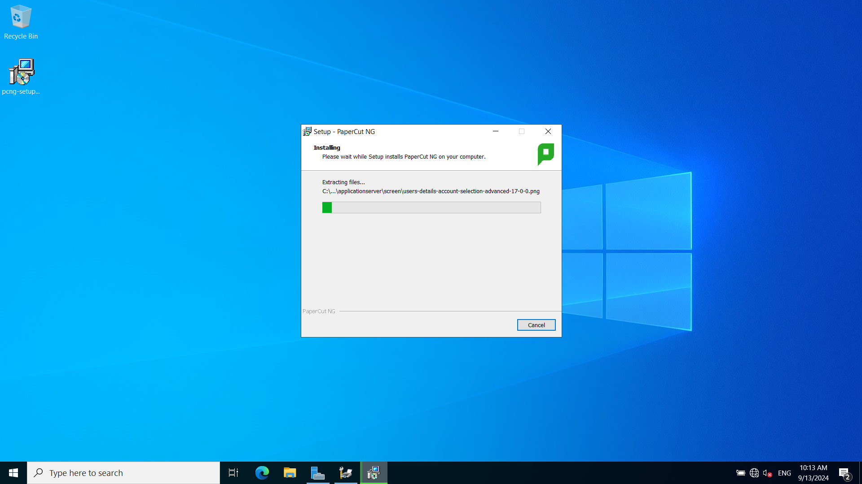

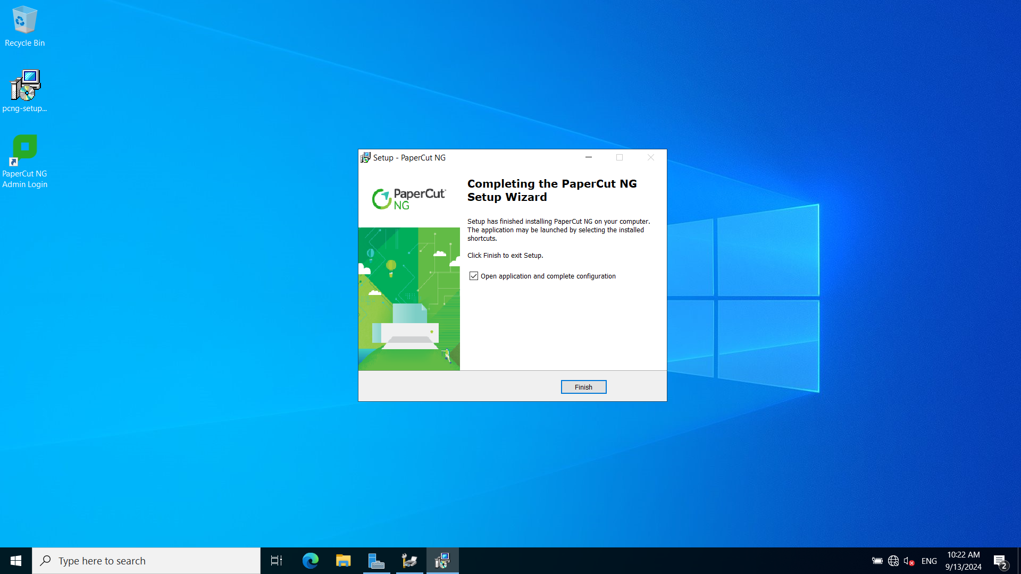

**3. Configure PaperCut**

3.1 Login to Admin portal.

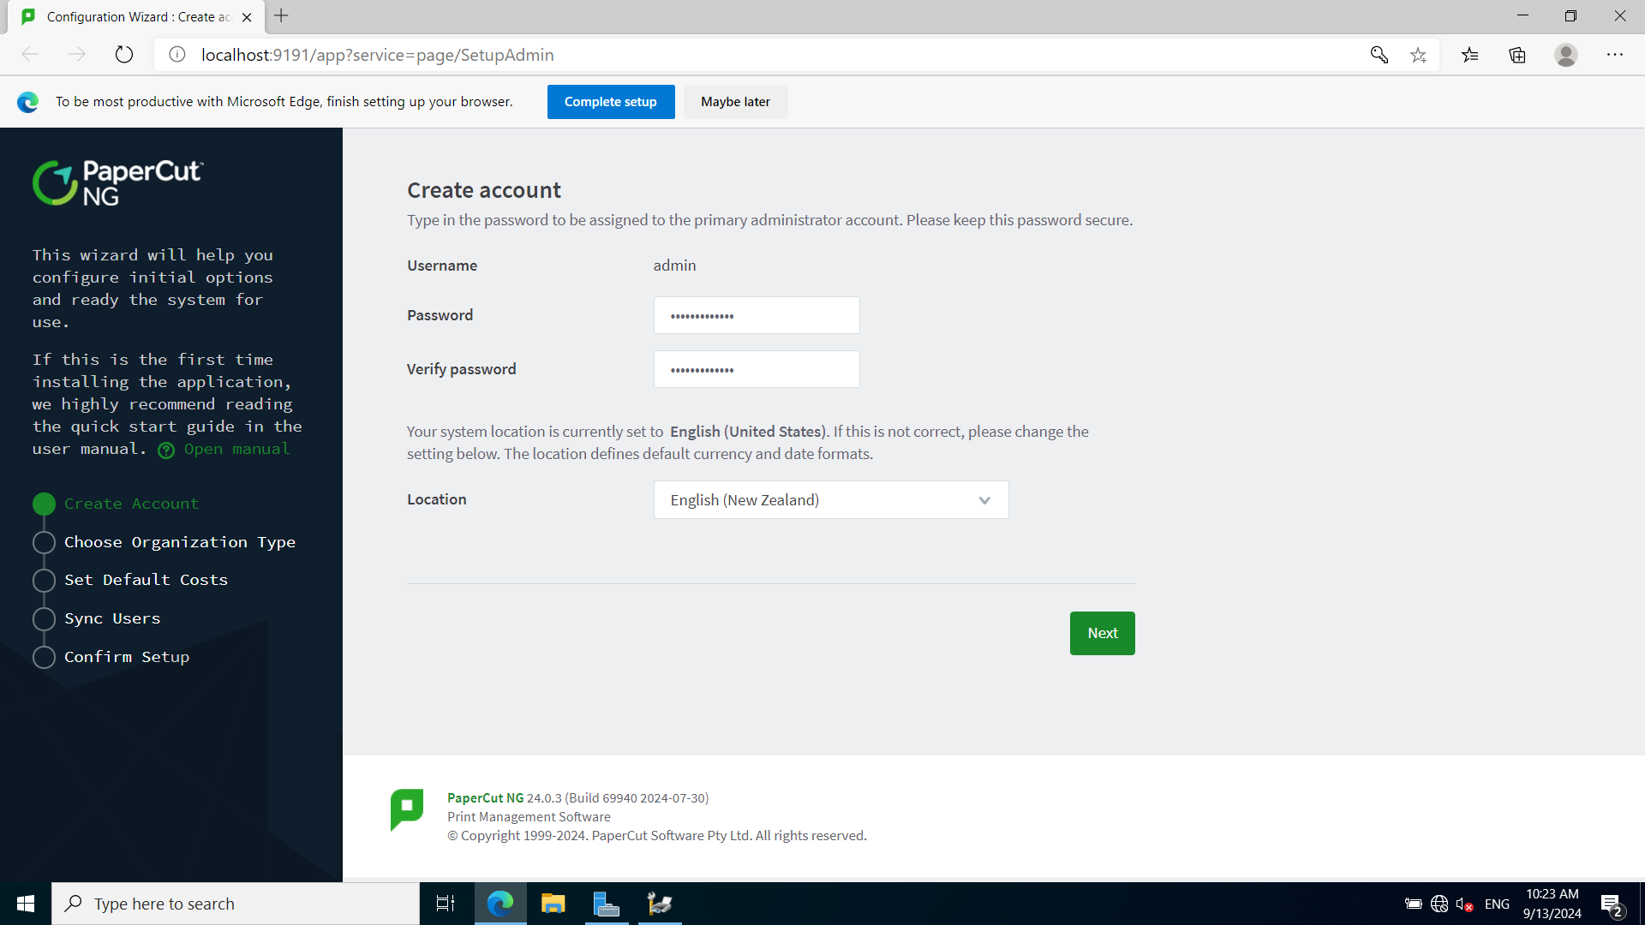

3.2 Set printing price

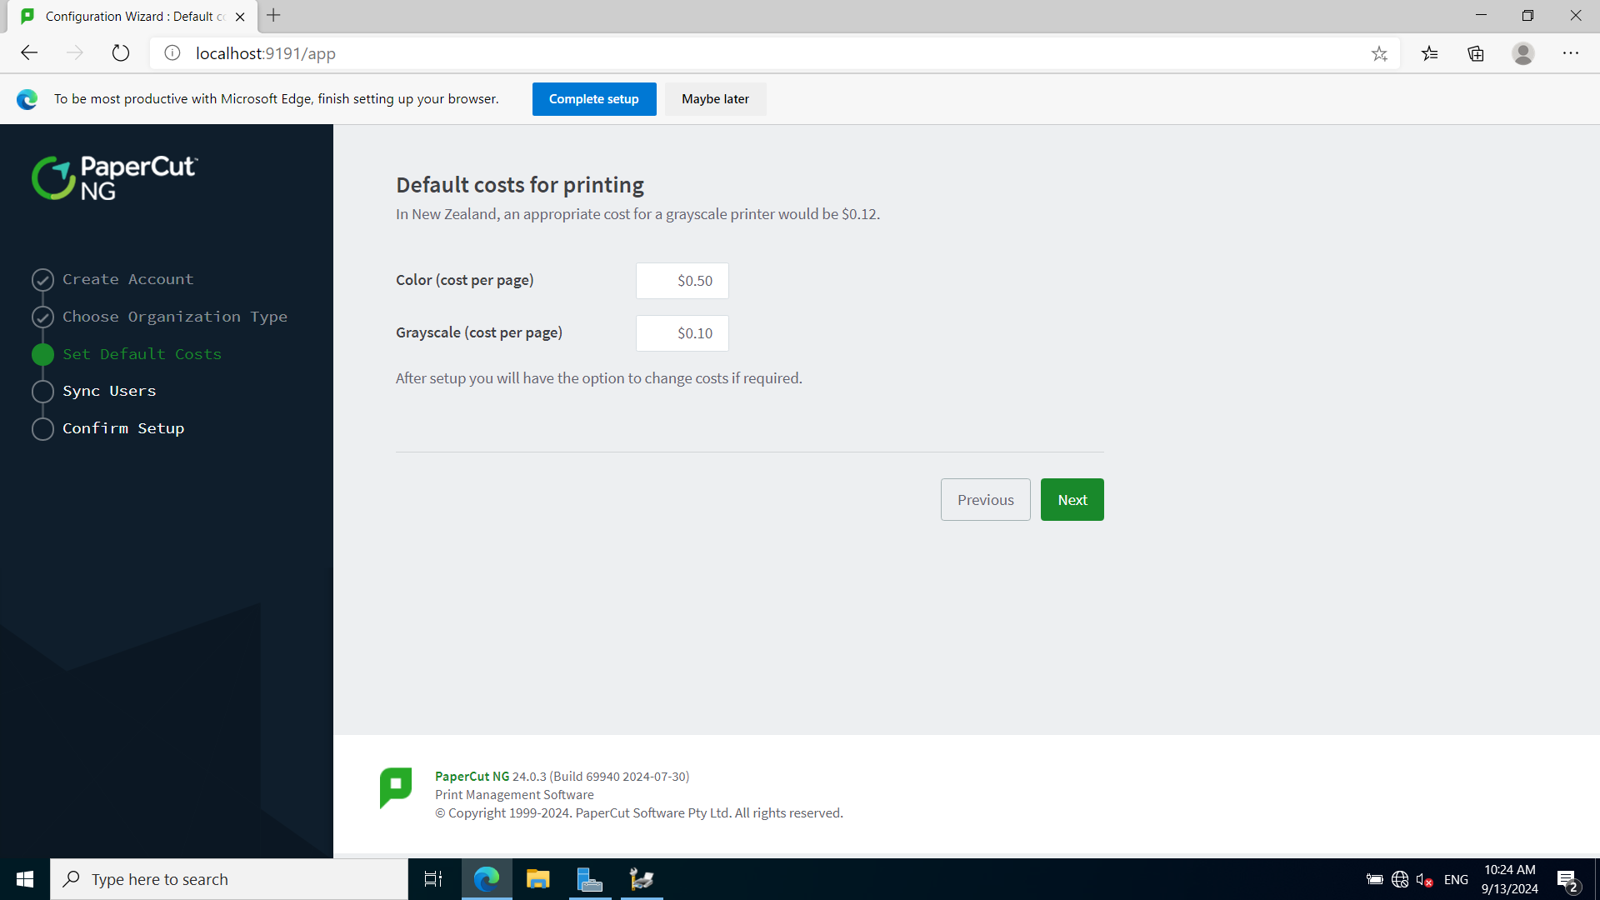

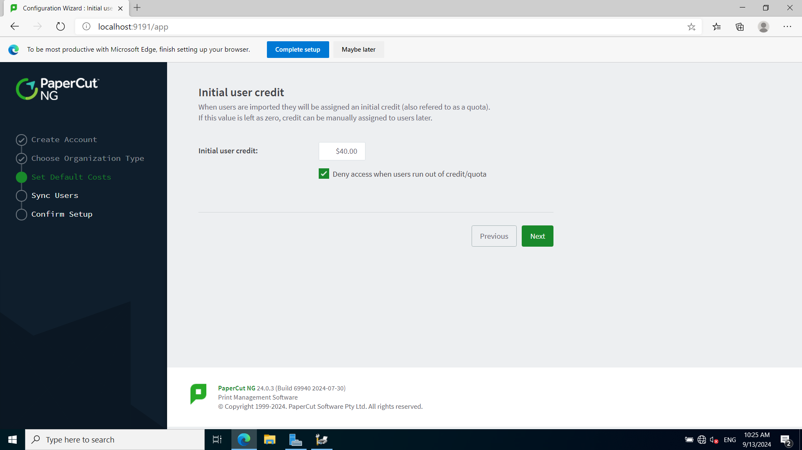

3.3 Sync users with AD

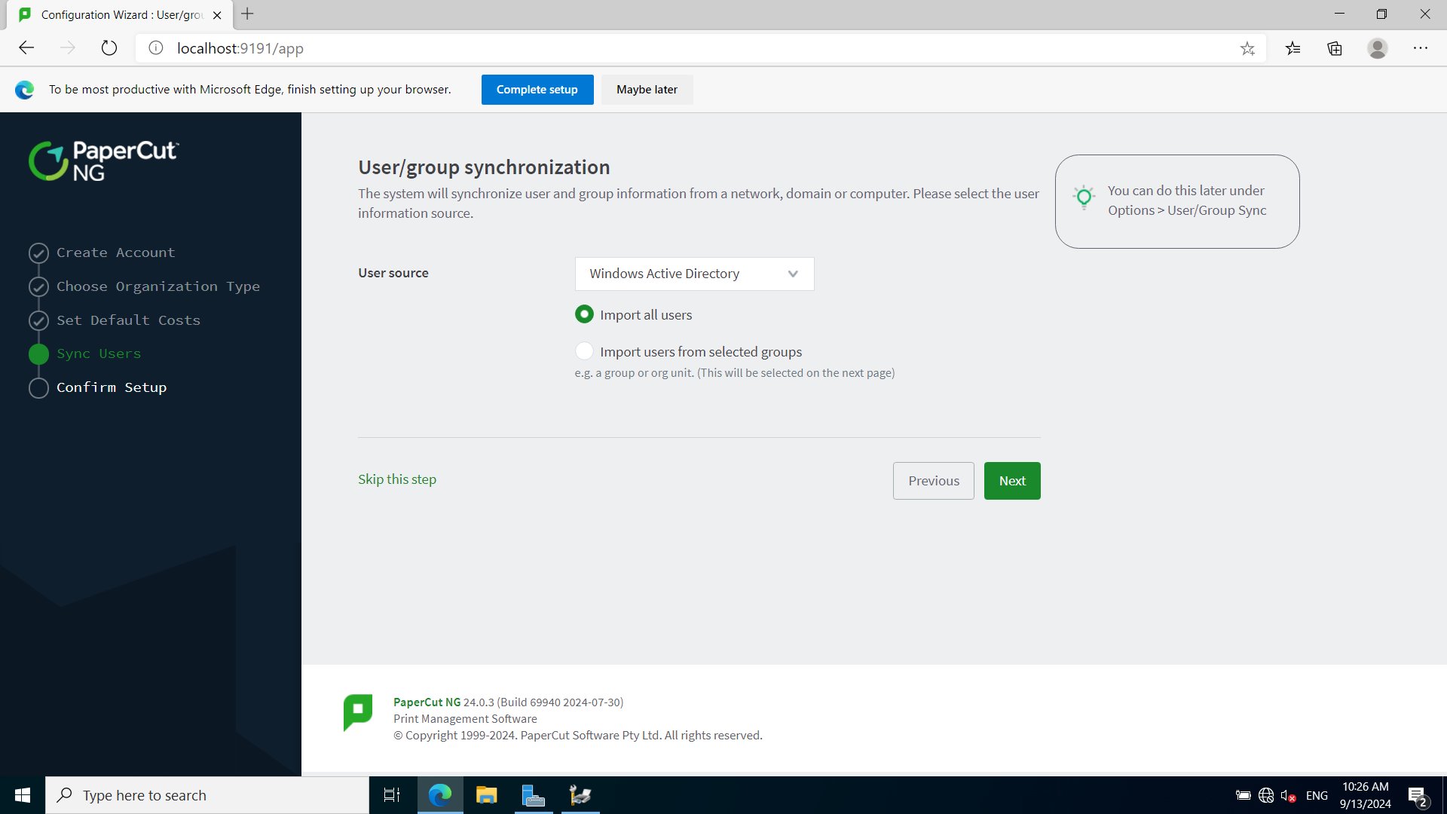

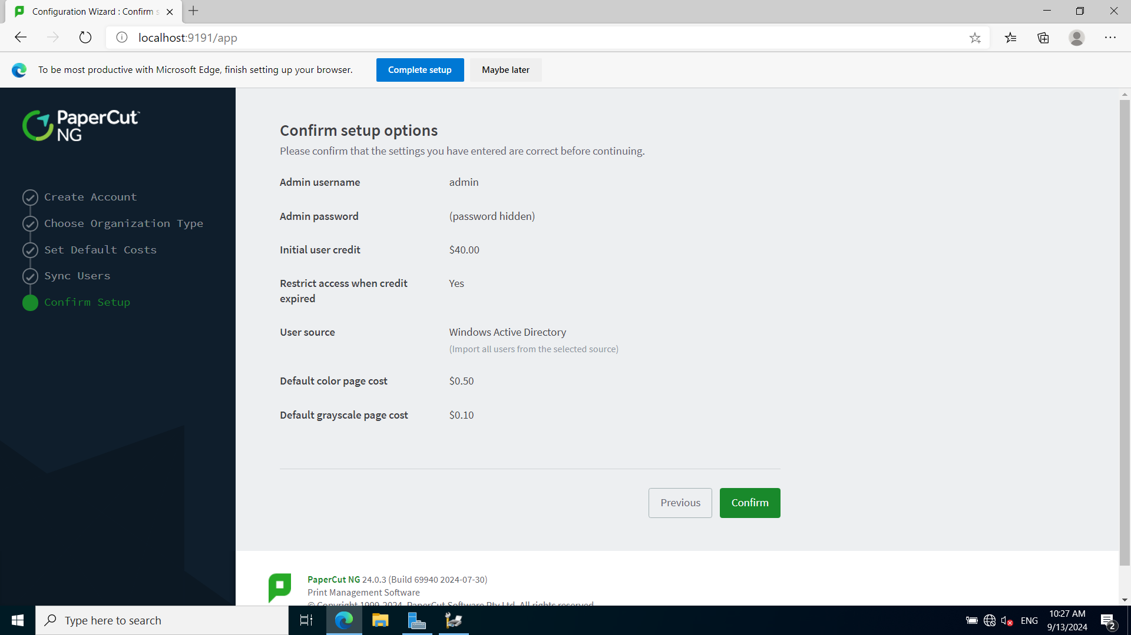

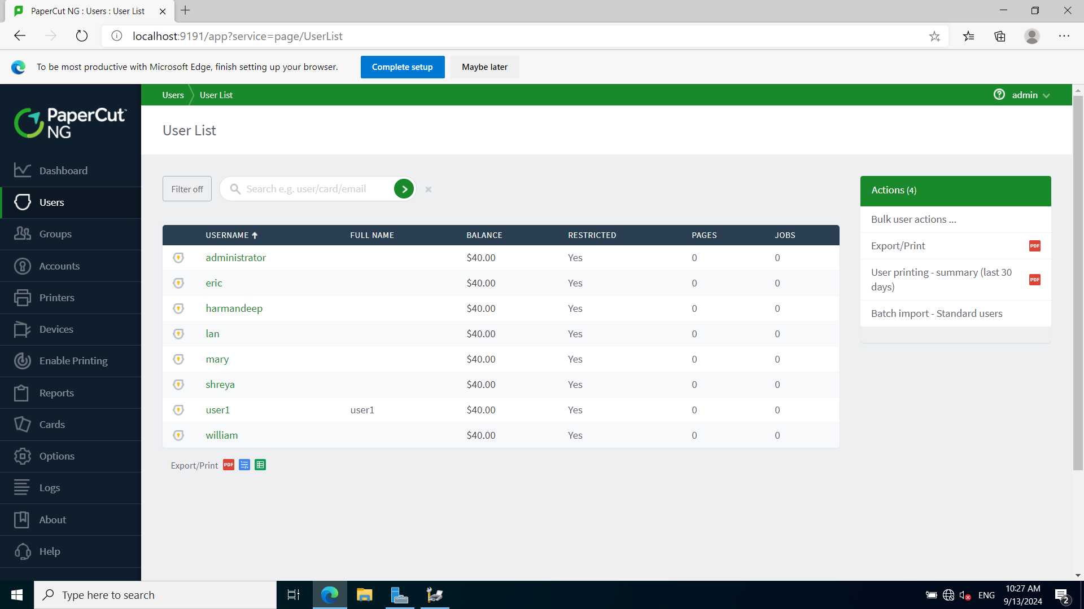

**4. Add printer with cloner to portal in "Enable Printing" option.**

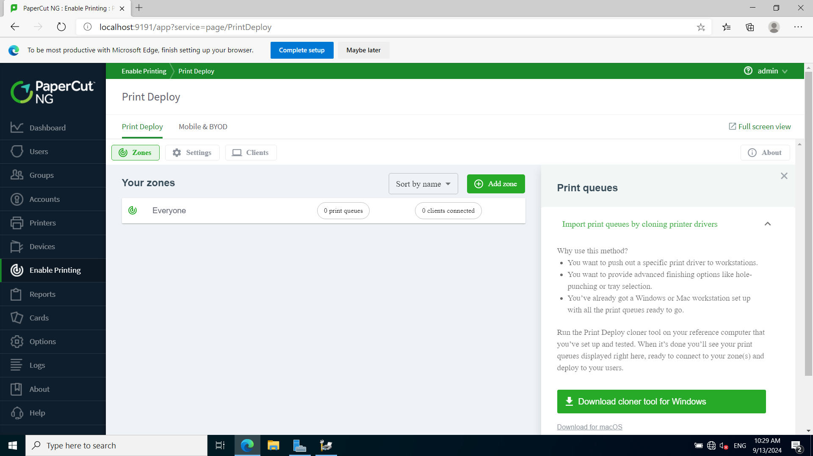

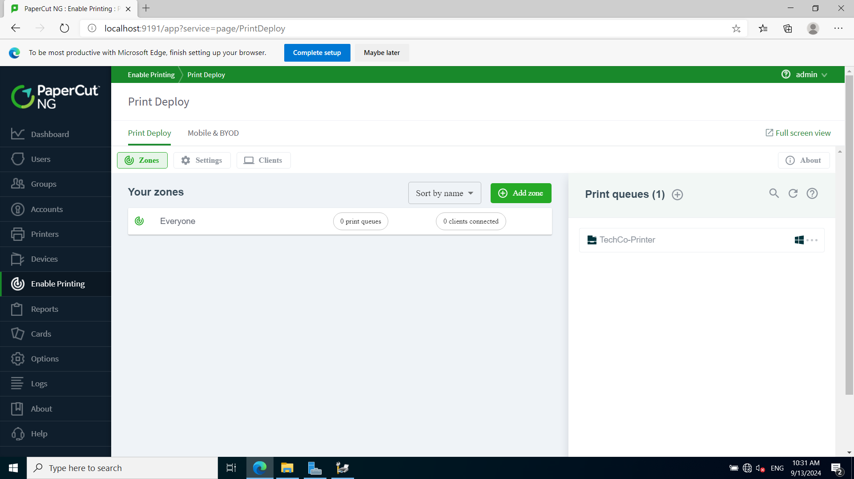

**5. Add printer to Zone.**

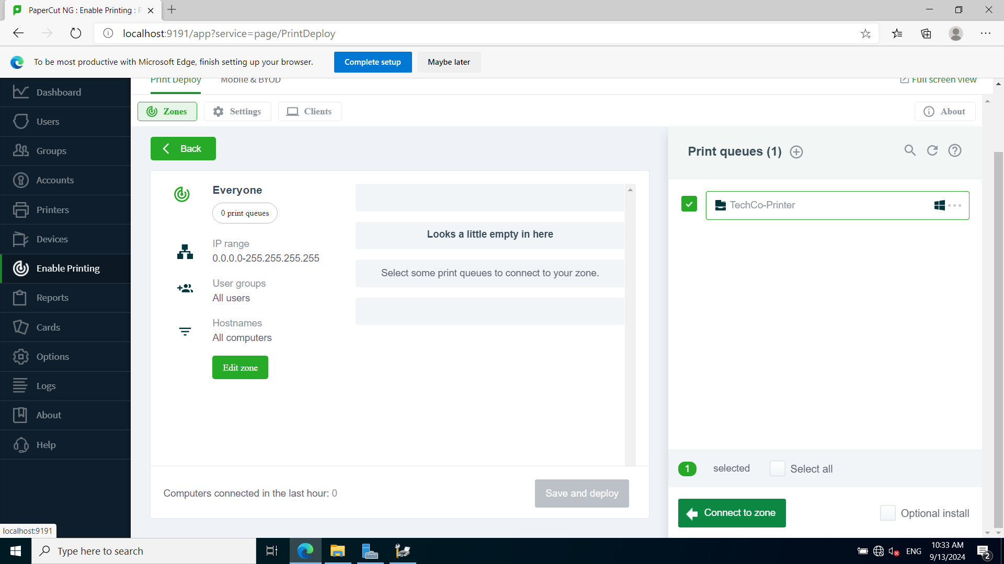

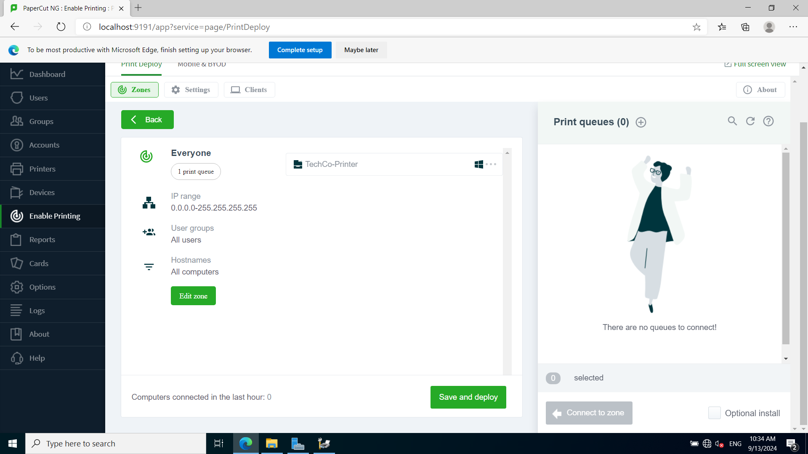

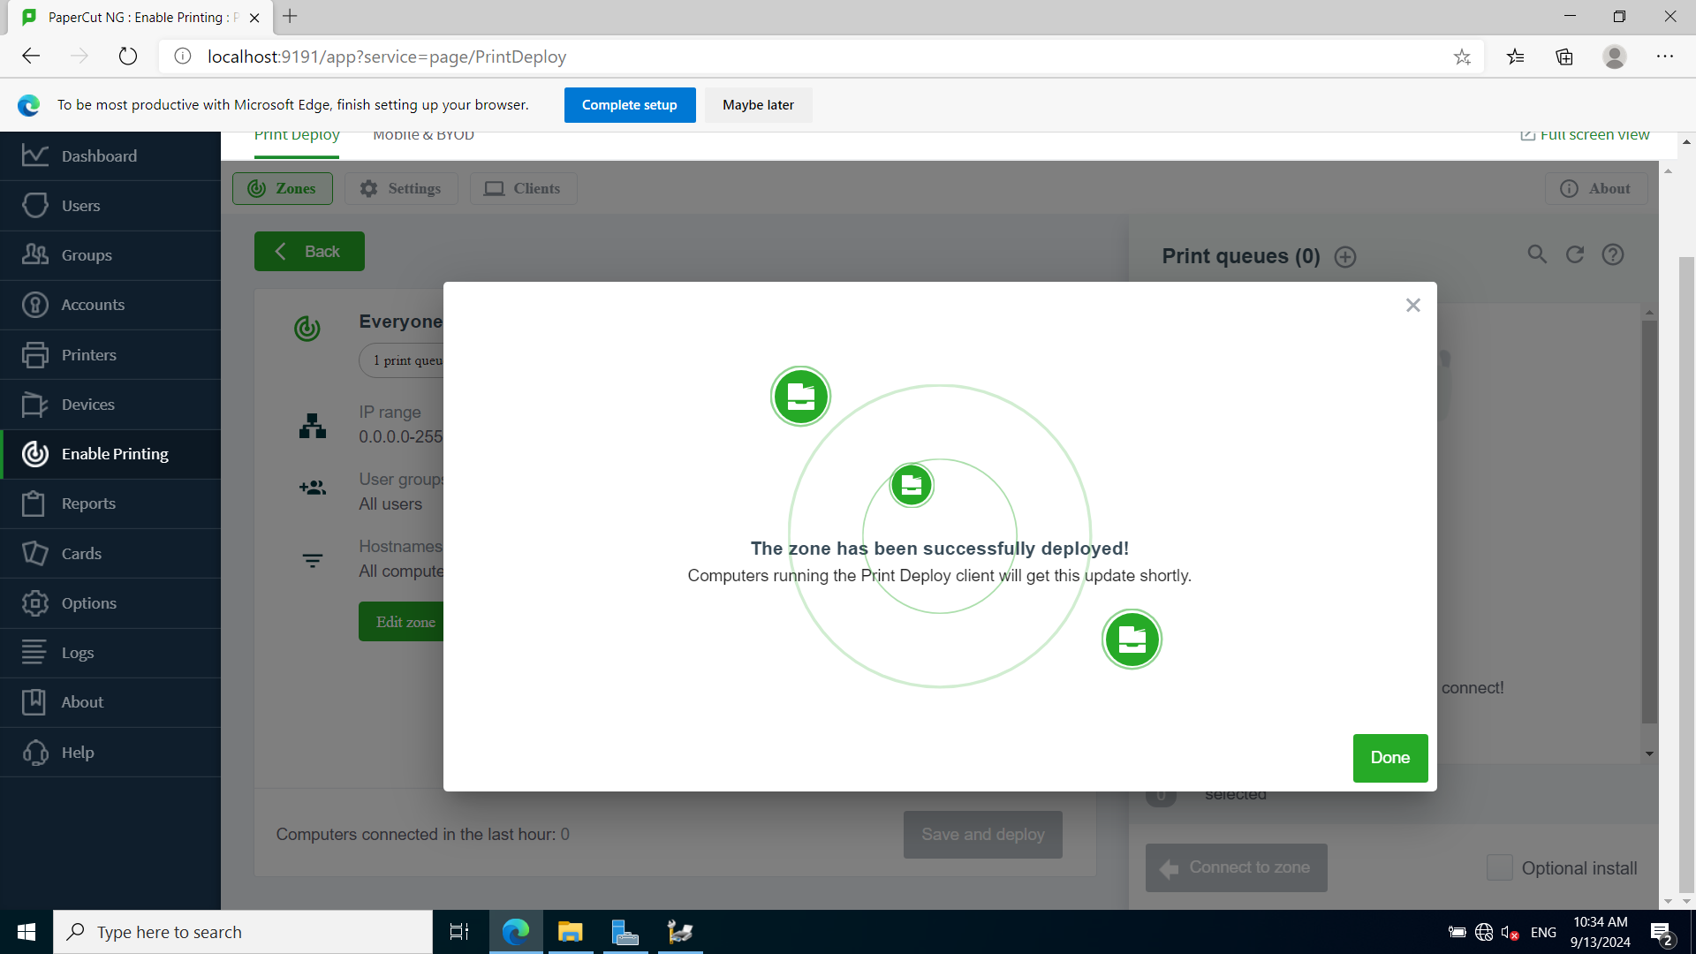

**6. Generate a client software in "Zone->Client->Windows"**

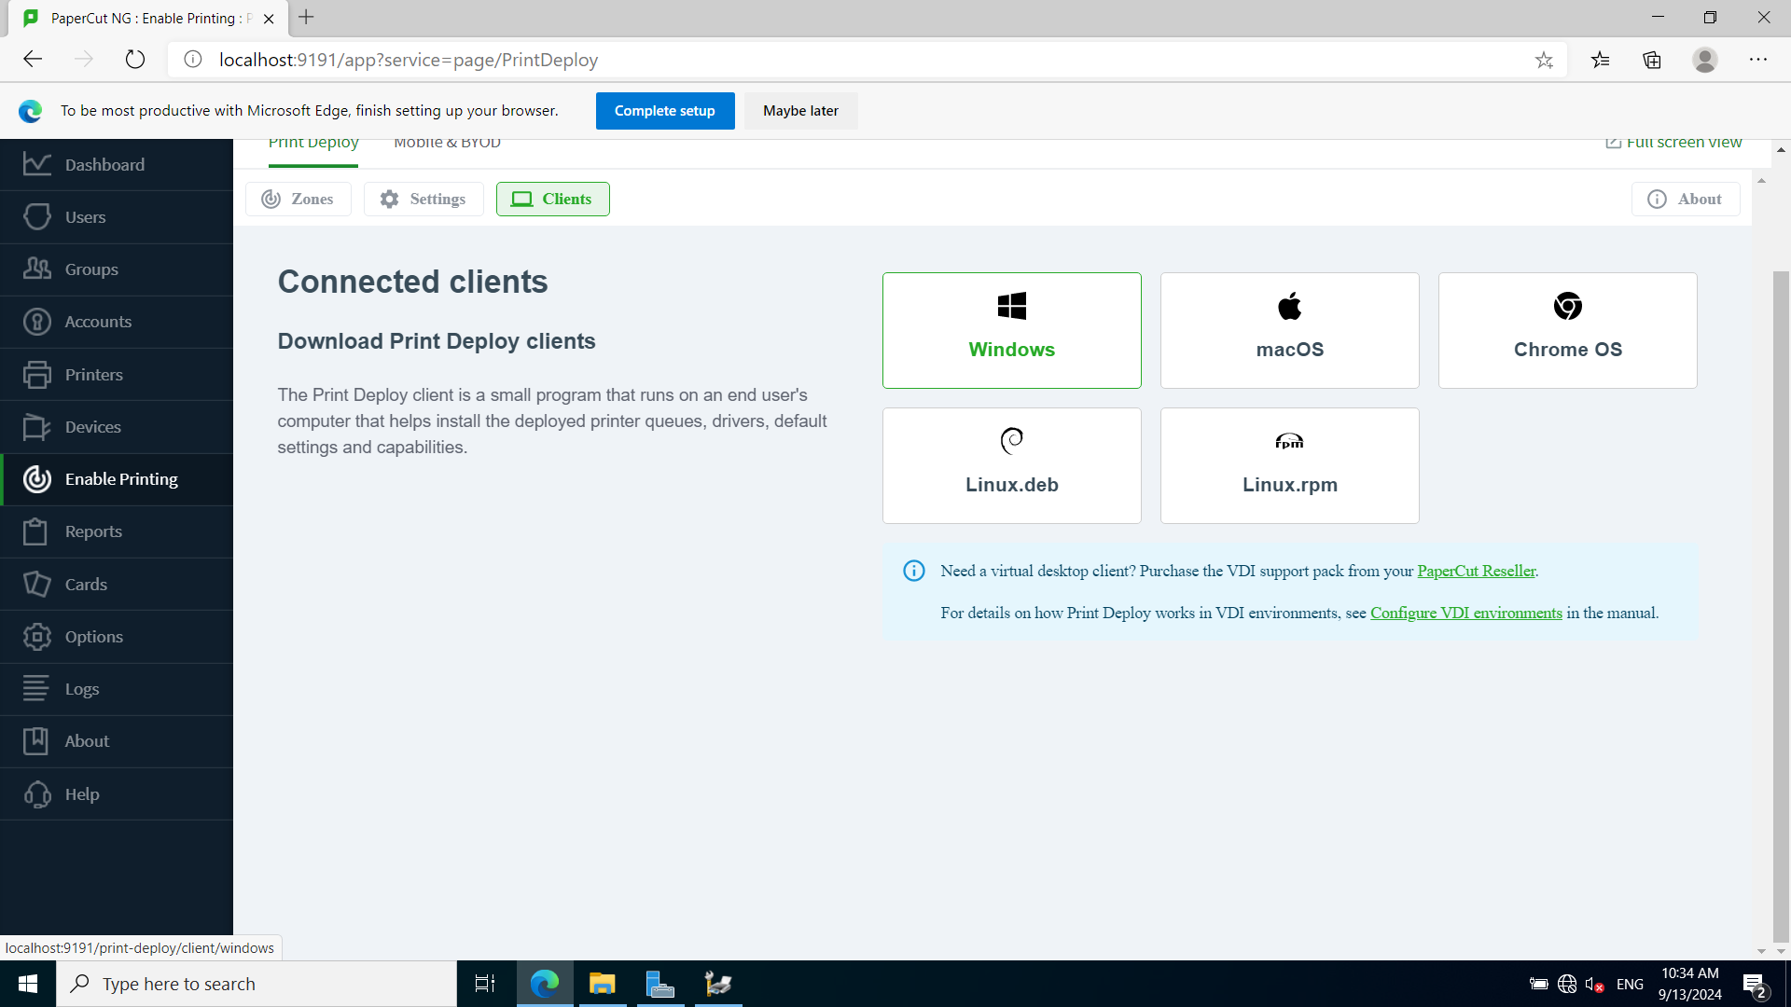

**7. Create a Papercut Group Policy to deploy the client software to the client machine.**

* Set up shared folder (Administrators, Domain Computers, Domain Users)

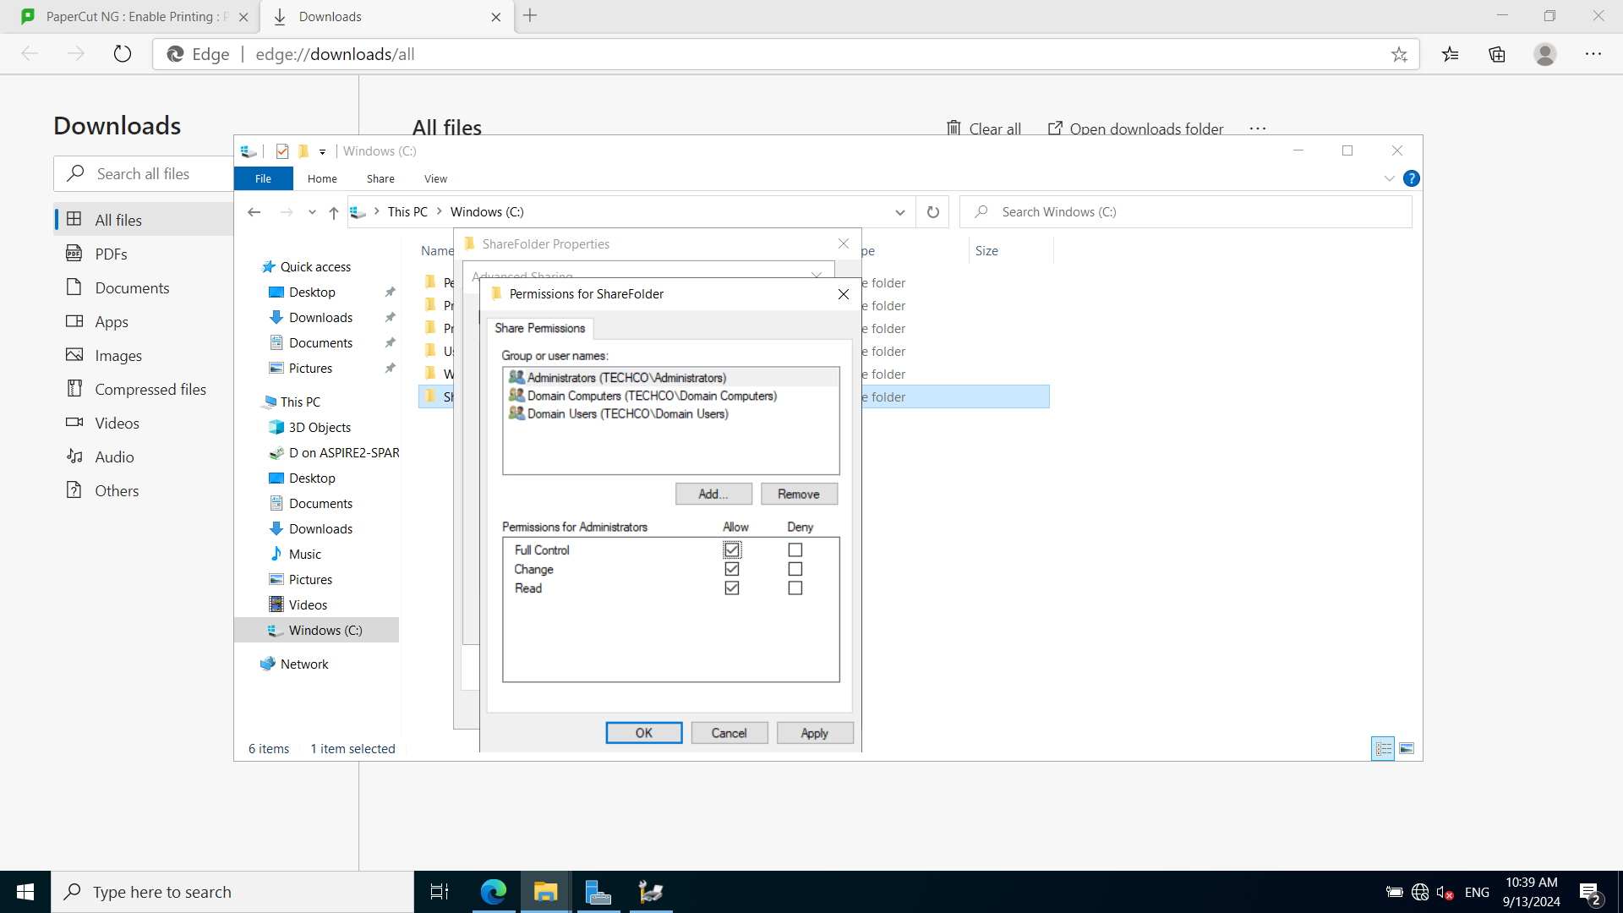

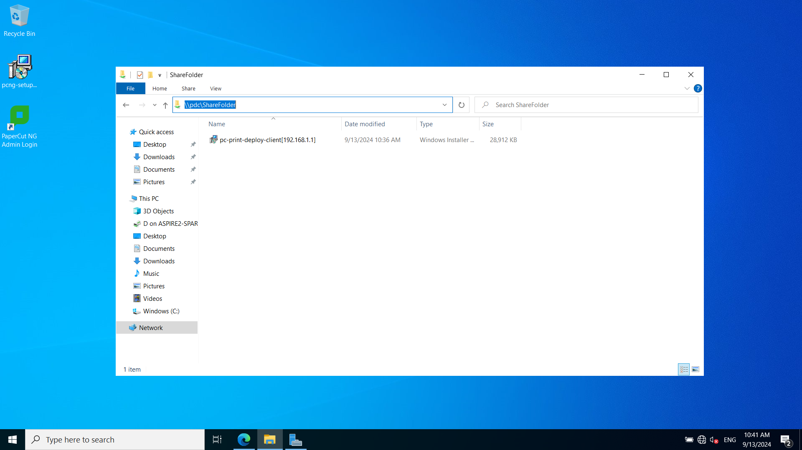

* Deploy client version of Papercut to client machine using GPO.

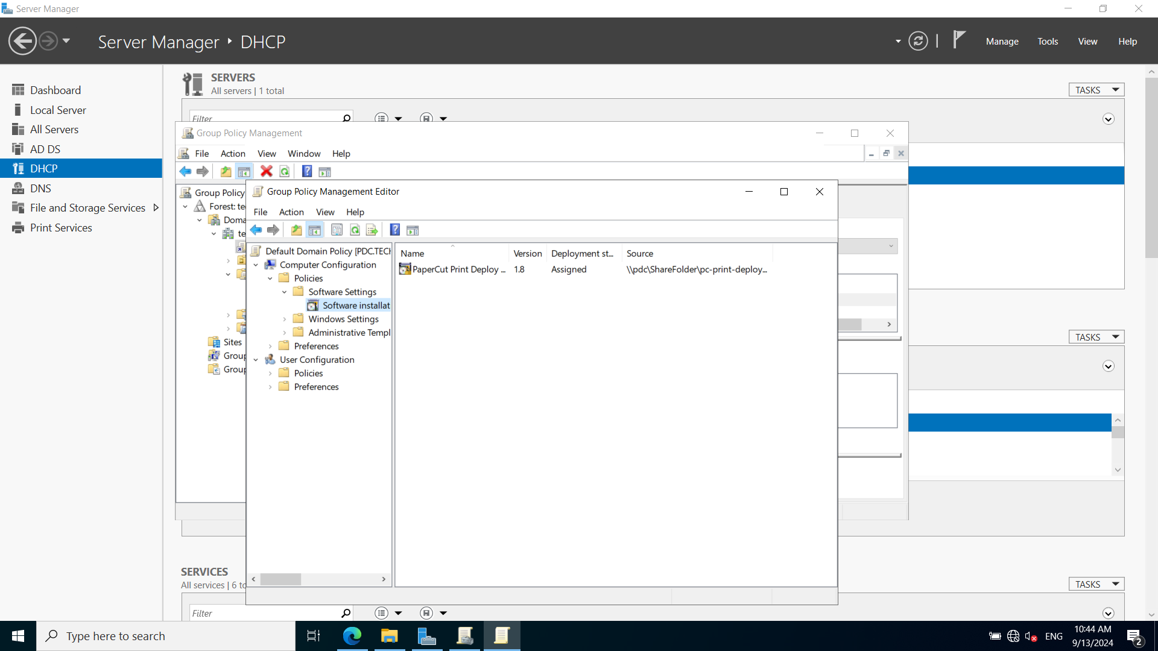

**8. Login to the Client machine to check the client software is deployed correctly.**

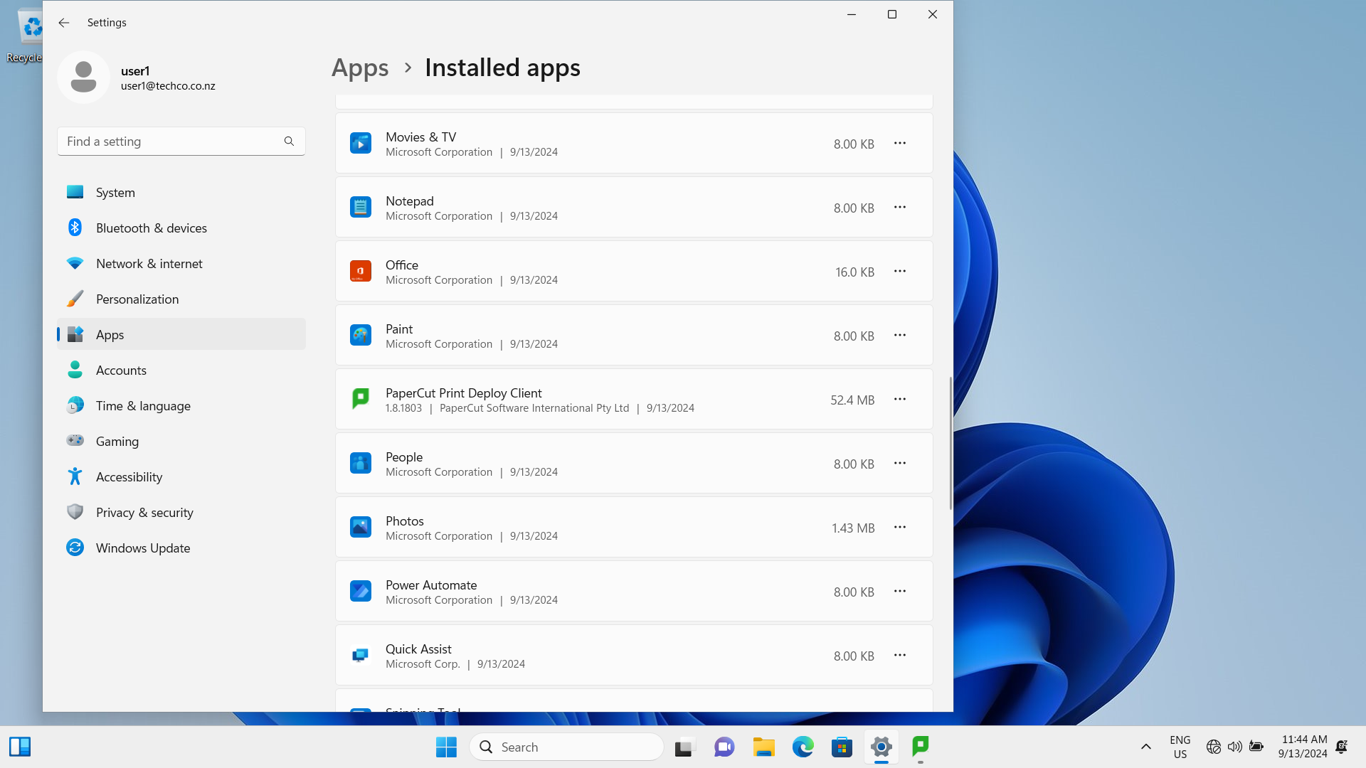

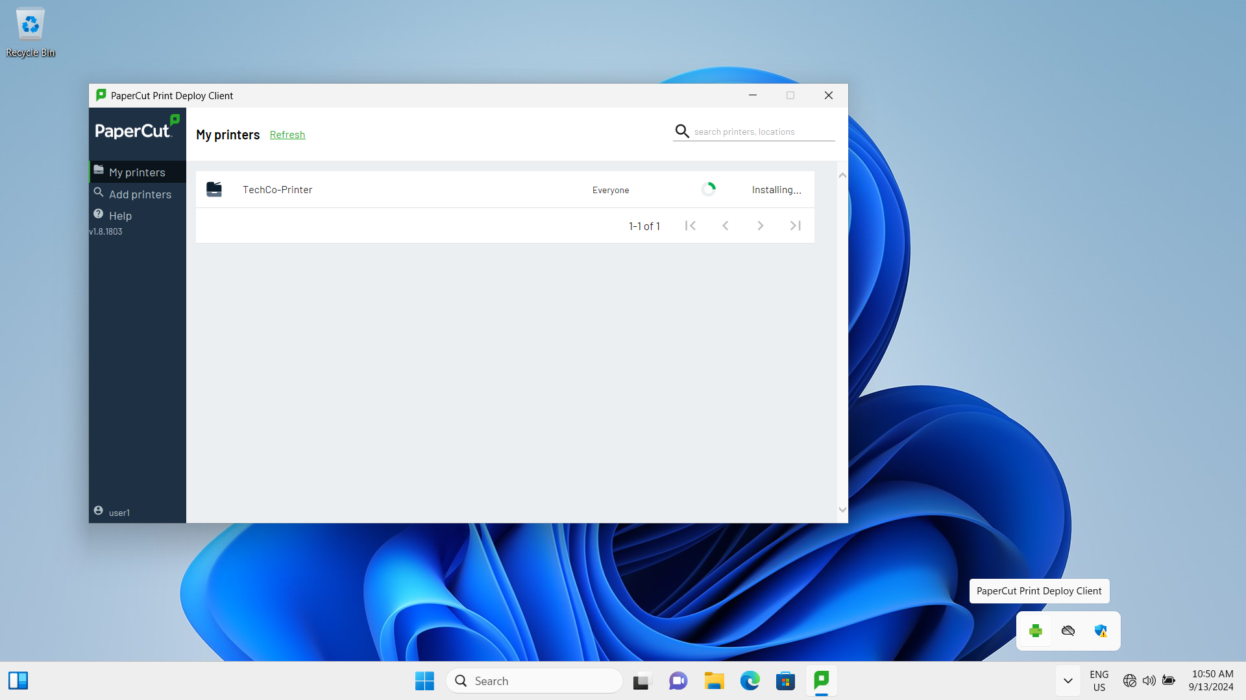

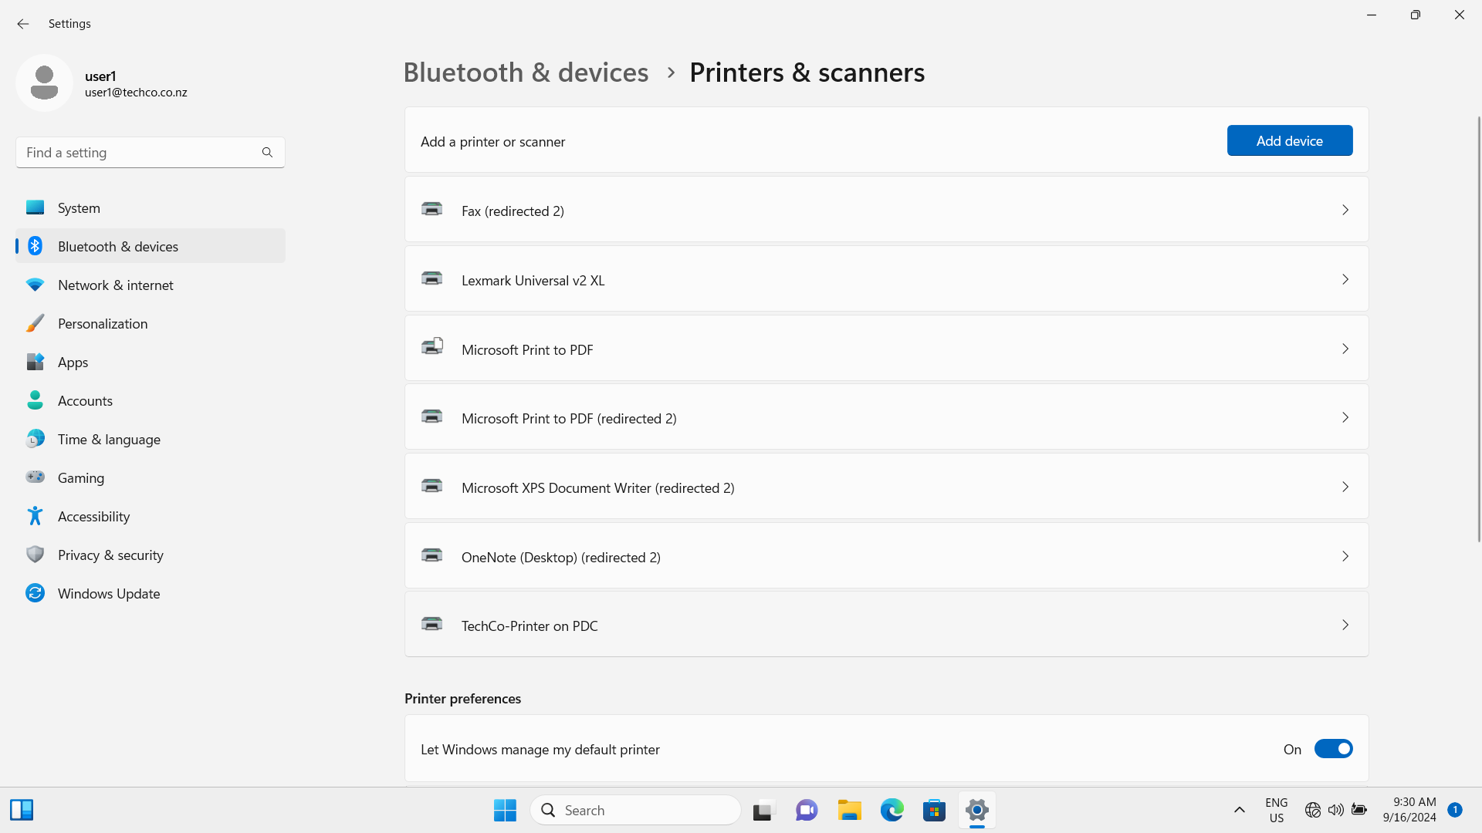

## Task/Mahi 3: Implementing & Managing Multi-Factor Authentication (MFA) for Network Access

### Task 3.1 Set up the MFA platform on a server and automate the deployment of MFA to the client machines

Cisco DUO provides the MFA platform which support the multiple factors authentication not only for users but also for applications on Windows, MacOS, and Android. DUO is chosen as MFA platform to strengthen TechCo Solutions network security.

**1. Sign up a new account on DUO website**

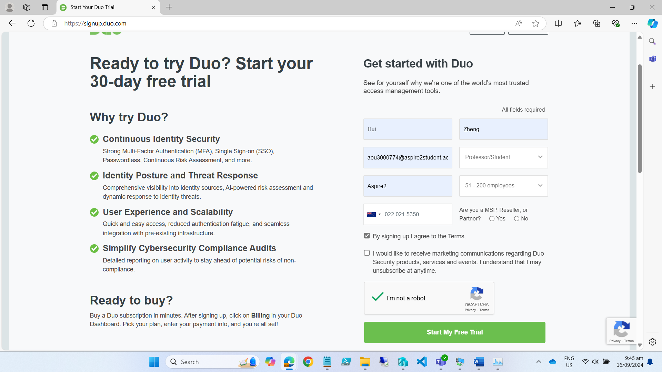

**2. Log in to Admin Console**

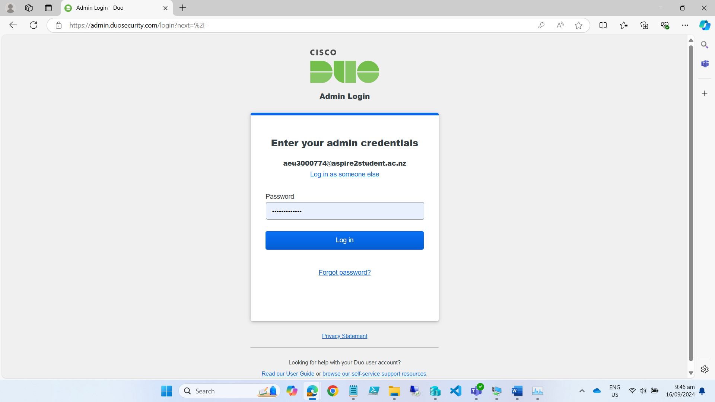

**3. Add a new user “techco\user1” and send enrolment email**

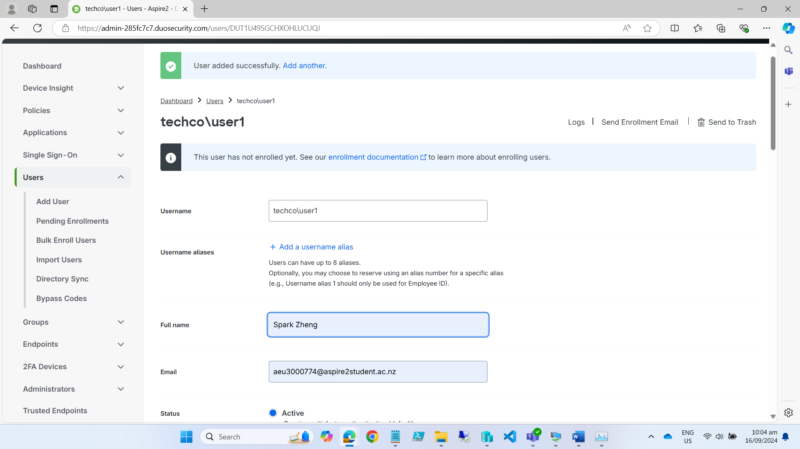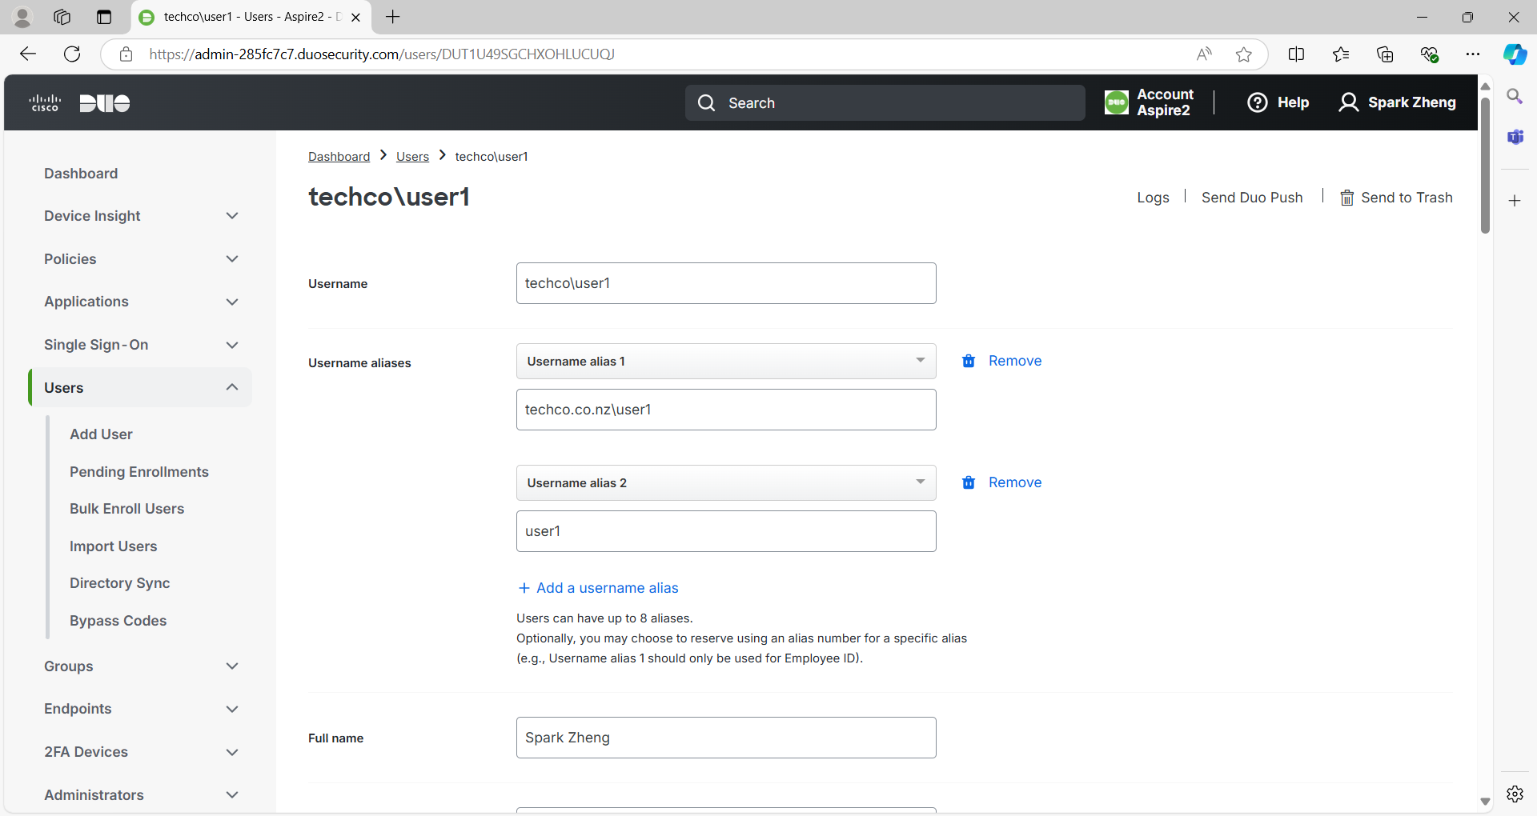

**4. Add a new protected application: RDP and keep the credentials information**

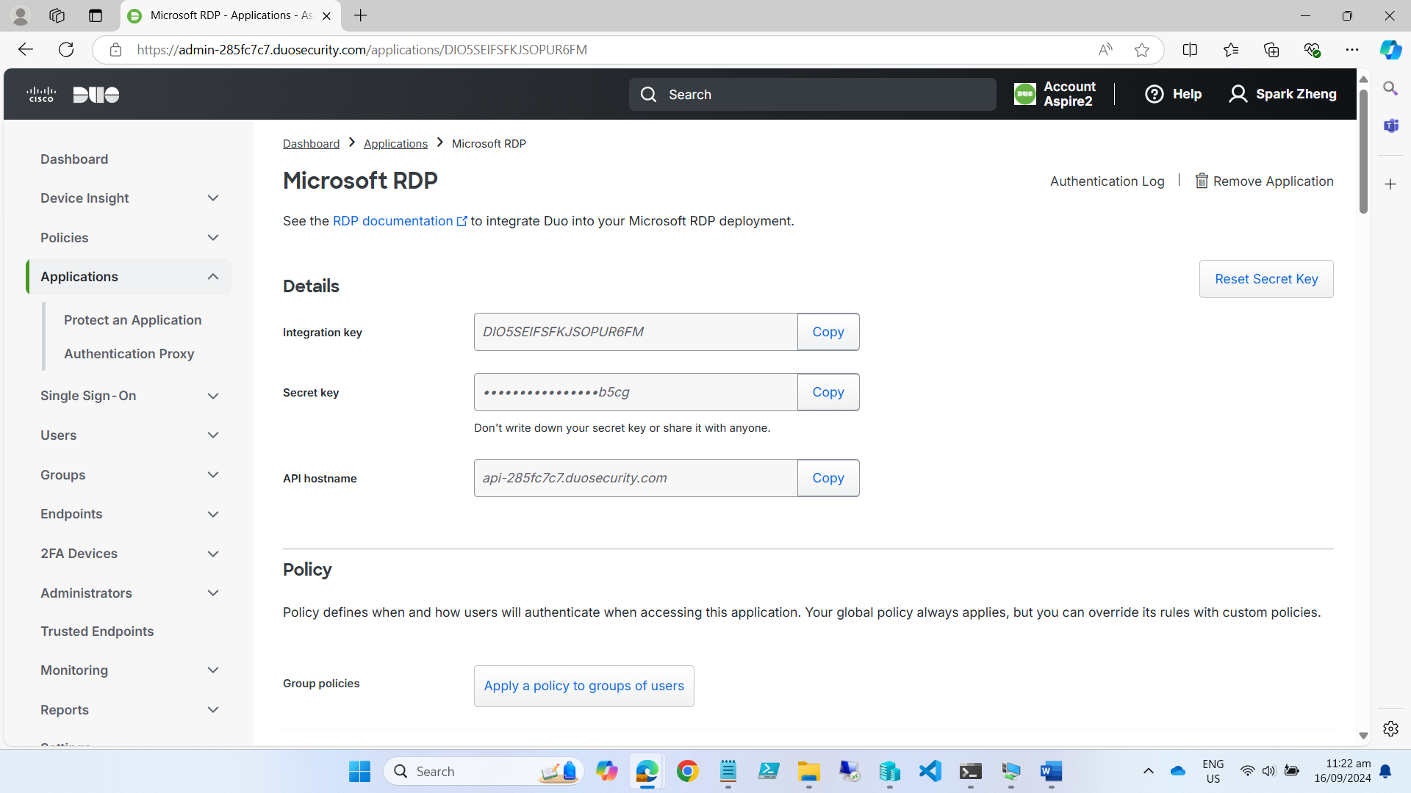

Integration key: DIO5SEIFSFKJSOPUR6FM

Secret key: bdNS18FAuPlTDCCgsz59N25IA5SfwEynPqCLb5cg

API hostname: api-285fc7c7.duosecurity.com

**5. Download GPO file from DUO website**

<https://dl.duosecurity.com/DuoWinLogon_MSIs_Policies_and_Documentation-latest.zip>

**6. Copy GPO file to policy folder on the Domain Controller Server**

DuoWindowsLogon.admx -> C:\Windows\PolicyDefinitions\

DuoWindowsLogon.adml -> C:\Windows\PolicyDefinitions\en-US\

DuoWindowsLogon64.msi -> \\VMWINDOWSSERVER\ShareFolder\

**7. Edit DUO related parameters in GPO of Domain Controller**

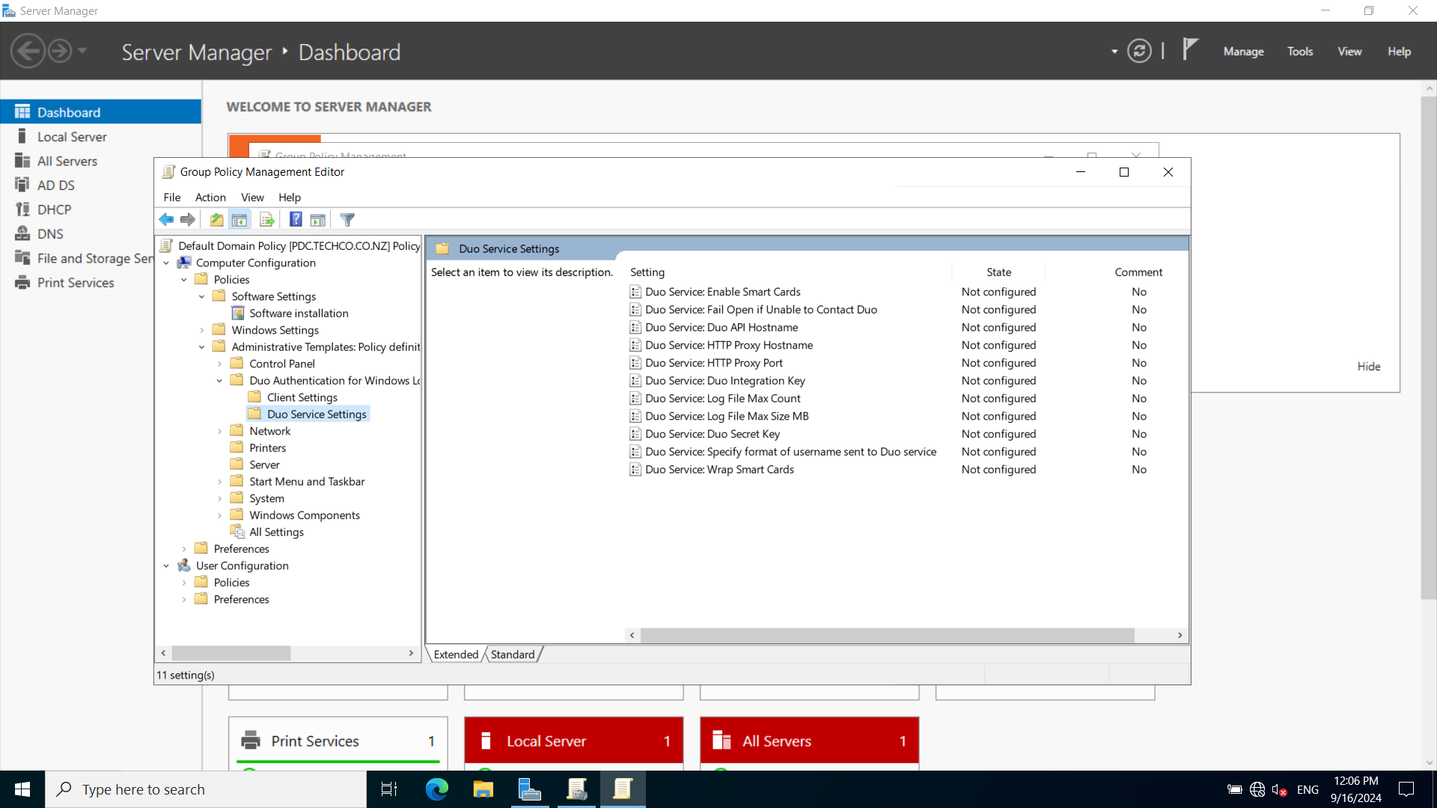

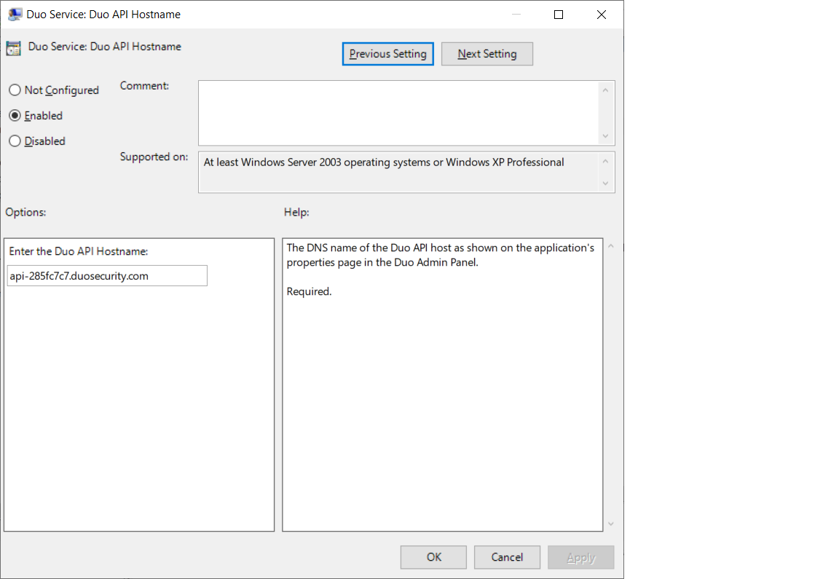

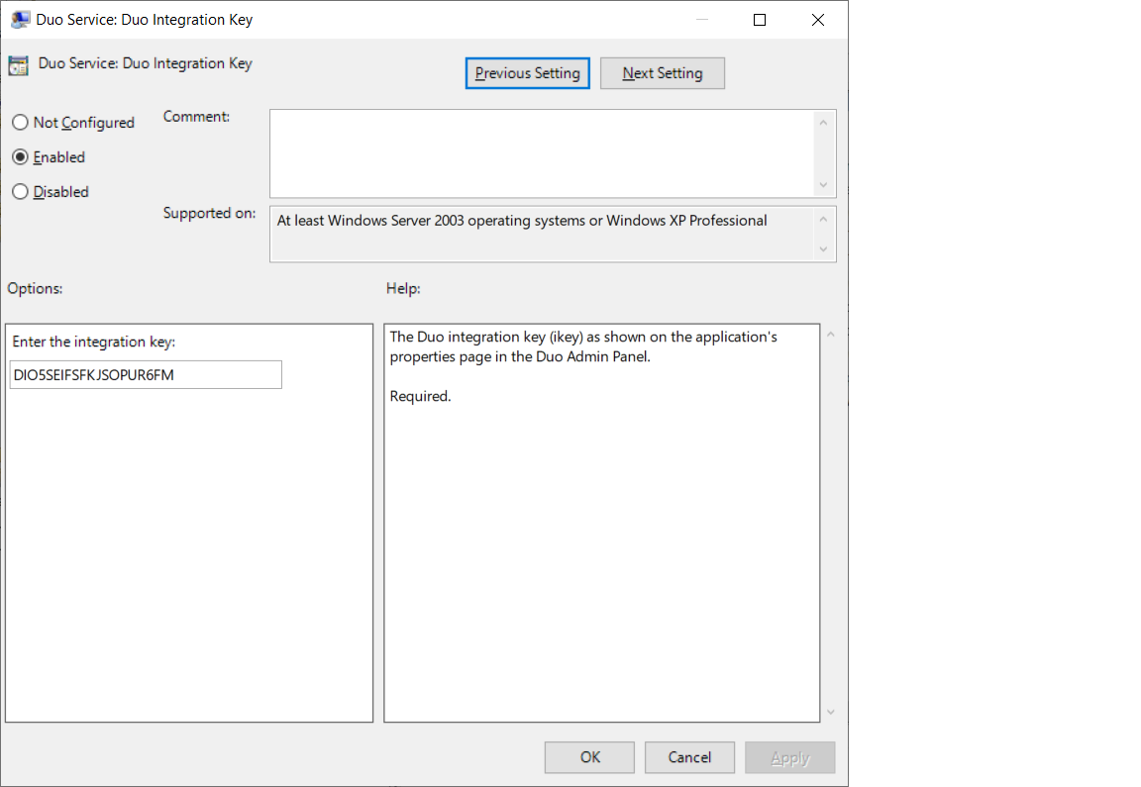

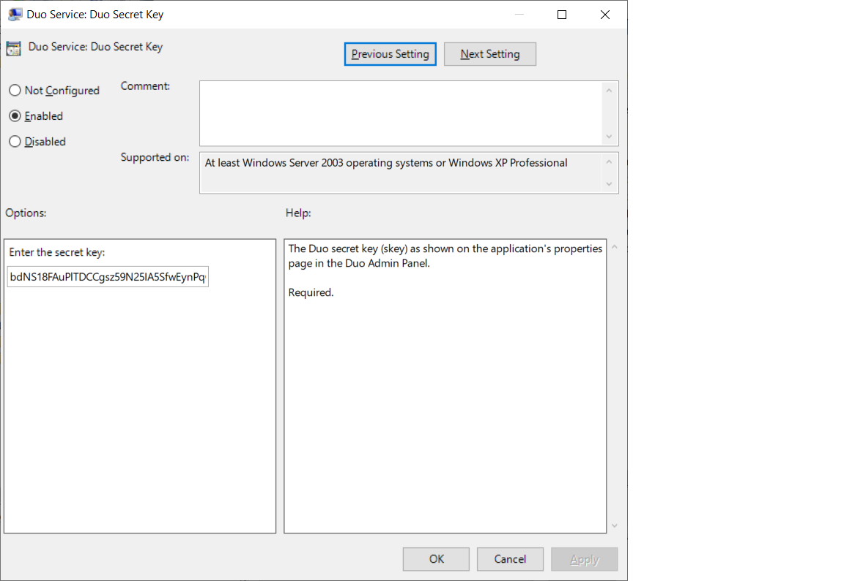

**8. Add new Software installation to the GPO policy**

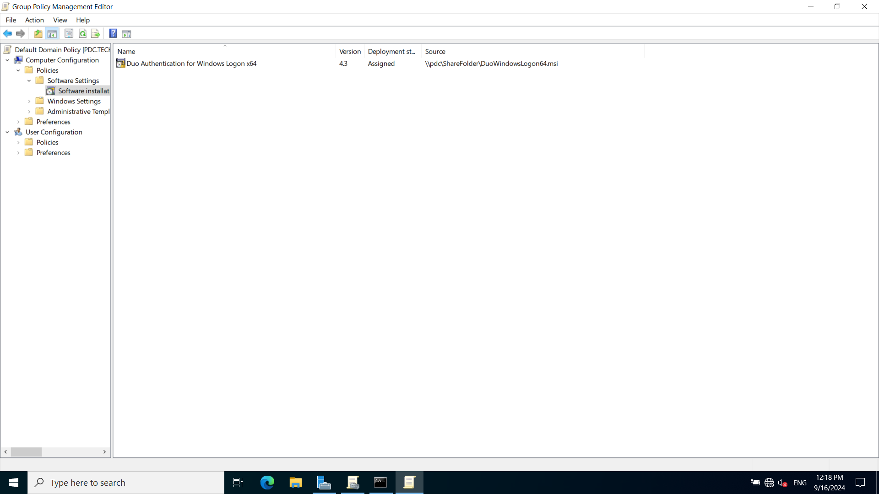

**9. Login on Client machine and update group policy**

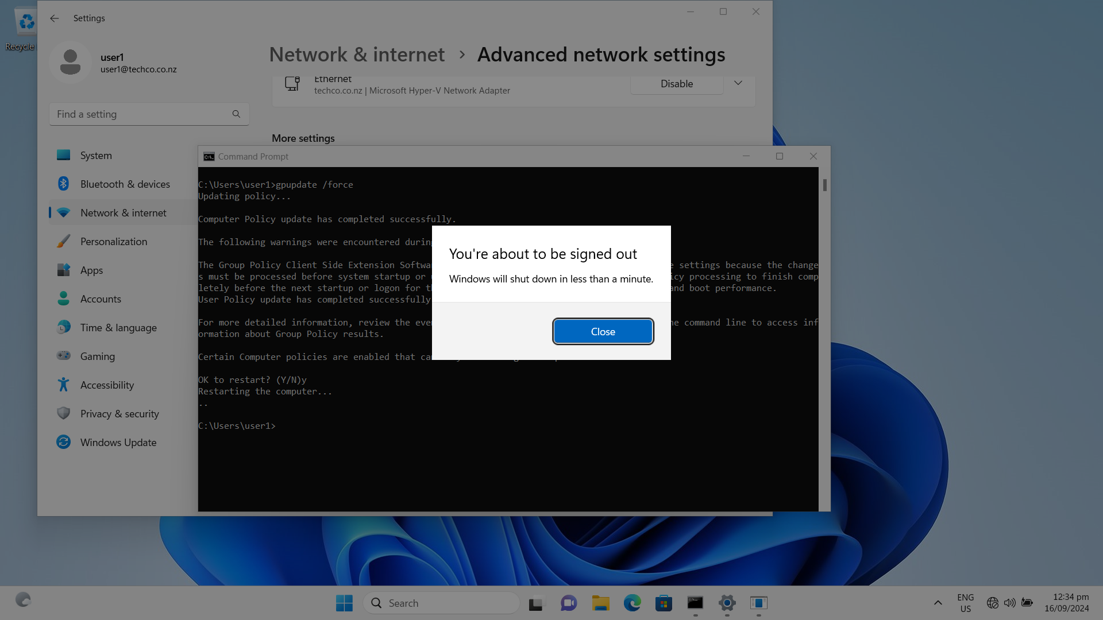

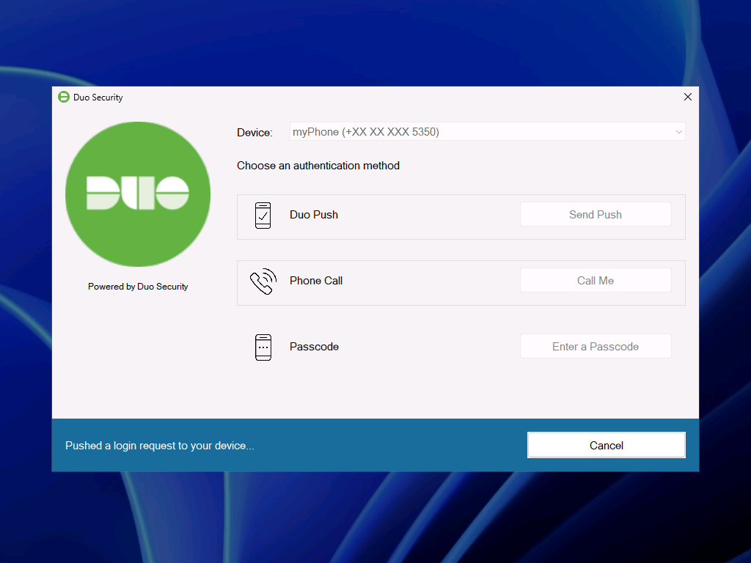

**10. Active mobile phone and approve the client login request**

* copy and paste active link into Duo Mobile manually:

https://m-285fc7c7.duosecurity.com/activate/83nFnX6BN7Aj7pBIOmAw

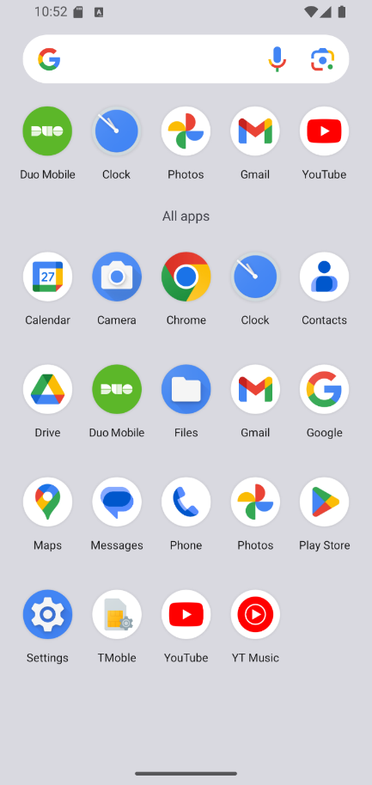 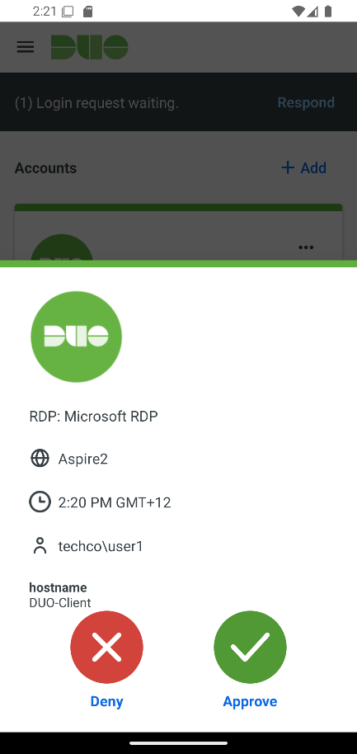

**11. Client machine logged in with DUO app installed.**

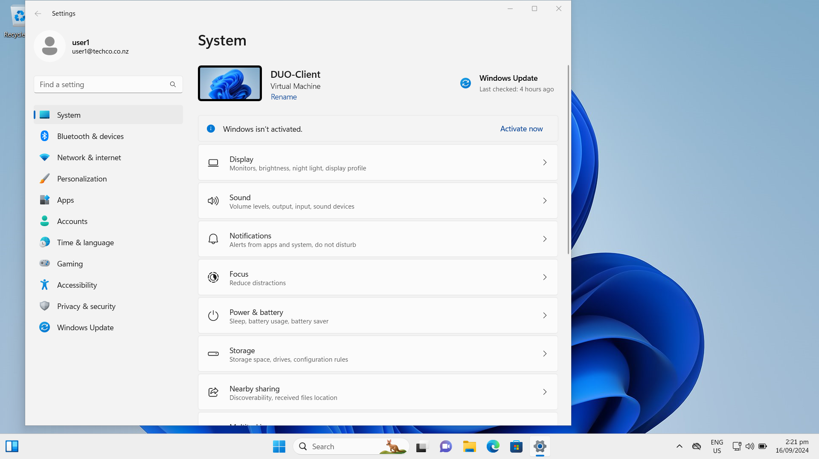

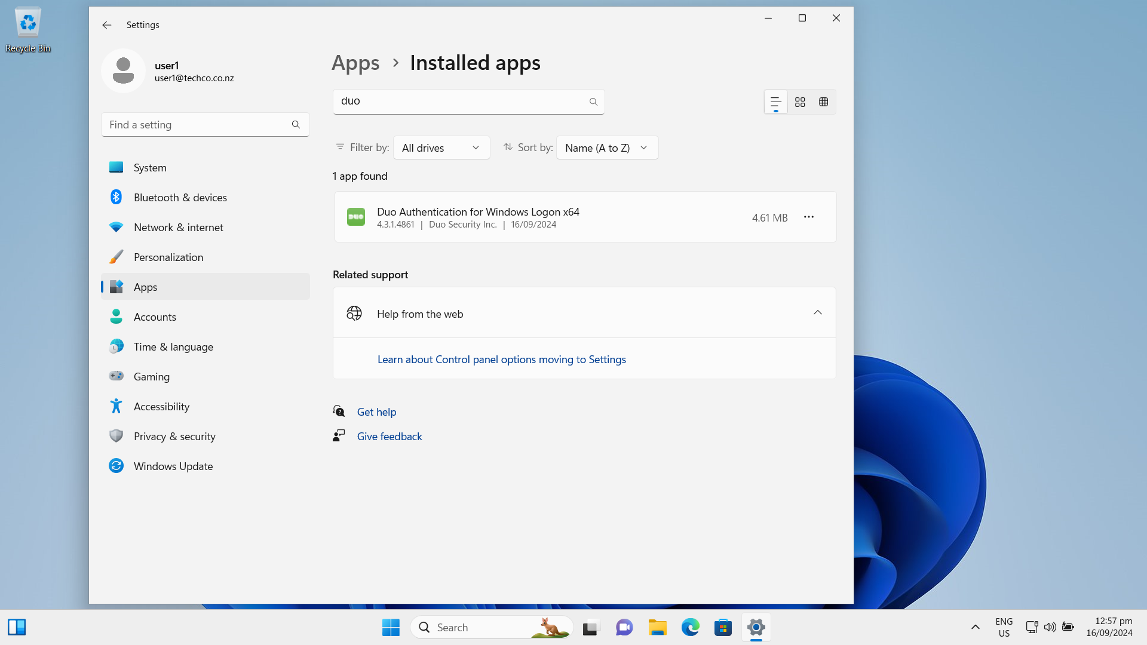

### Task 3.2 Troubleshooting the MFA configurations on a client machine and MFA Admin App

**1. Mobile device is restricted for the privilege of approvement and needs to be reactivated.**

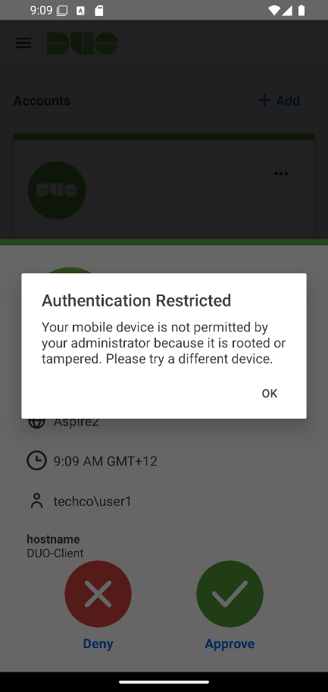

**2. Reactivate the mobile device and send notification email**

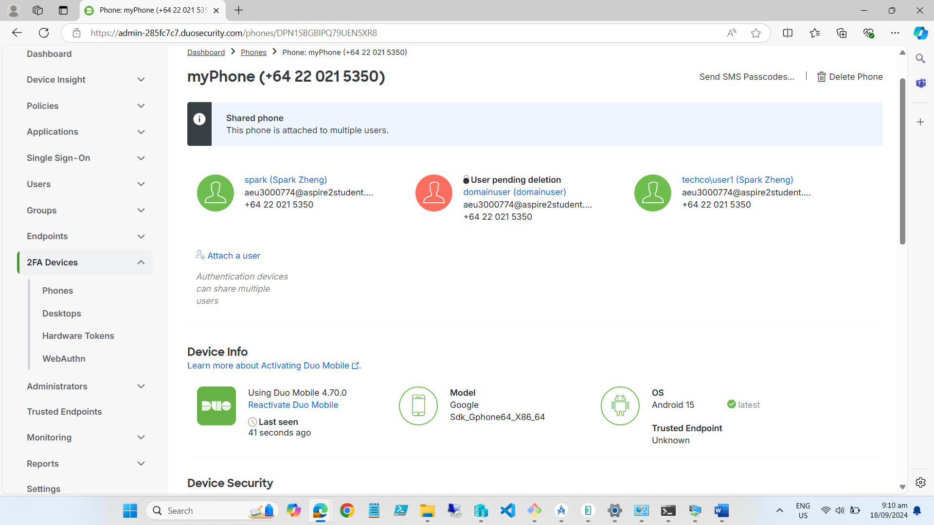

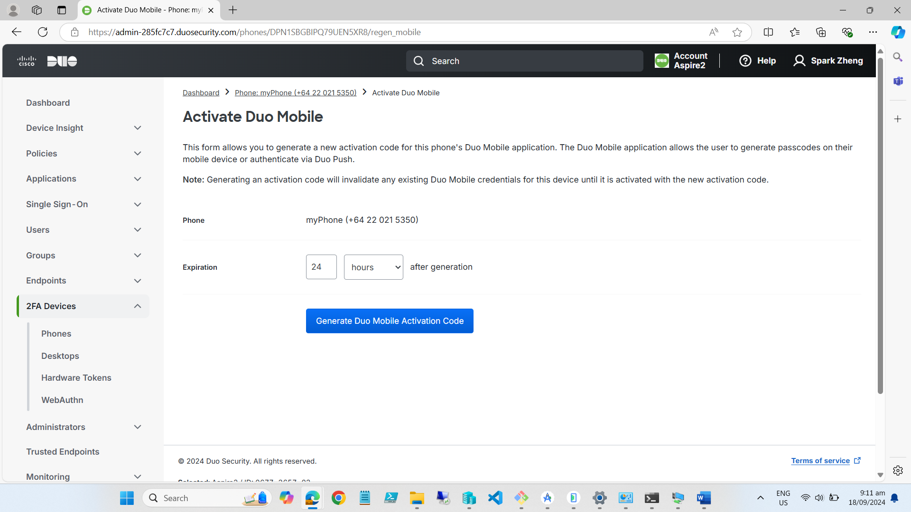

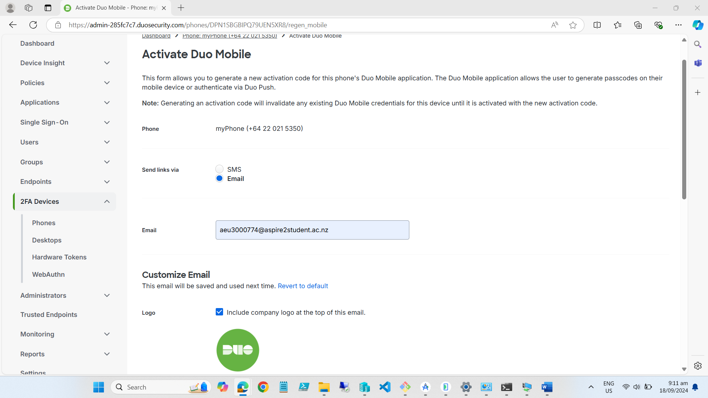

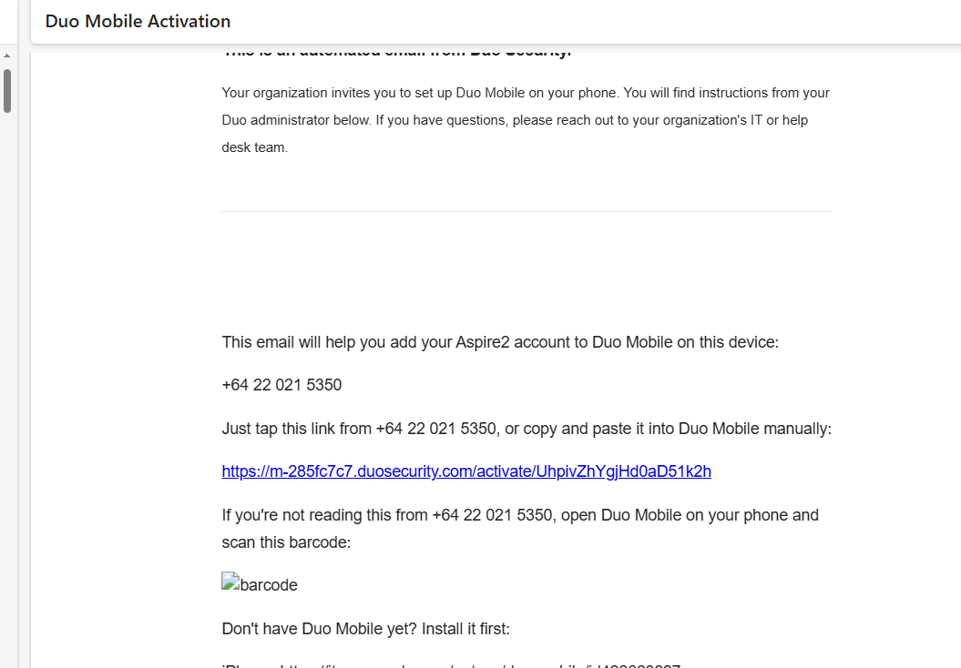

**3. Access reactivating link on the mobile device and the issue is resolved.**

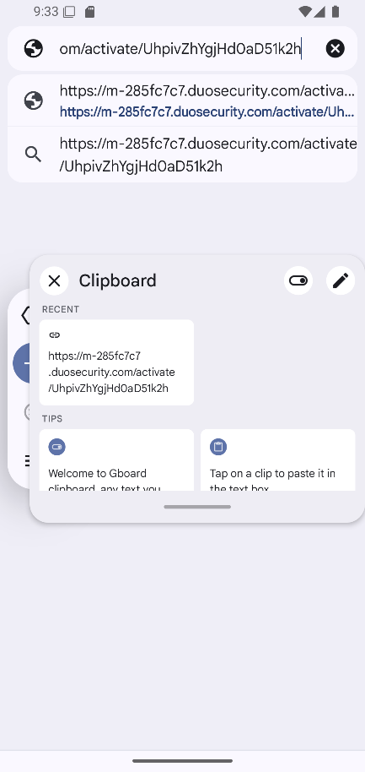 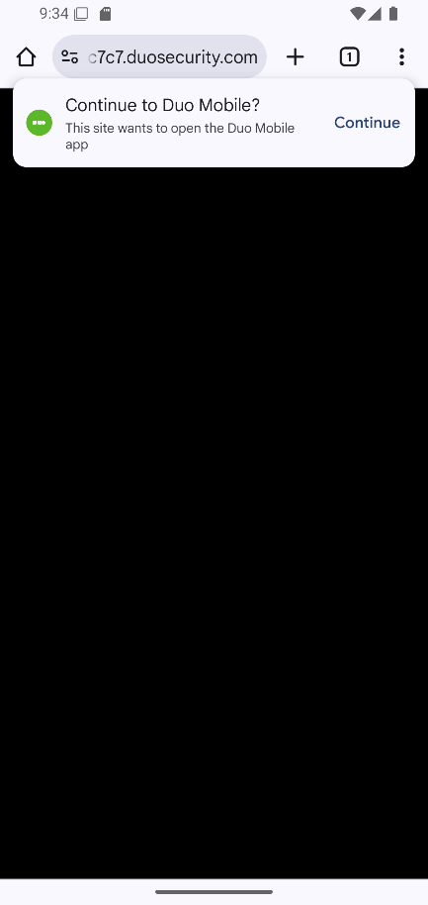

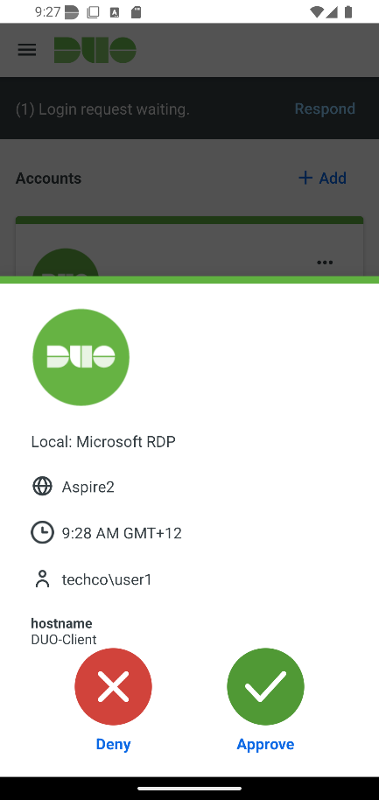

## Task/Mahi 4: Manage the remote access via VPN

### Task 4.1 Set up and configure a member server of the domain to act as a VPN server

**1. Create a new virtual machine with 2 network adapters**

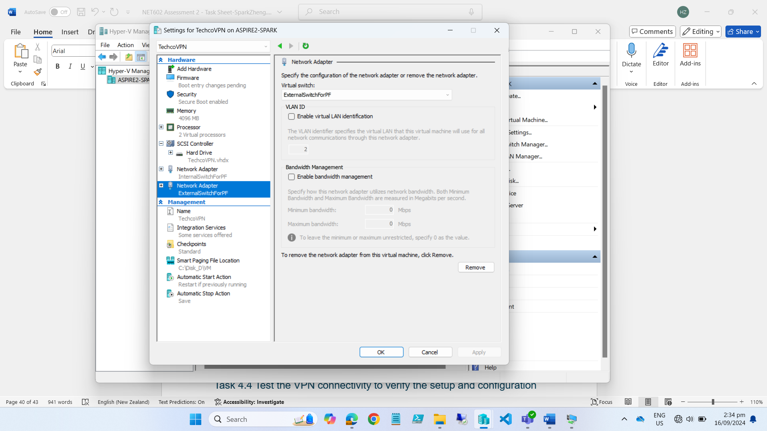

**2. Add the new virtual machine to domain “techco.co.nz”**

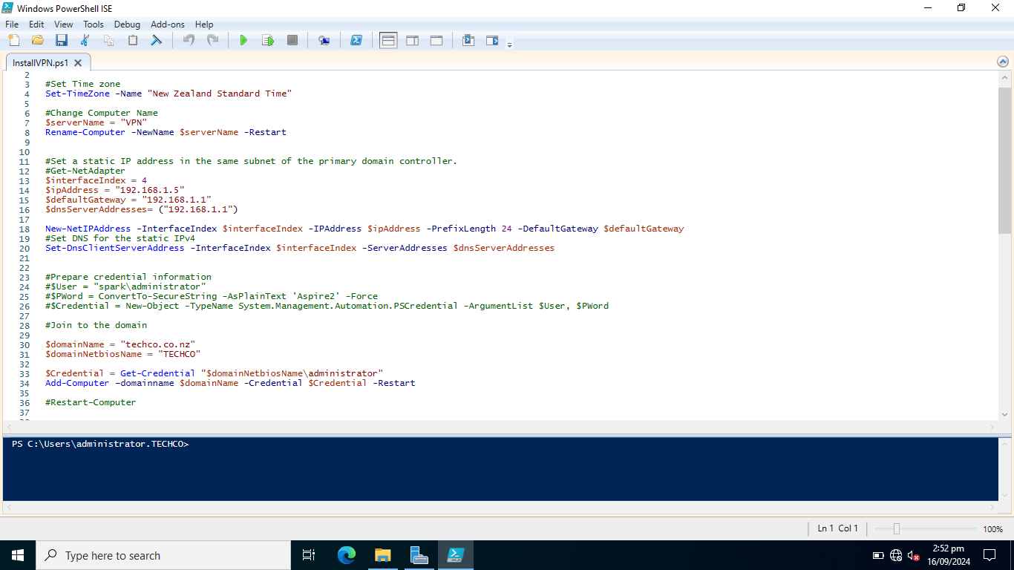

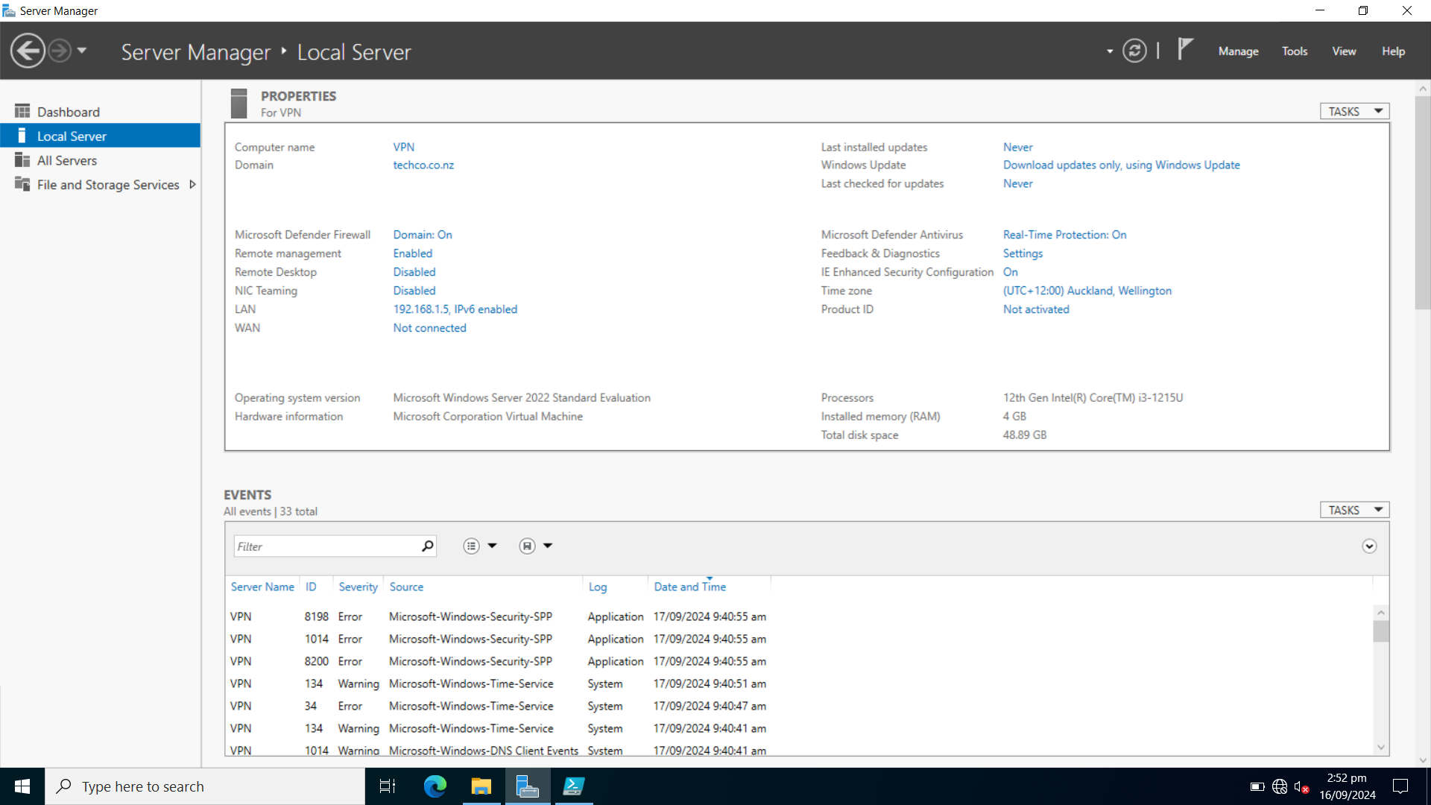

**3. Add Roles and Features of NPAS and DirectAccess-VPN**

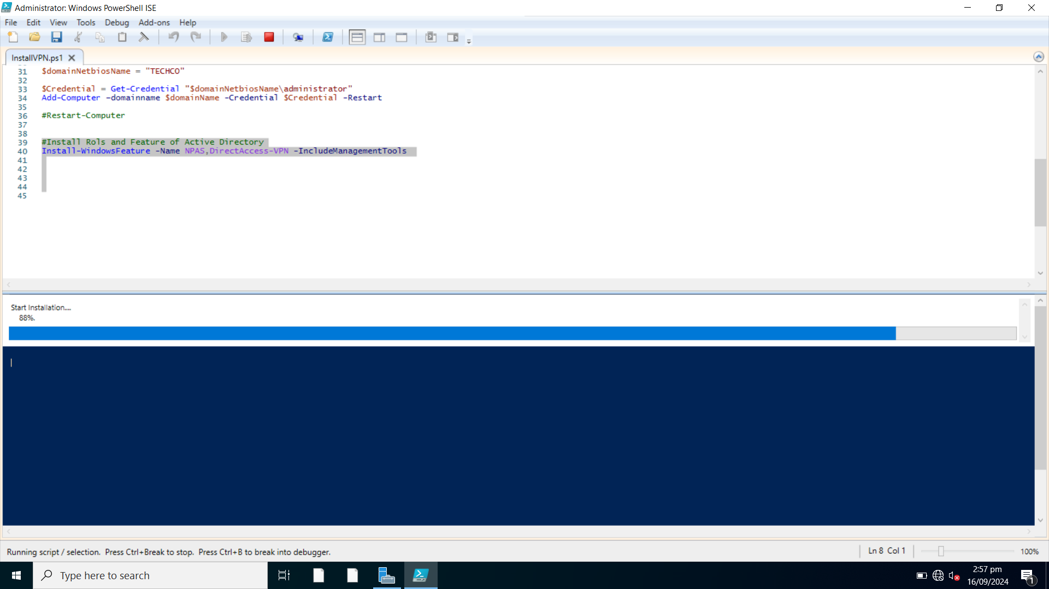

**4. Create new VPN group and VPN users**

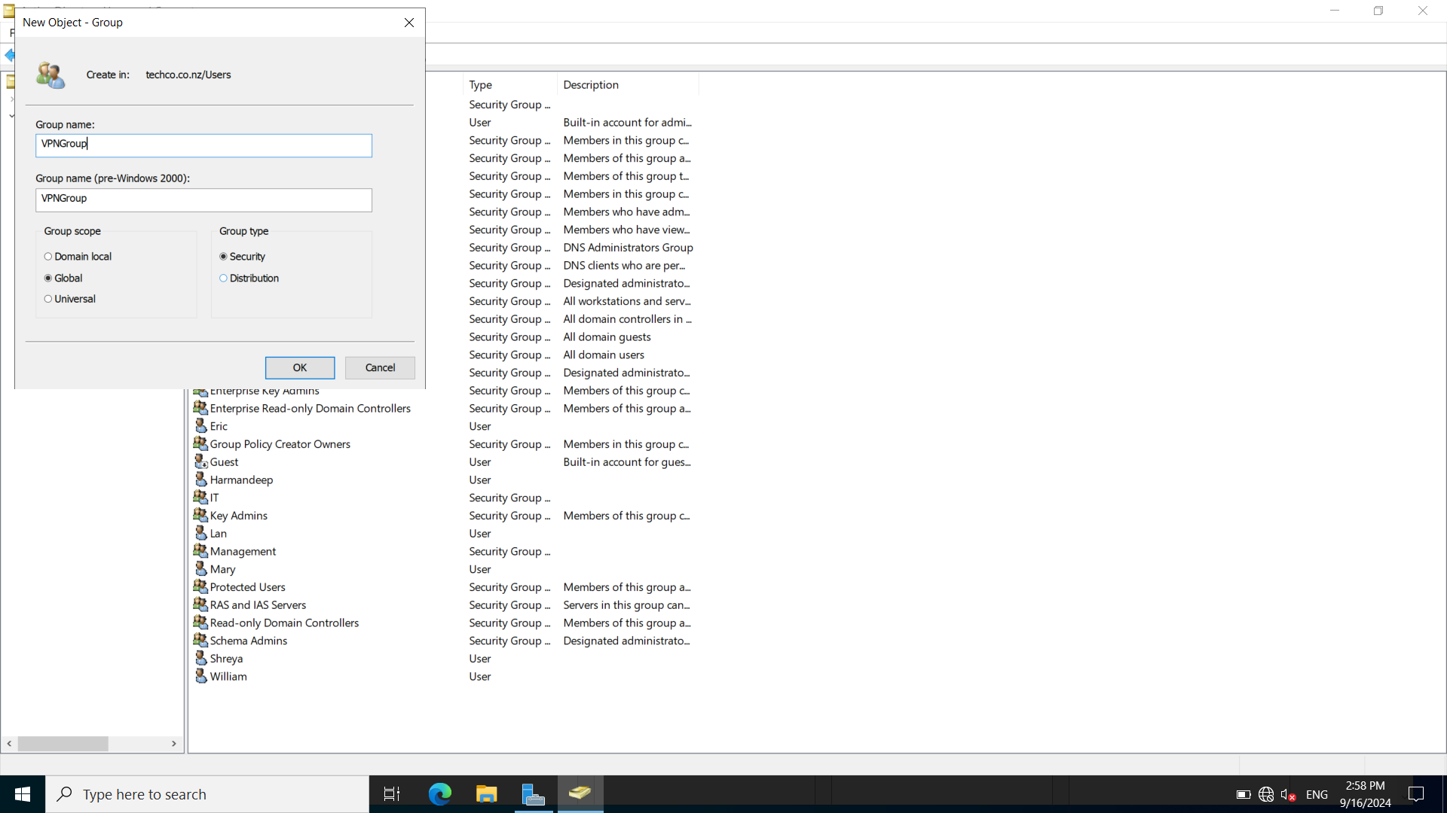

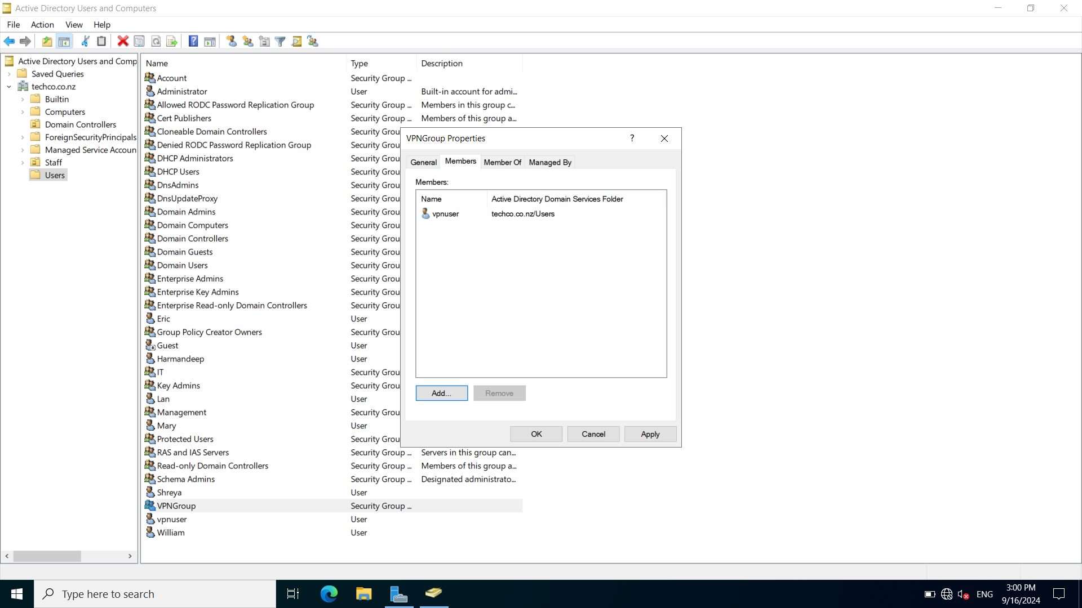

**5. Configure DirectAccess and VPN**

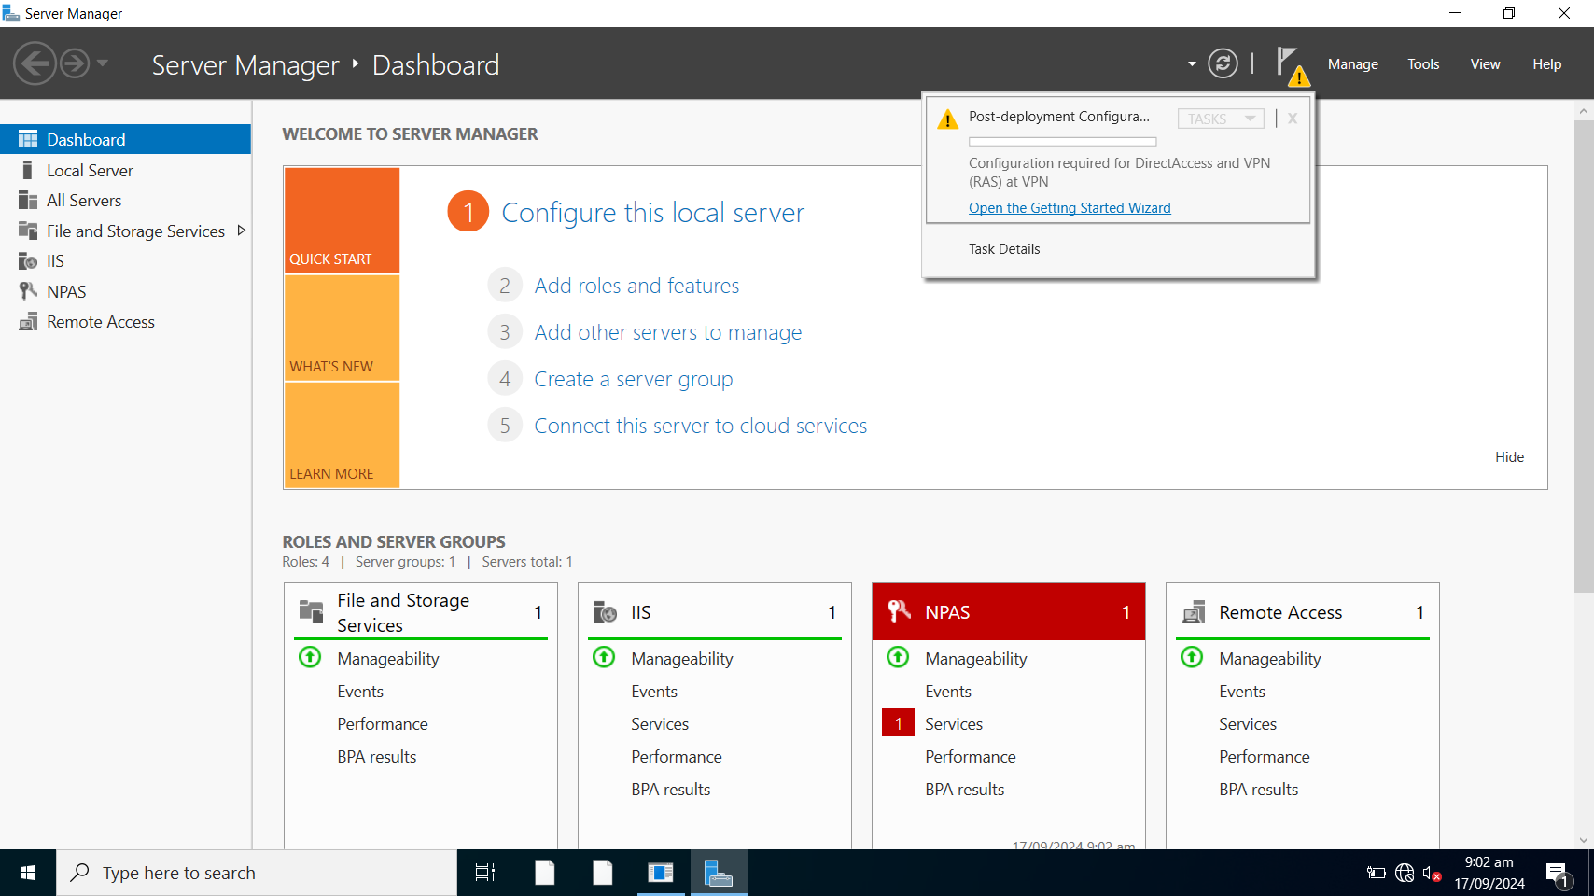

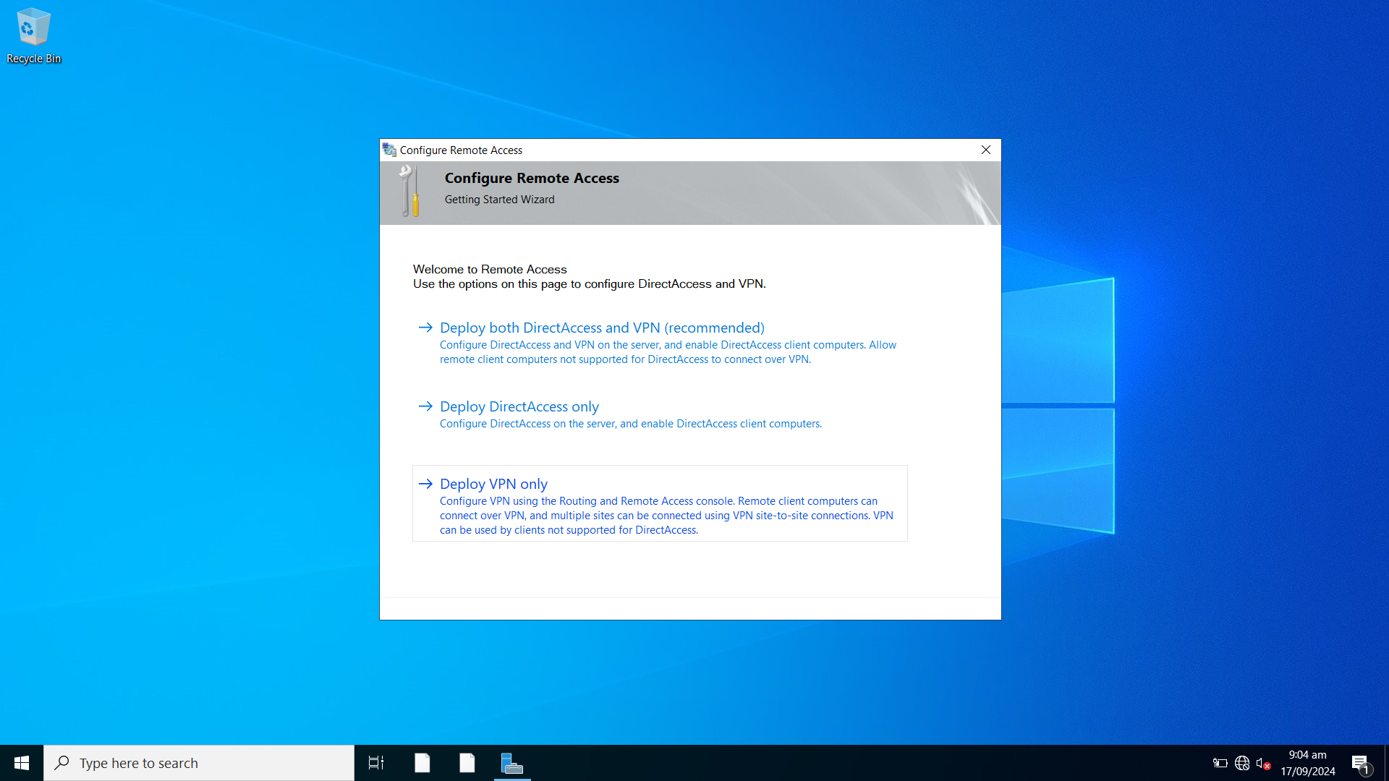

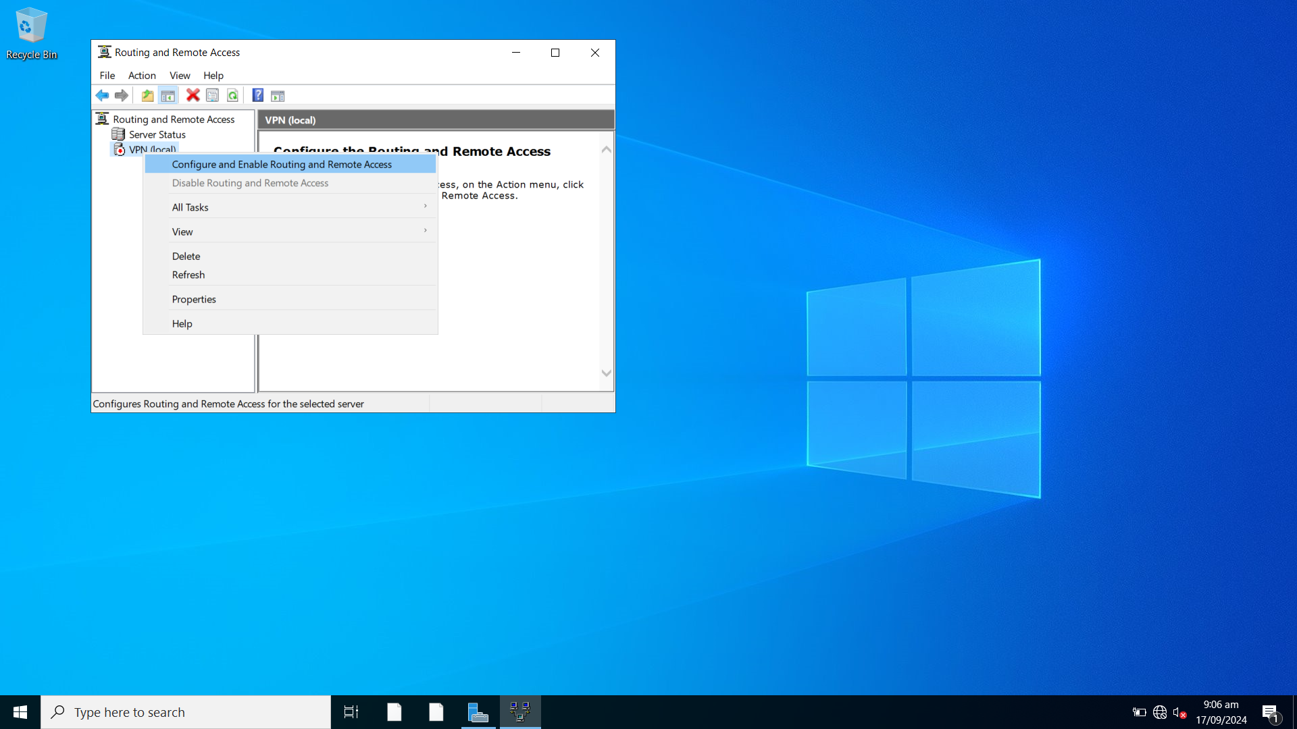

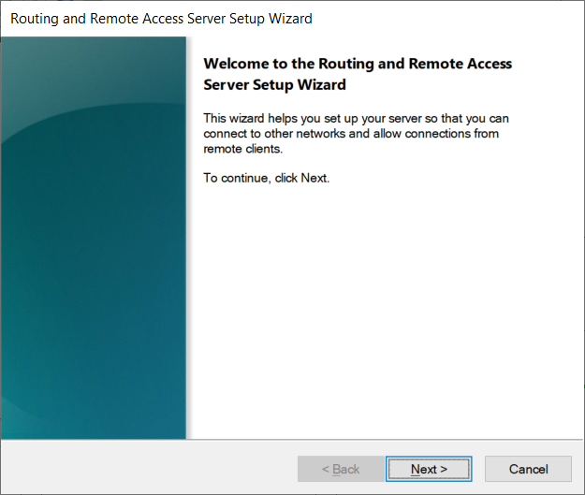

Choose Virtual Private Network(VPN) access and NAT.

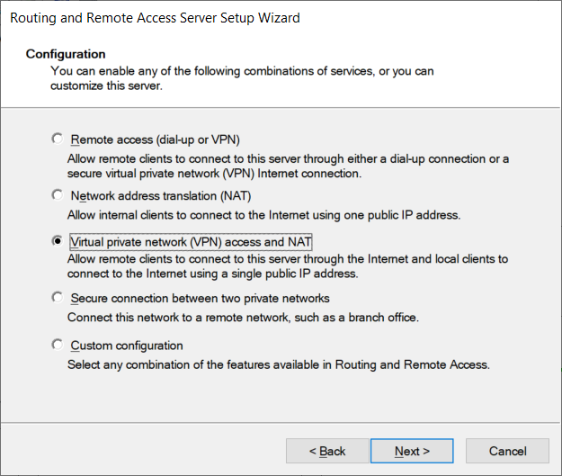

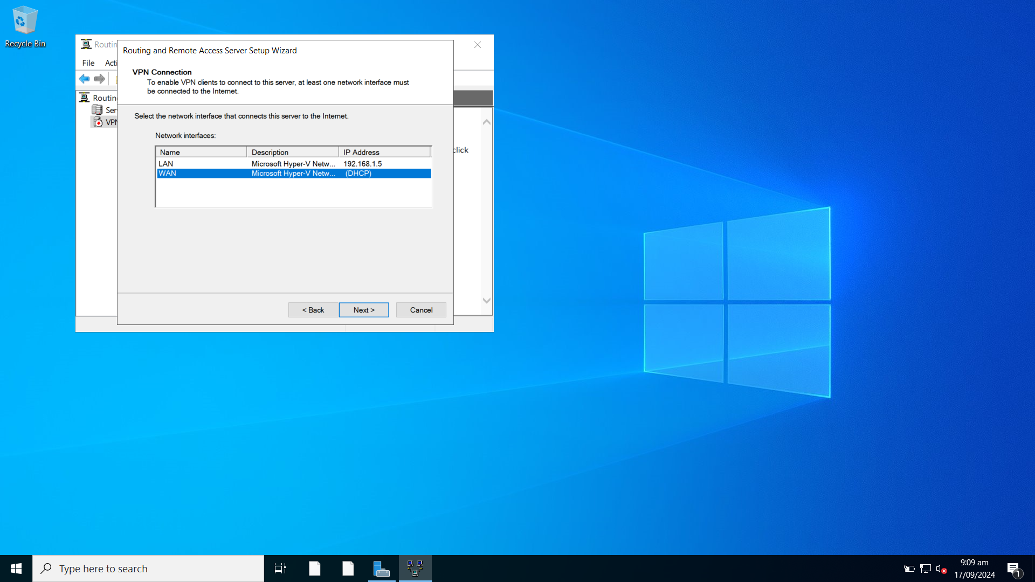

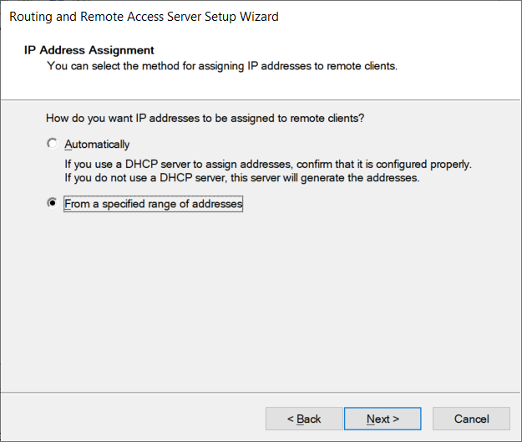

40 IP addresses assigned to VPN users. (192.168.1.101~140/24)

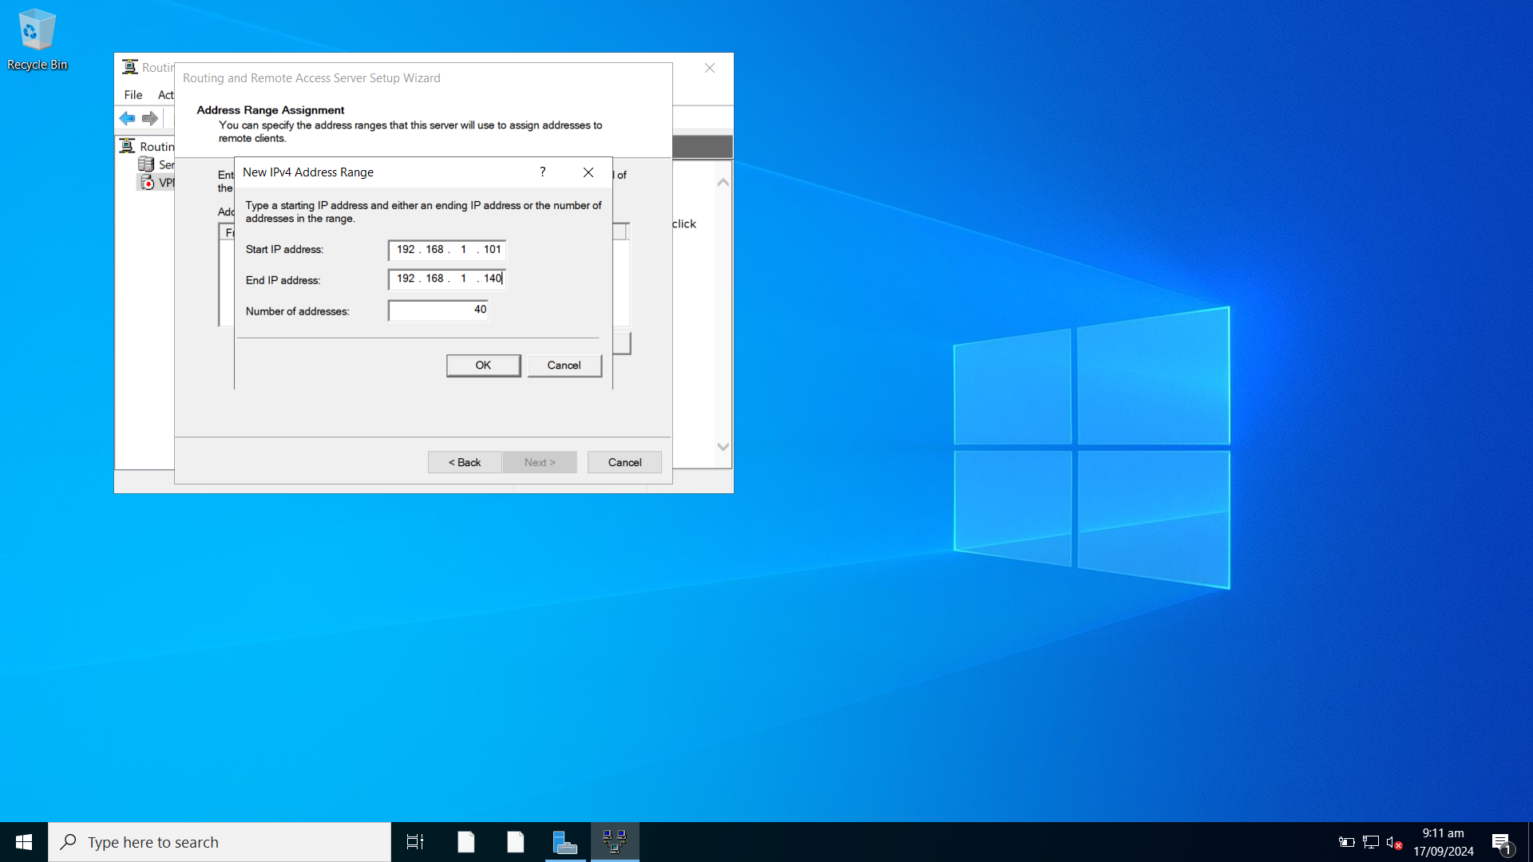

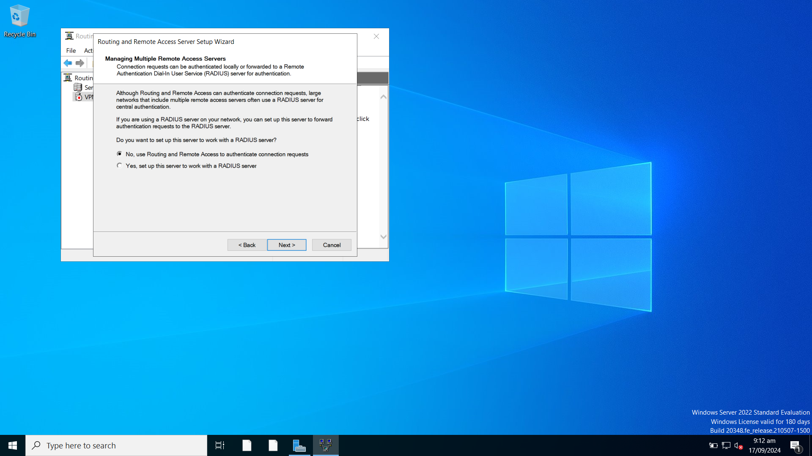

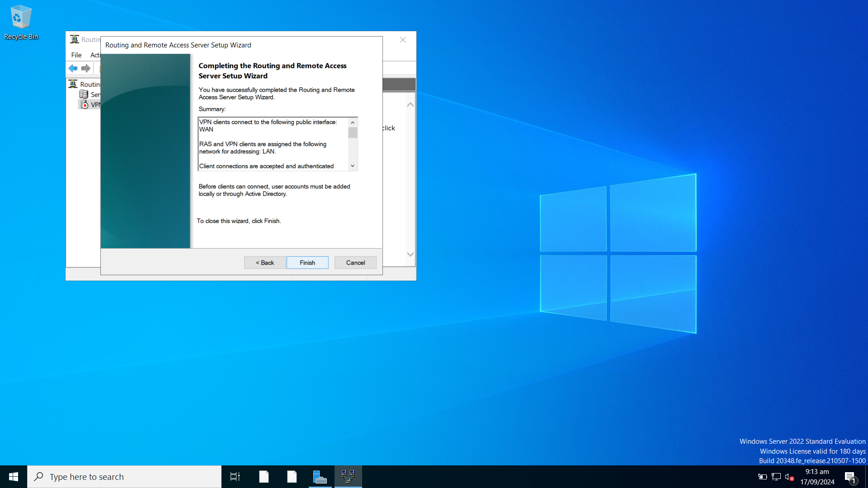

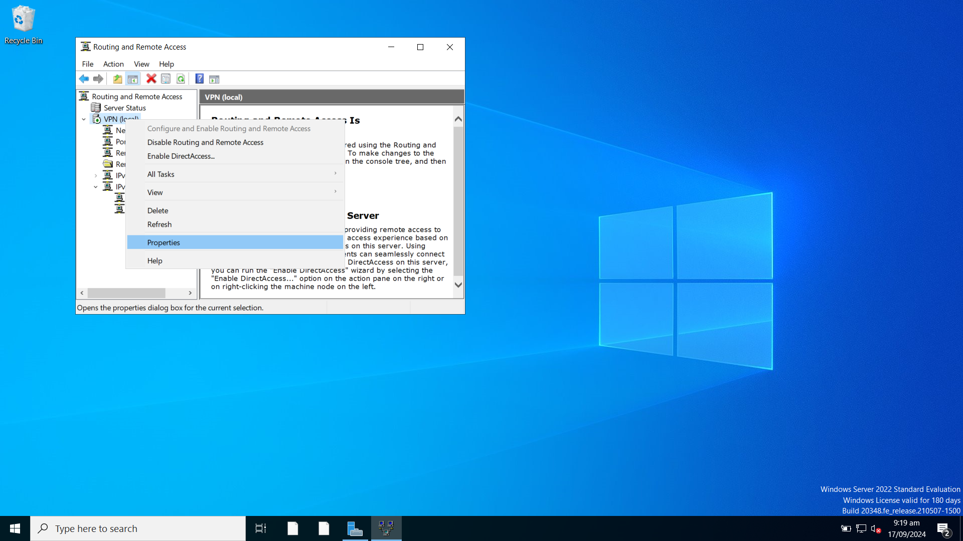

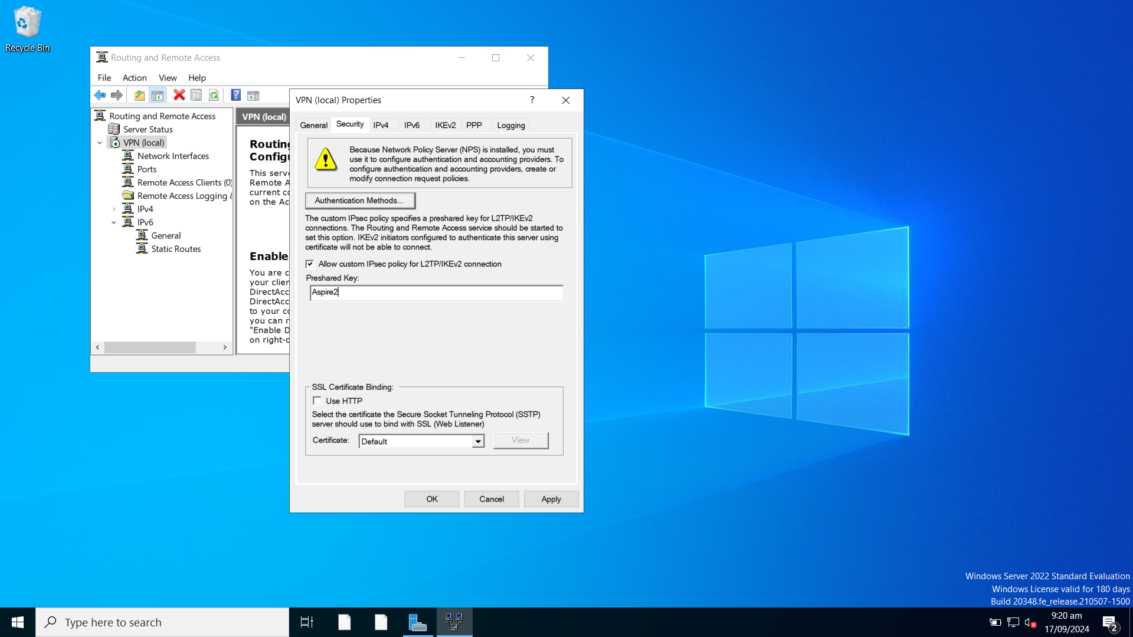

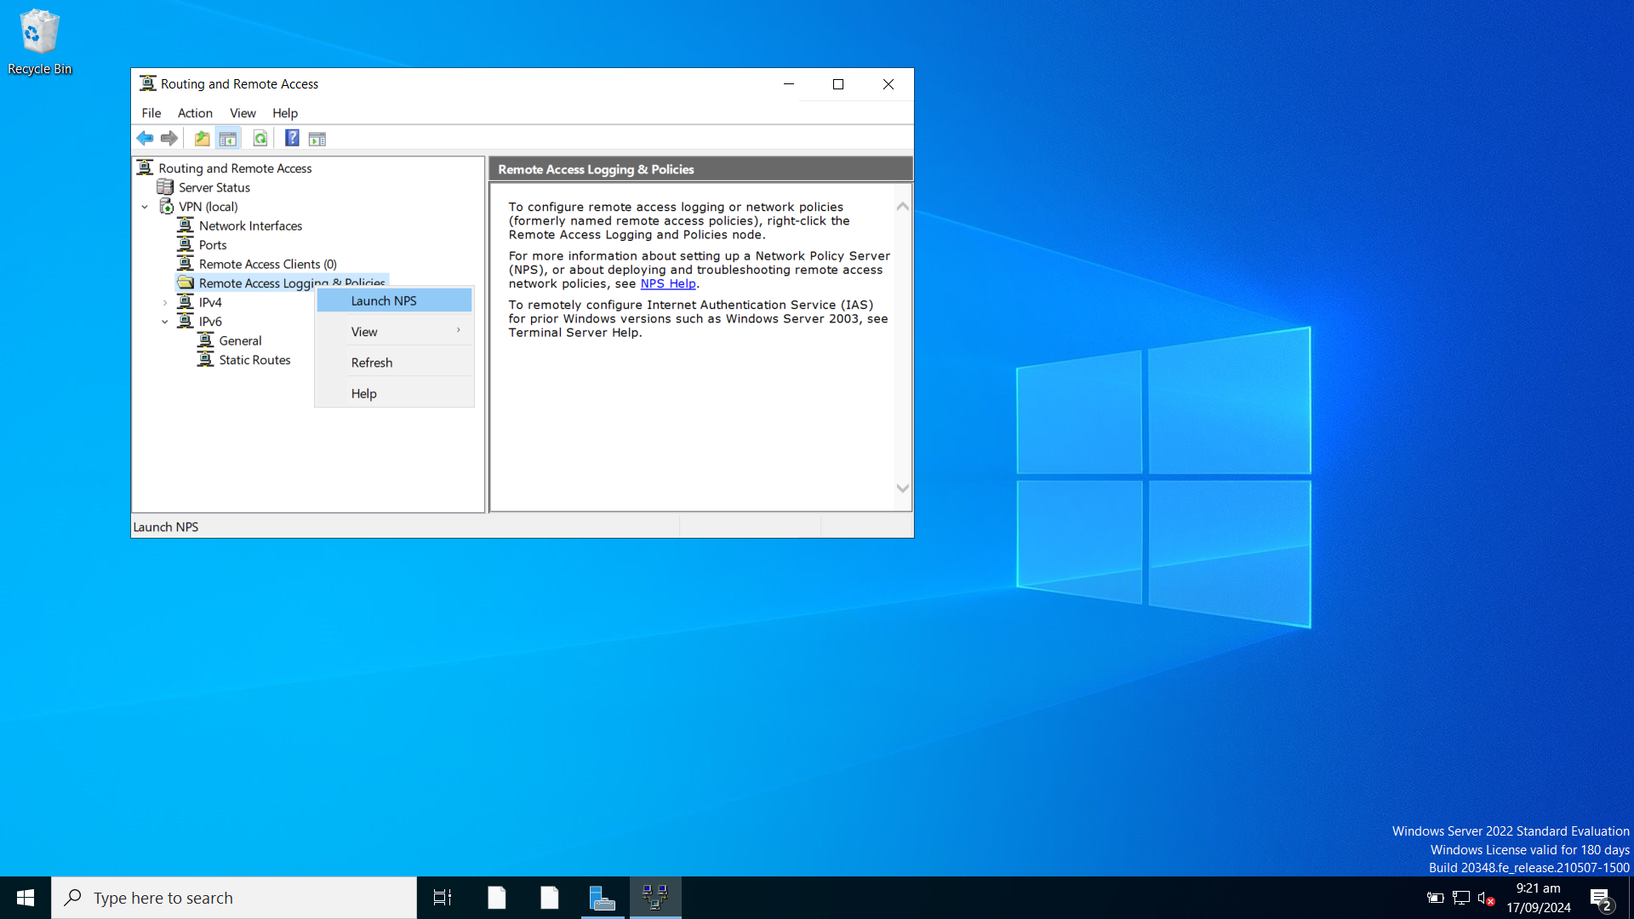

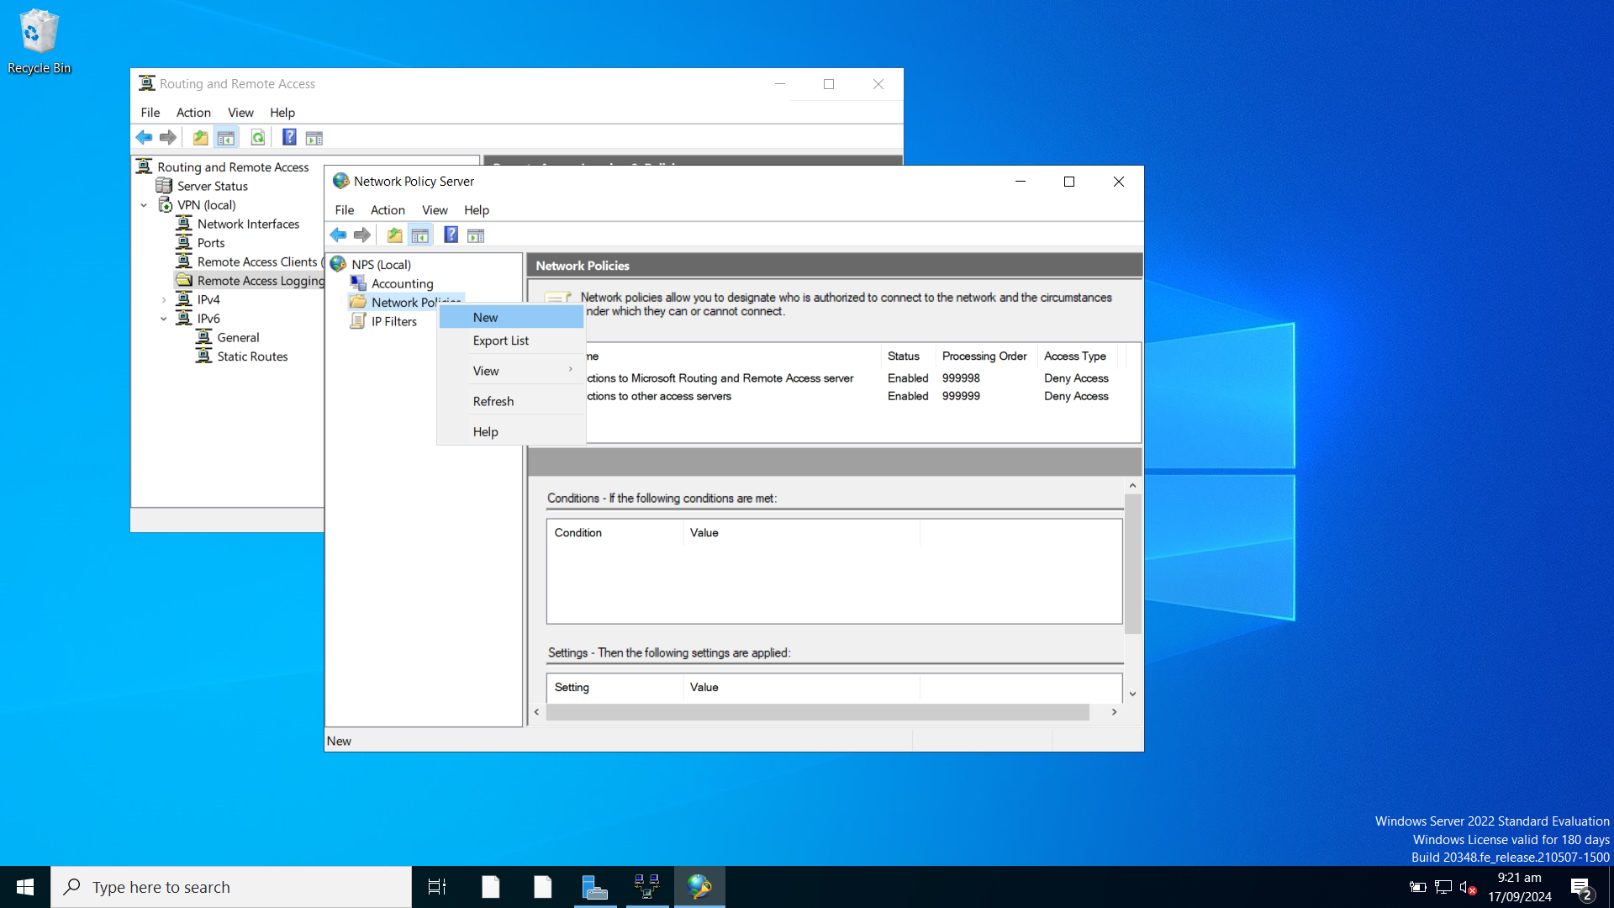

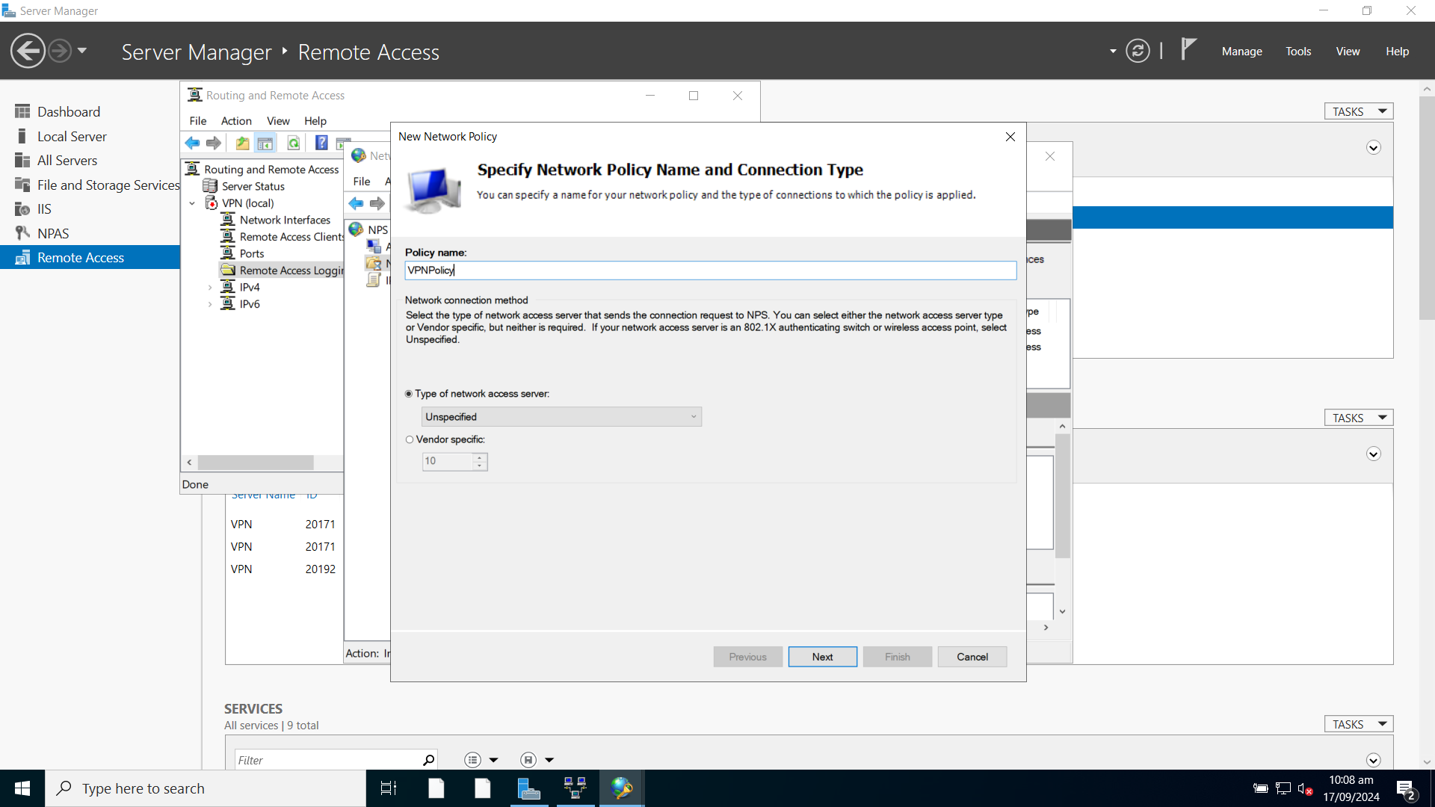

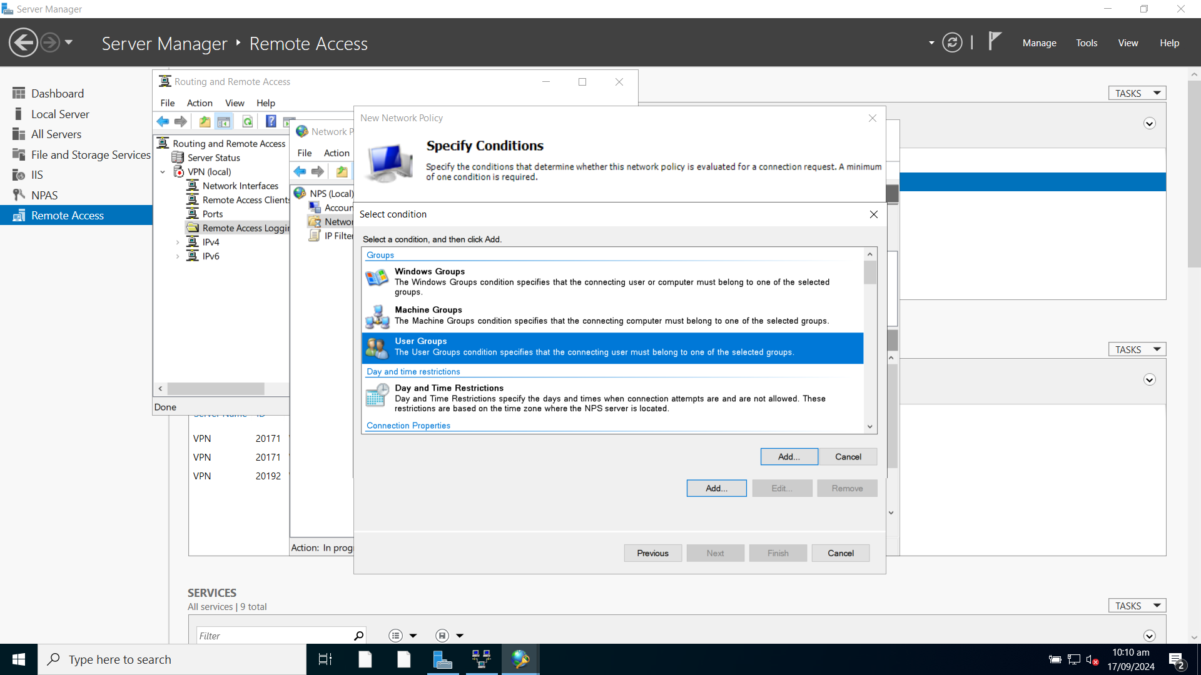

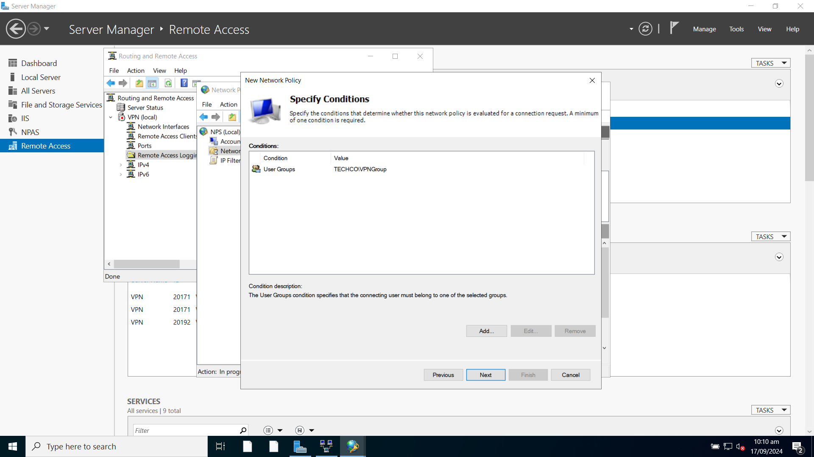

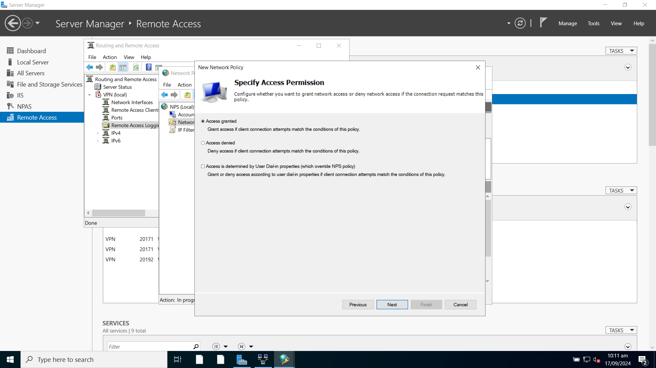

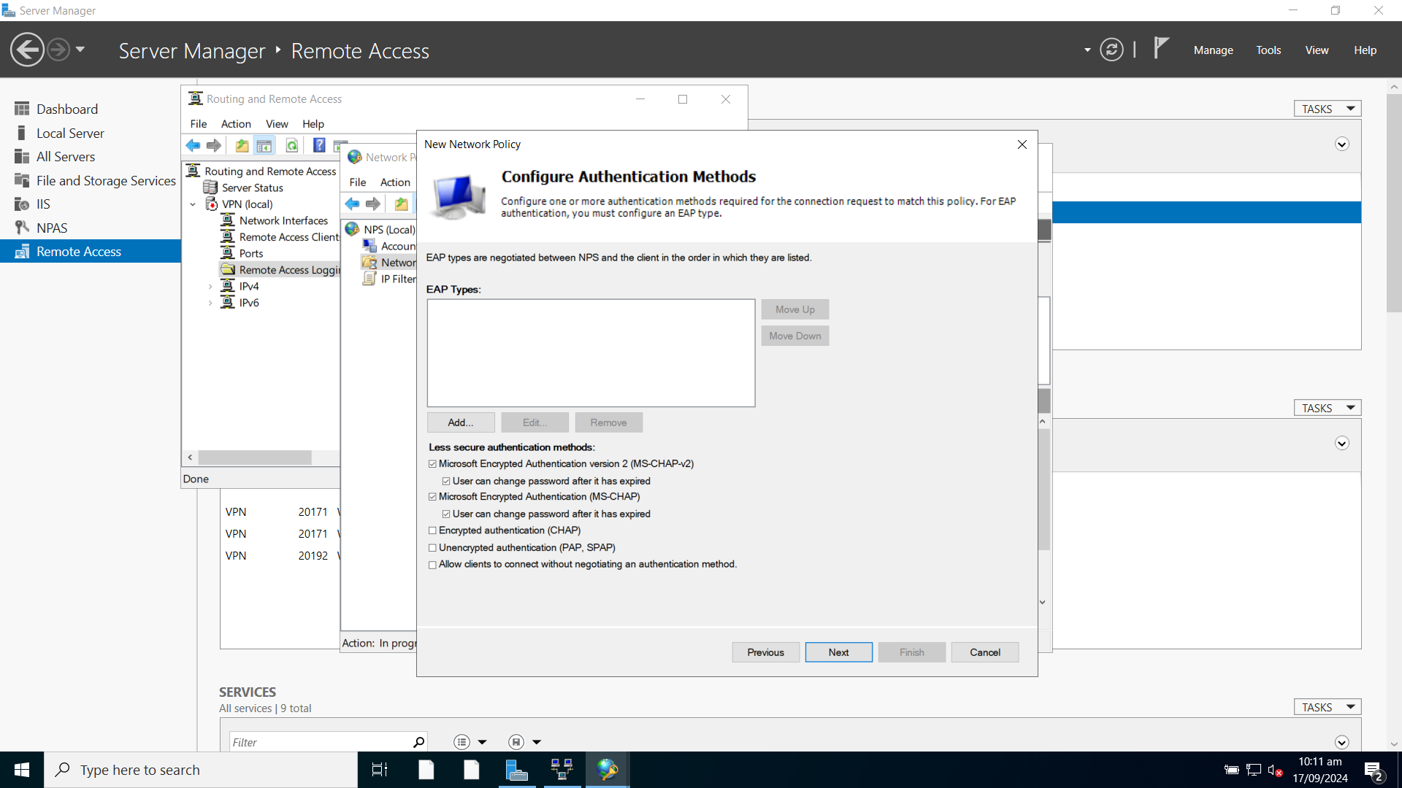

Set the default idle timeout for VPN connections to 15 minutes.

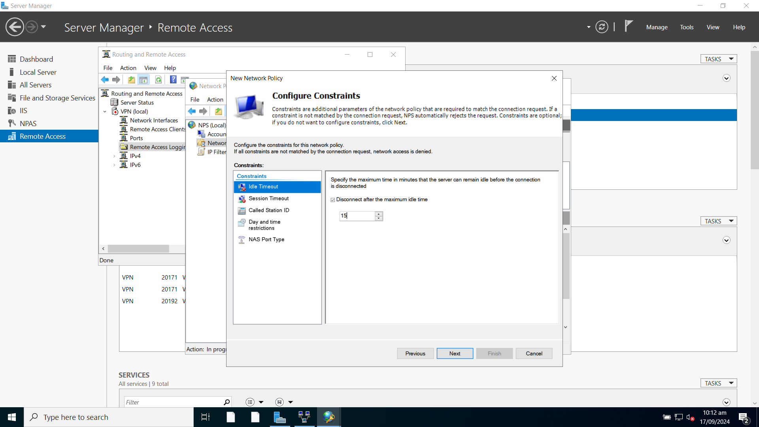

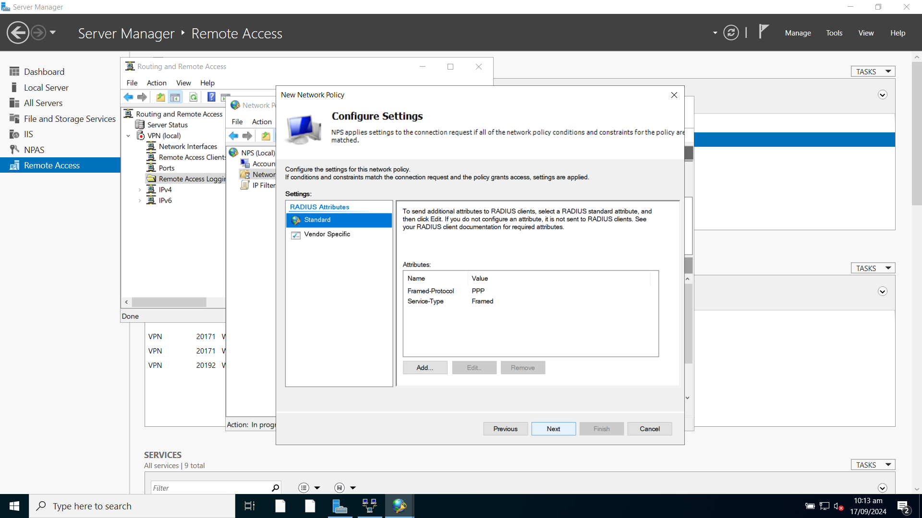

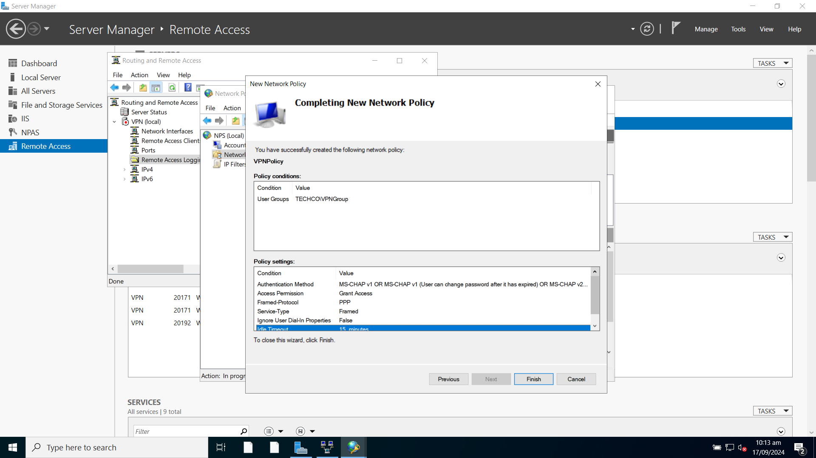

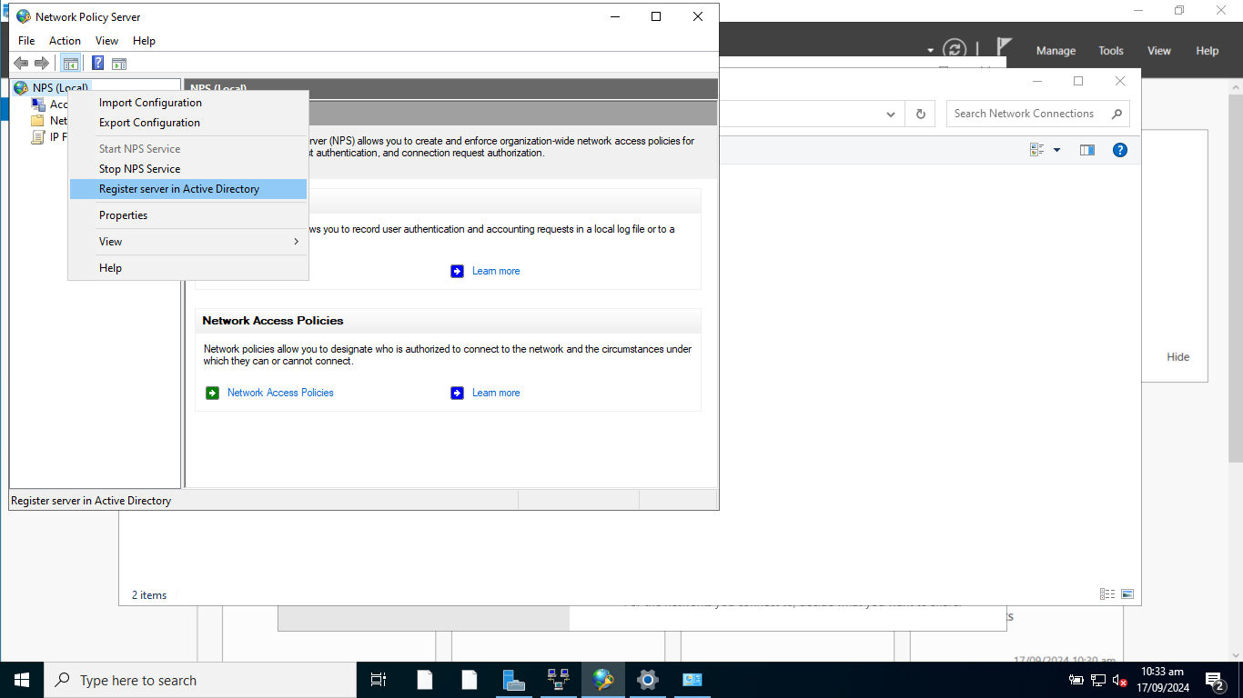

VPN server is ready.

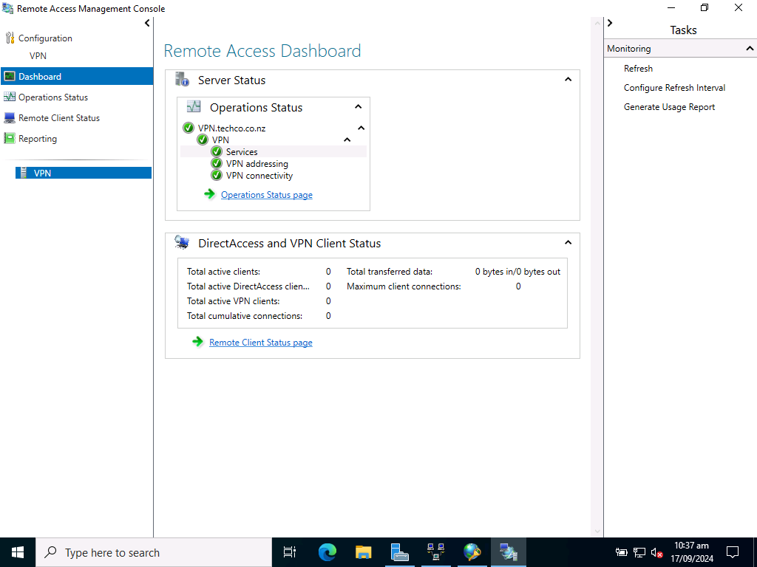

### Task 4.2 Set up a secure VPN connection

**1. Login a client machine with a WAN network adapter and create a VPN connection**

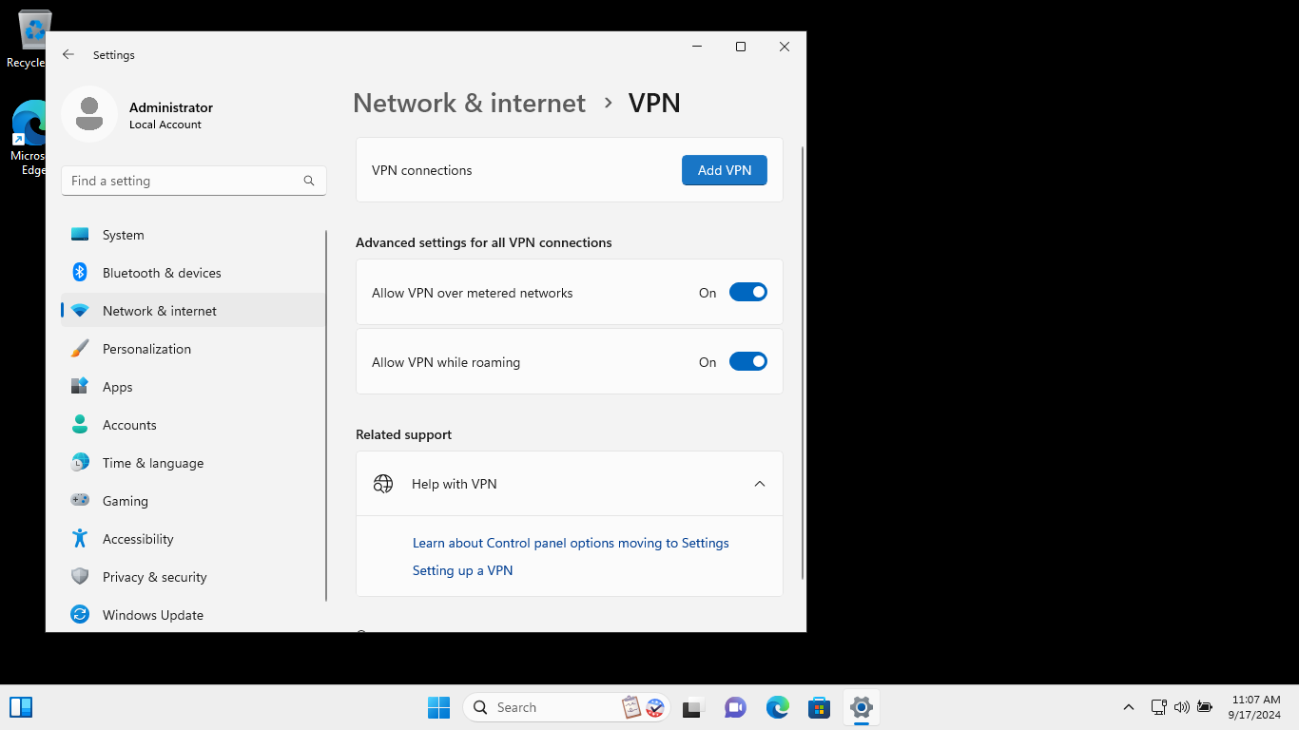

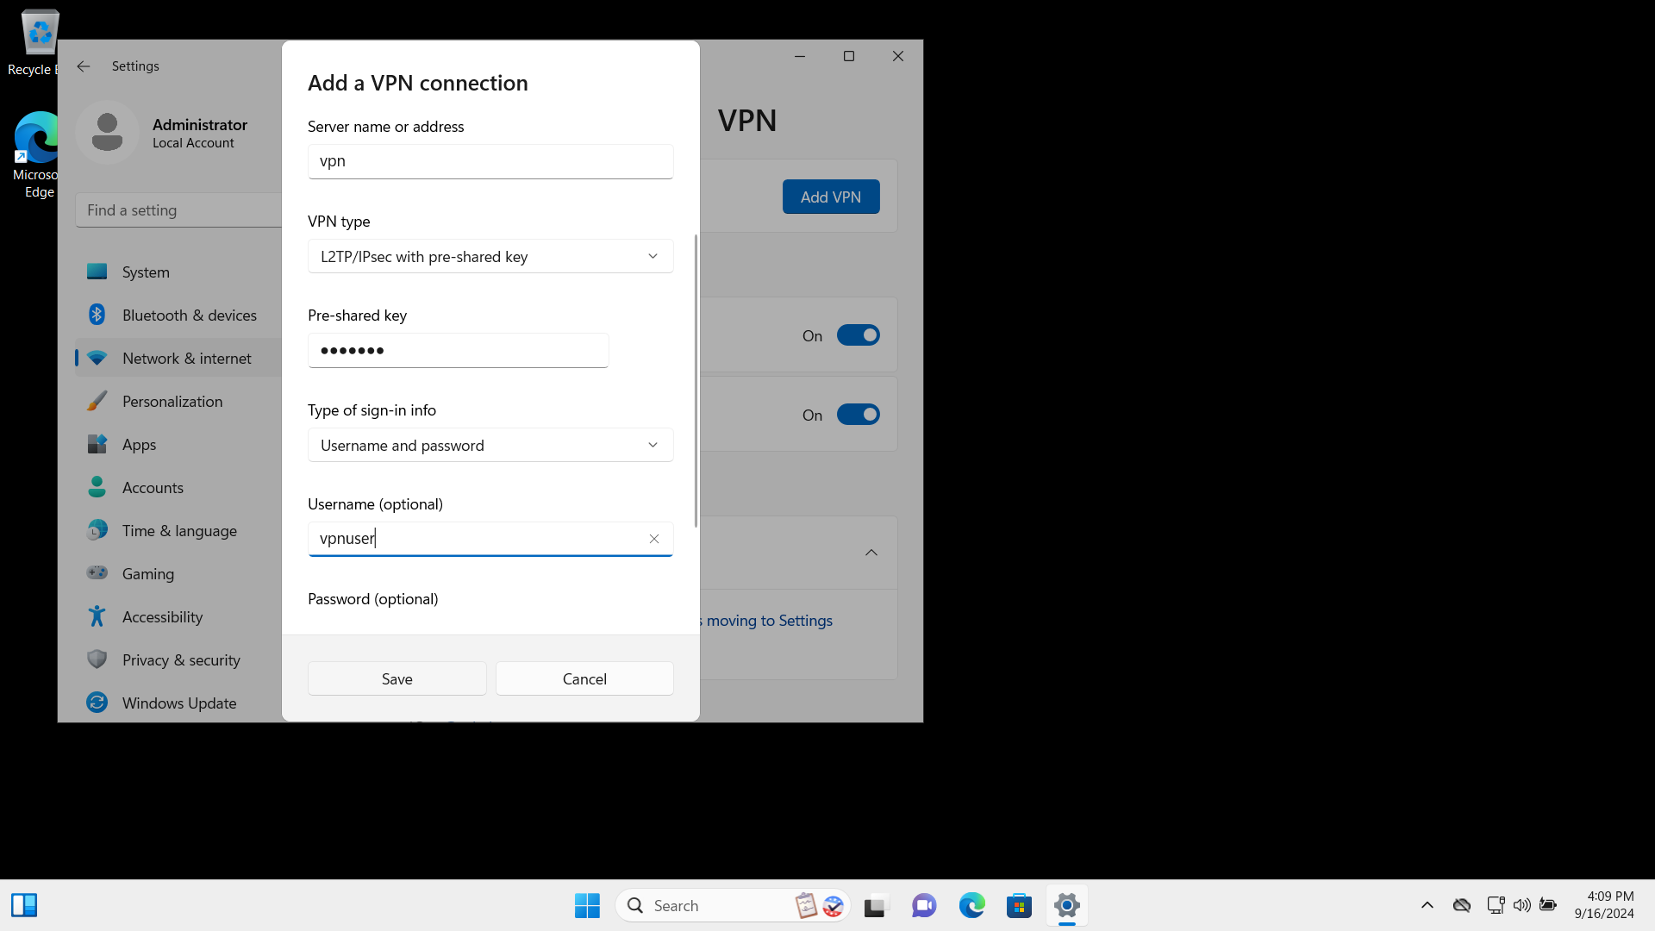

**2. Modify the properties of VPN to allow MS CHAP v2.**

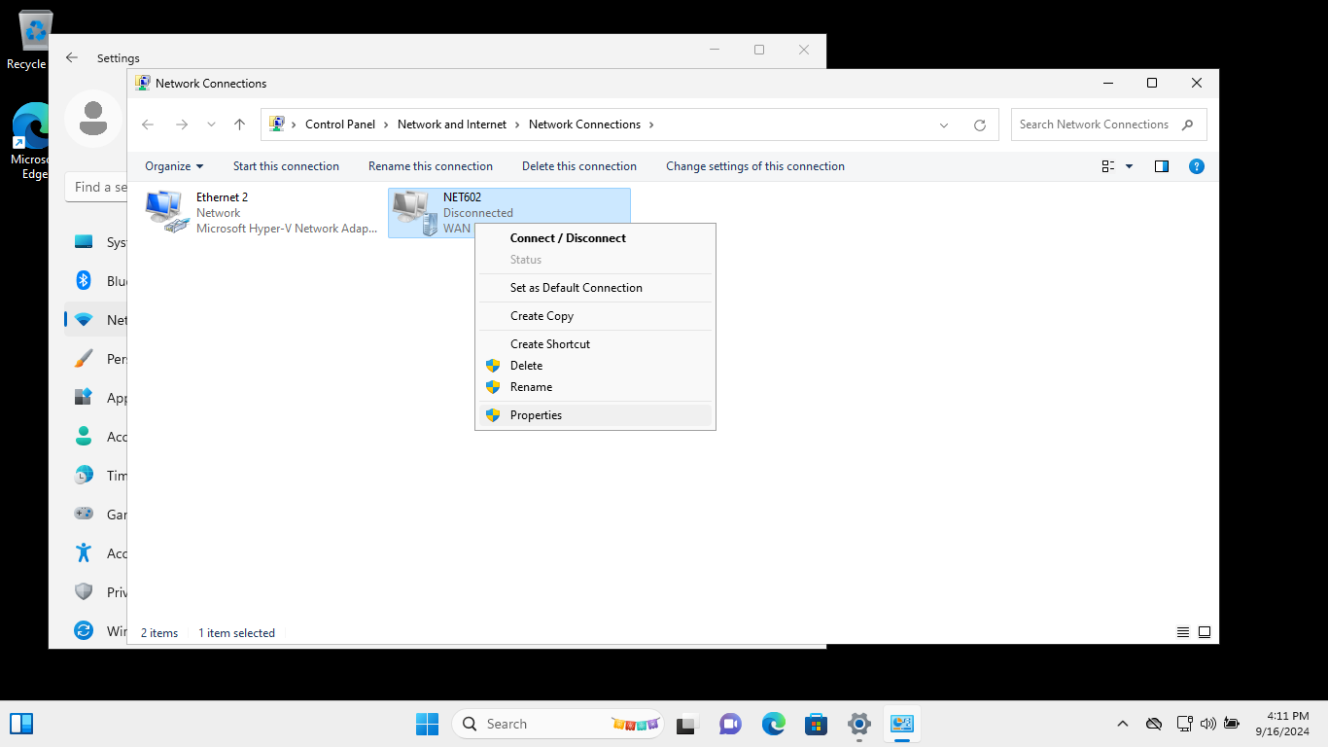

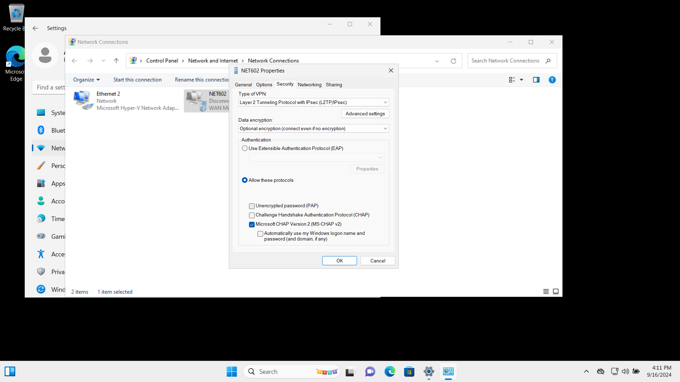

### Task 4.3 Allow file sharing for a shared folder

**1. Create a shared folder on VPN server**

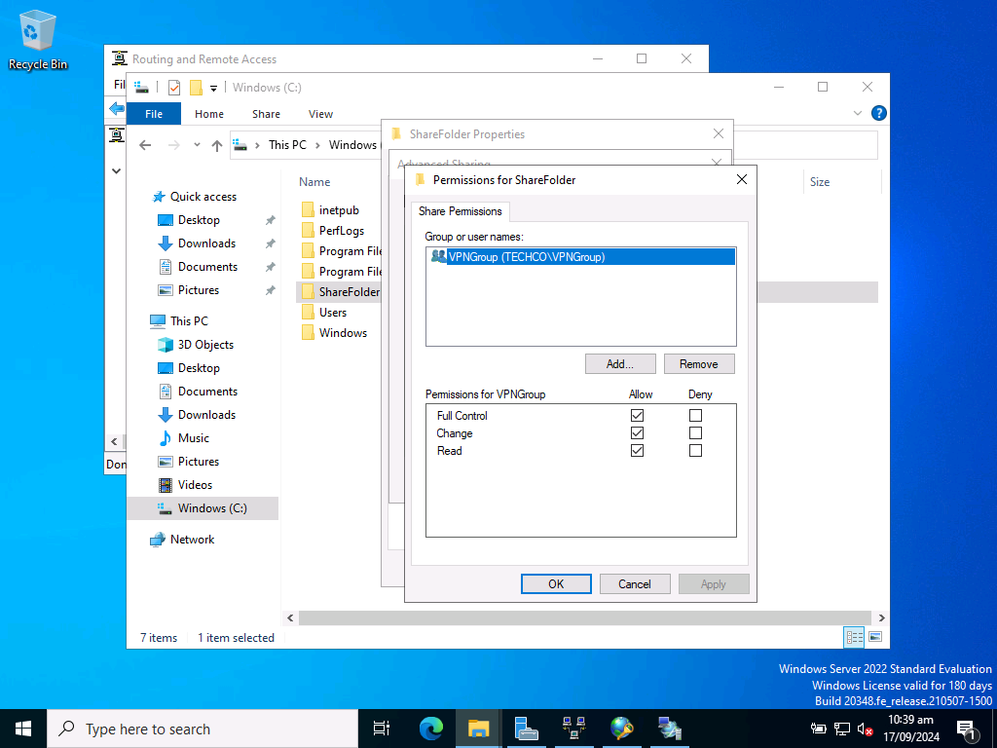

**2. Disable all inbound rules which allow port 445 on Windows Firewall settings**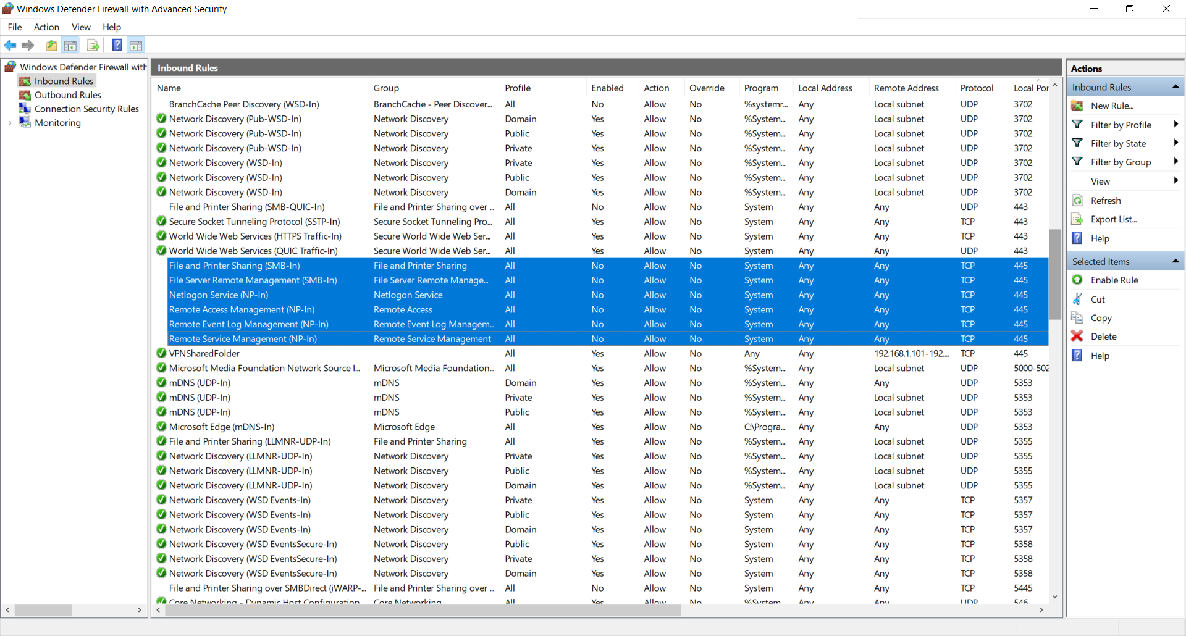

**3. Create a new inbound rule which allows port 445**

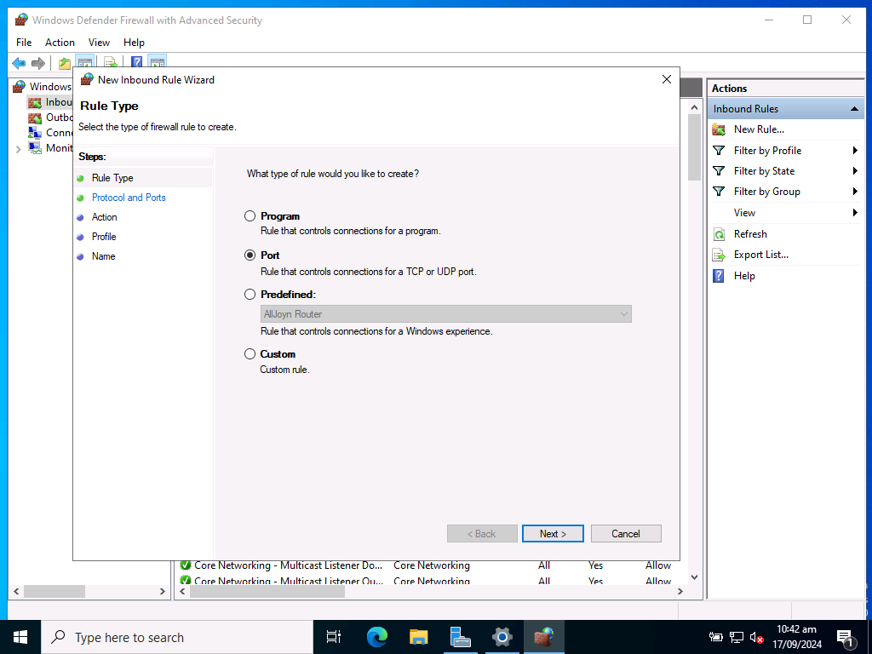

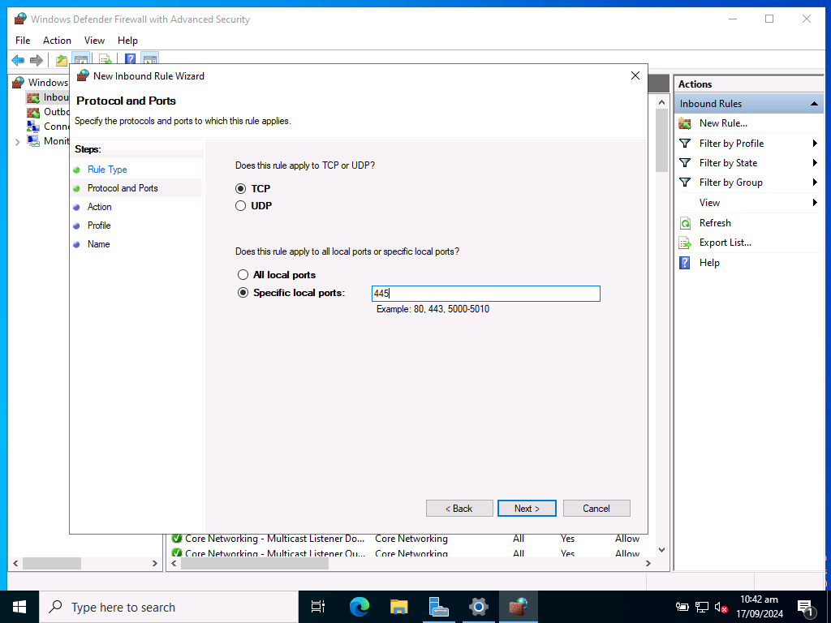

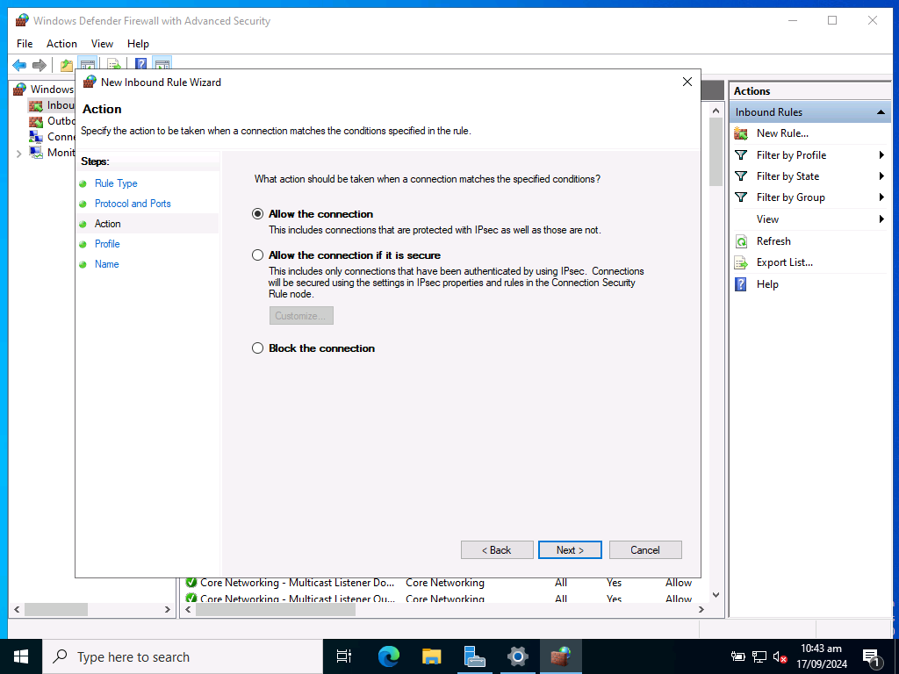

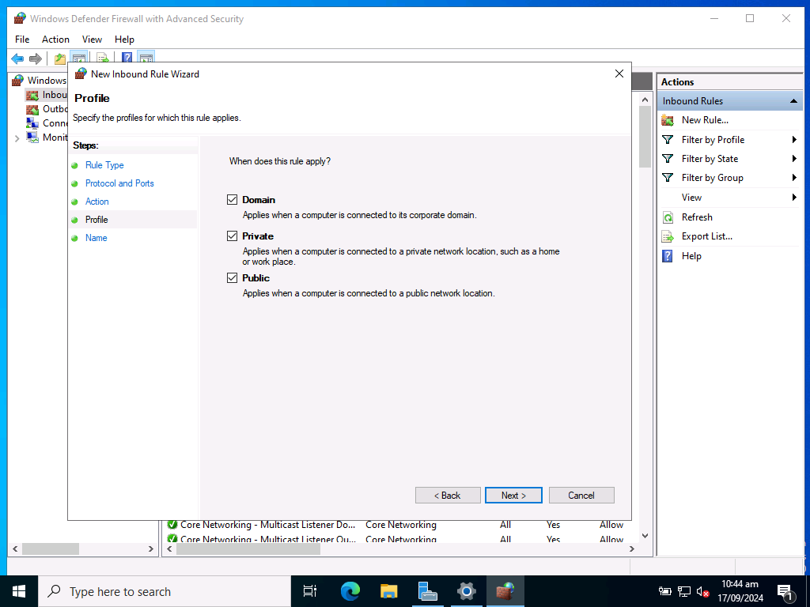

**4. Set the inbound rule properties, and set remote IP addresses scope same as VPN settings.**

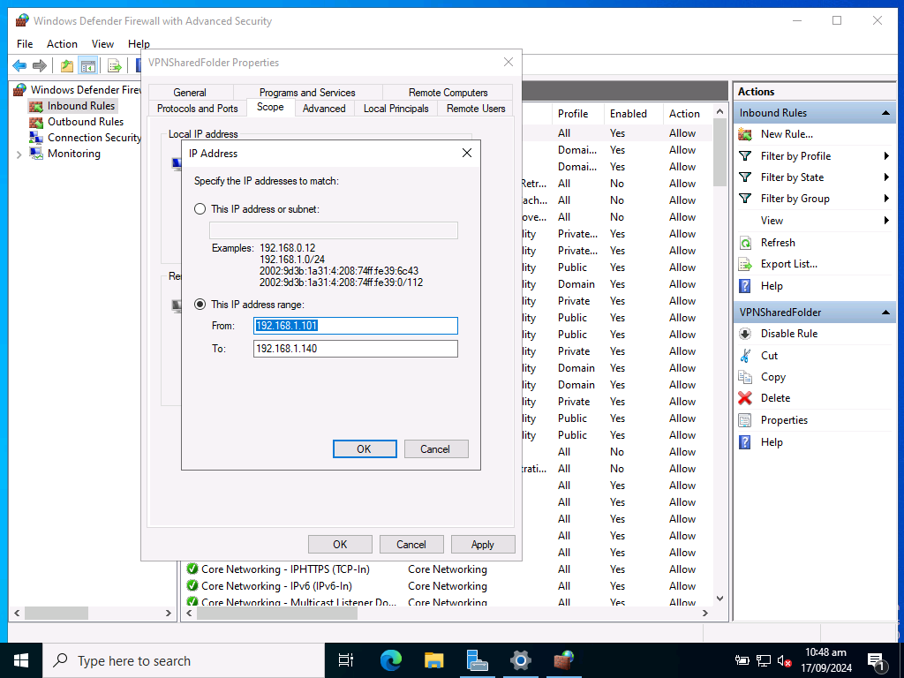

### Task 4.4 Test the VPN connectivity to verify the setup and configuration

**1. Connect the client machine VPN**

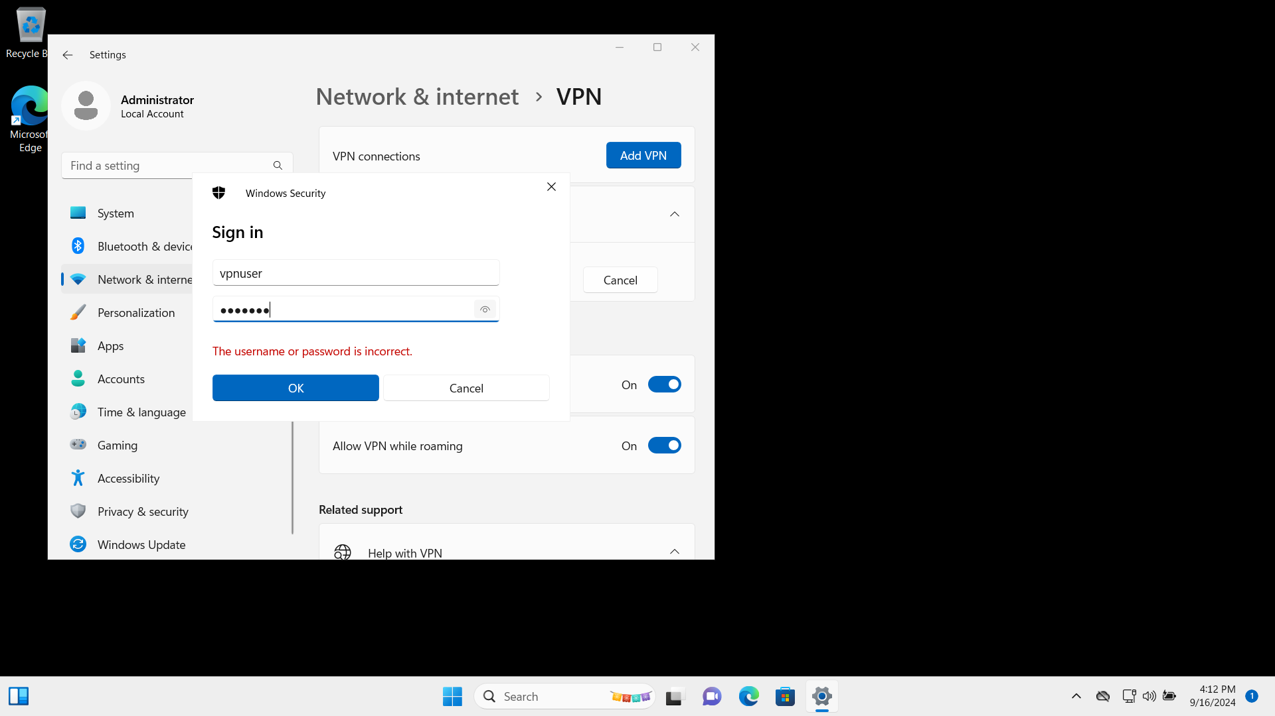

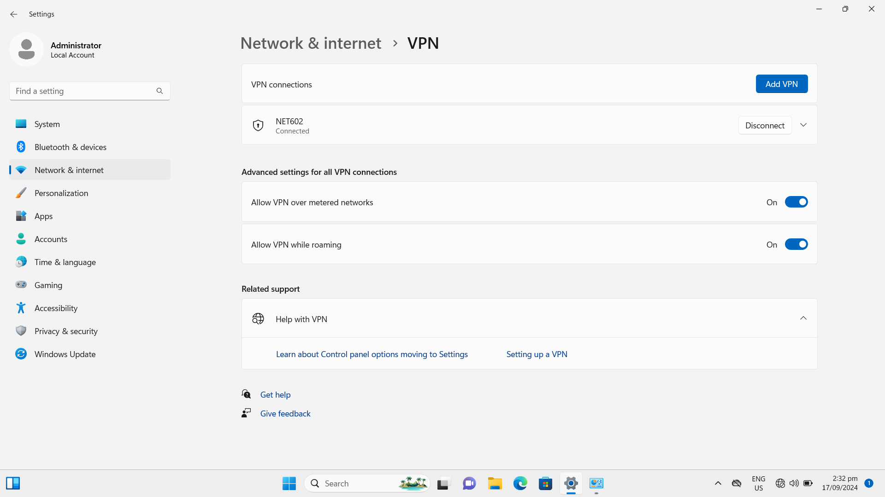

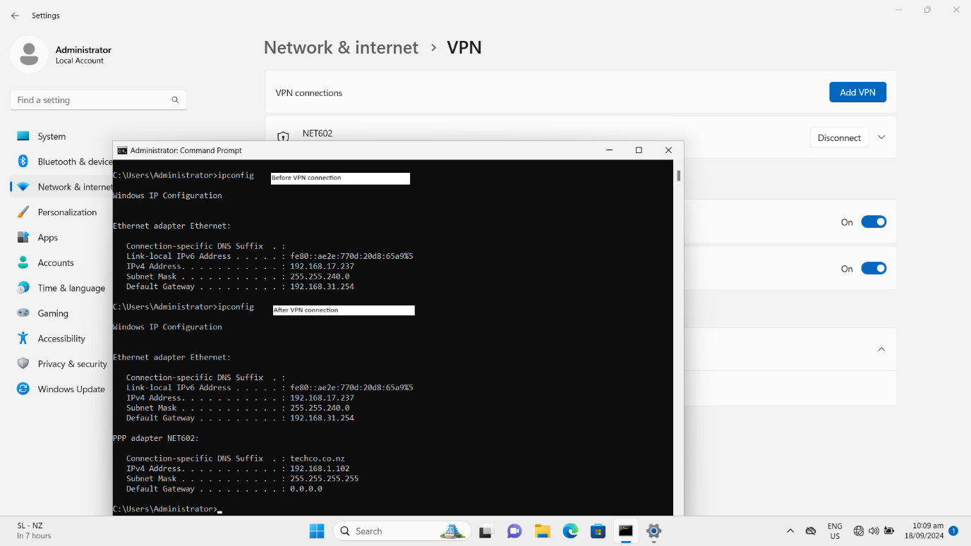

**2. The VPN user “vpnuser” can access the shared folder on the VPN server:**

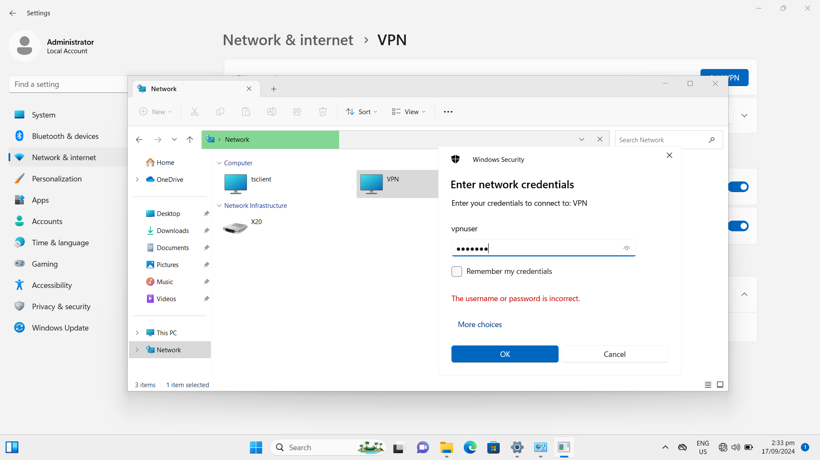

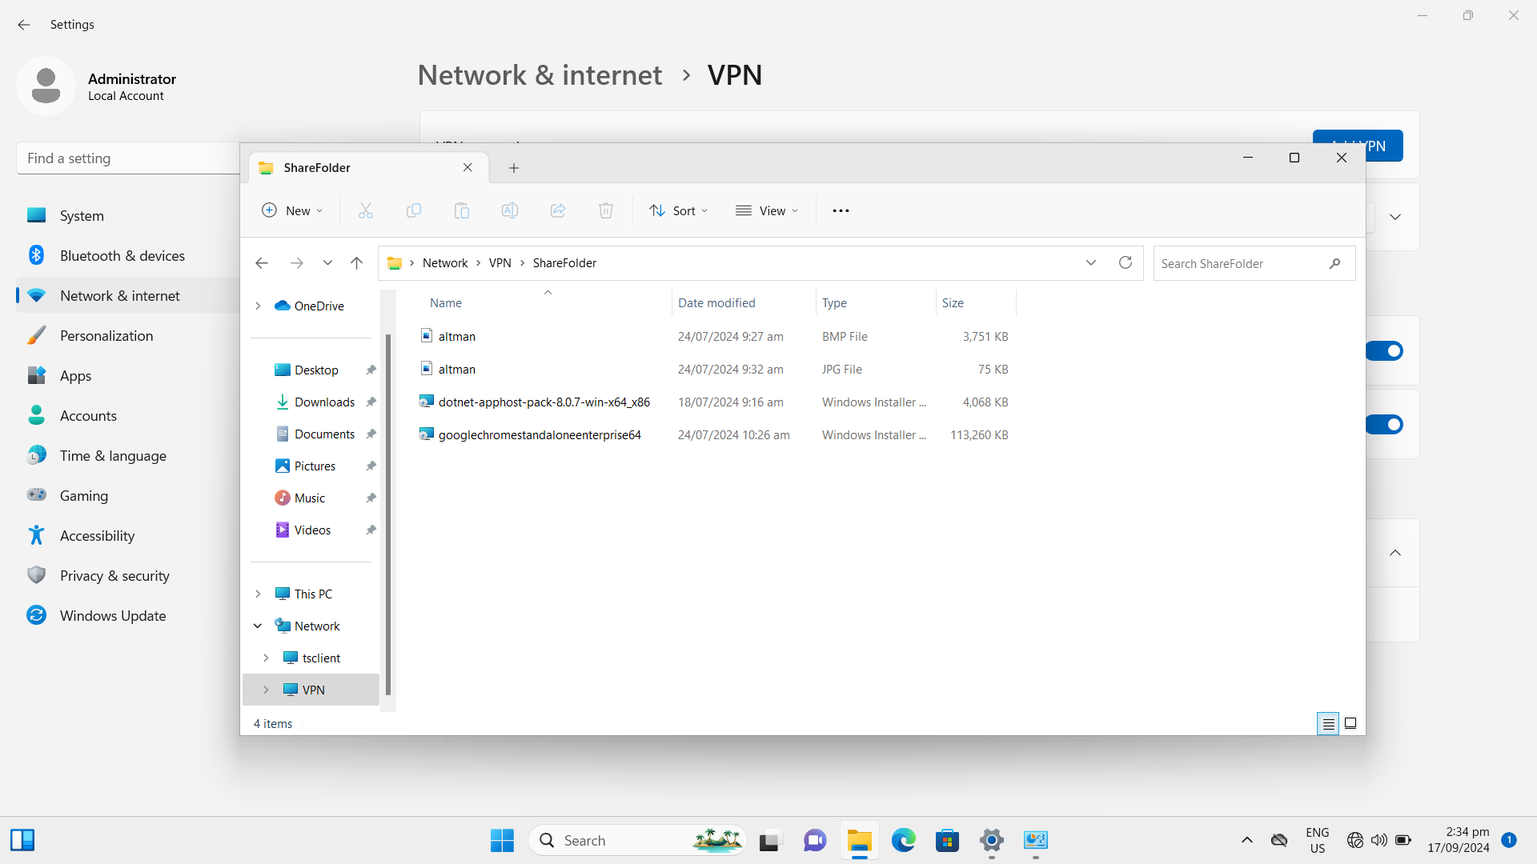

**3. The shared folder cannot be accessed from the client machine since the IP address of the client machine is not in the range of firewall Inbound rules.**

The IP address of the client machine is: 192.168.1.10

The range of firewall Inbound rules: 192.168.1.101~192.168.1.140

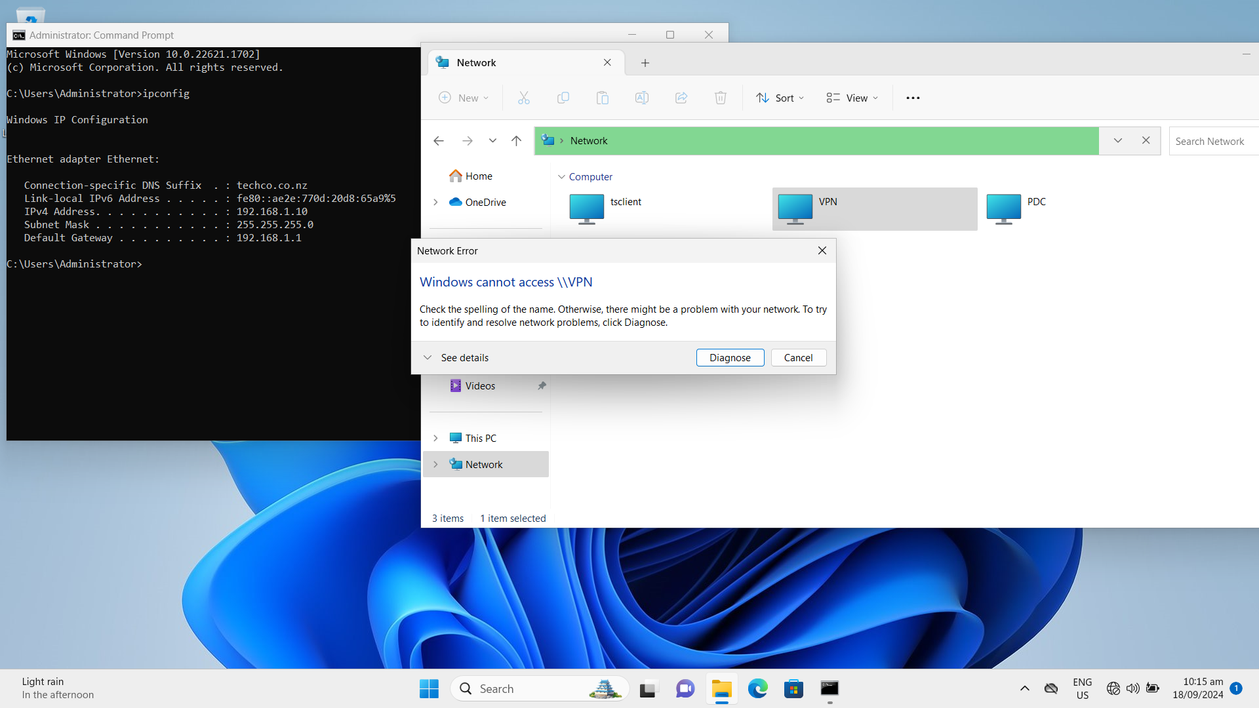

## Task/Mahi 5: Implementing Server Backup

### Task 5.1 Create a complete backup policy using PowerShell Scripts to automate the backup process

##########################################

##### Spark Zheng 18/09/2024 #############

##########################################

# The variables are predefined.

$VolumeName = "C:\" #The disk volume which will be backuped.

$BackupFolderName = "BackupFolder" #The folder name for backup

$BackupFolderPath = "D:\$BackupFolderName" #The full path for backup

$BackupNetworkPath = "\\$env:COMPUTERNAME\$BackupFolderName" #network share place

$BackupTime = "11:40" #The time is scheduled to start backup action.

# 1. Prepare Backup folder on Backup server

New-Item $BackupFolderPath -Type directory -Force

New-SmbShare -Name $BackupFolderName -Path $BackupFolderPath -FullAccess Administrators

# 2. Install Windows Backup Services

Install-WindowsFeature -Name Windows-Server-Backup -IncludeManagementTools

# 3. Create a new Windows backup policy

$Policy = New-WBPolicy

# Configure the path of the files to backup

$FileSpec = New-WBFileSpec -FileSpec $VolumeName

# Add the file path to the backup policy

Add-WBFileSpec -Policy $Policy -FileSpec $FileSpec

# Prepare the Credential to access backup storage

$User = "administrator"

$PWord = ConvertTo-SecureString -AsPlainText 'Aspire2' -Force

$Credential = New-Object -TypeName System.Management.Automation.PSCredential -ArgumentList $User, $PWord

# Configure the backup location

$BackupLocation = New-WBBackupTarget -NetworkPath $BackupNetworkPath -Credential $Credential

# Add the target location to the backup policy

Add-WBBackupTarget -Policy $Policy -Target $BackupLocation

# 4. Set backup policy schedule time and add it to the task scheduler

Set-WBSchedule -Policy $Policy -Schedule $BackupTime

# Add the backup policy to the backup server

Set-WBPolicy -Policy $Policy

# 5. Encrypt the backup folder after the backup finished.

Get-ChildItem -Path $BackupNetworkPath -Recurse |Where-Object { if($_.GetType().Name -eq "FileInfo") {$_.Encrypt()}}

# 6. Decrypt the backup folder before to recover.

Get-ChildItem -Path $BackupNetworkPath -Recurse |Where-Object { if($_.GetType().Name -eq "FileInfo") {$_.Decrypt()}}

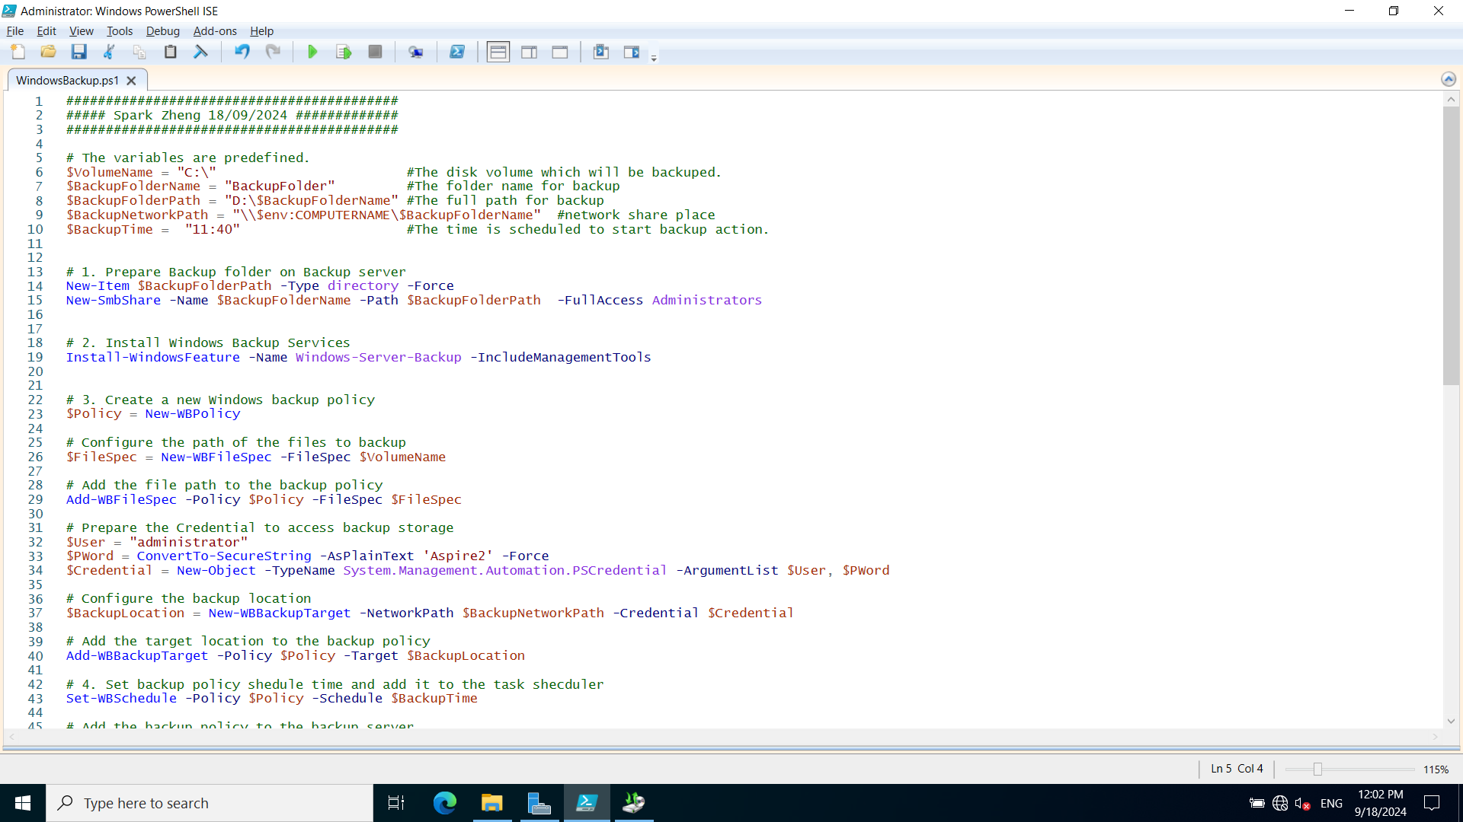

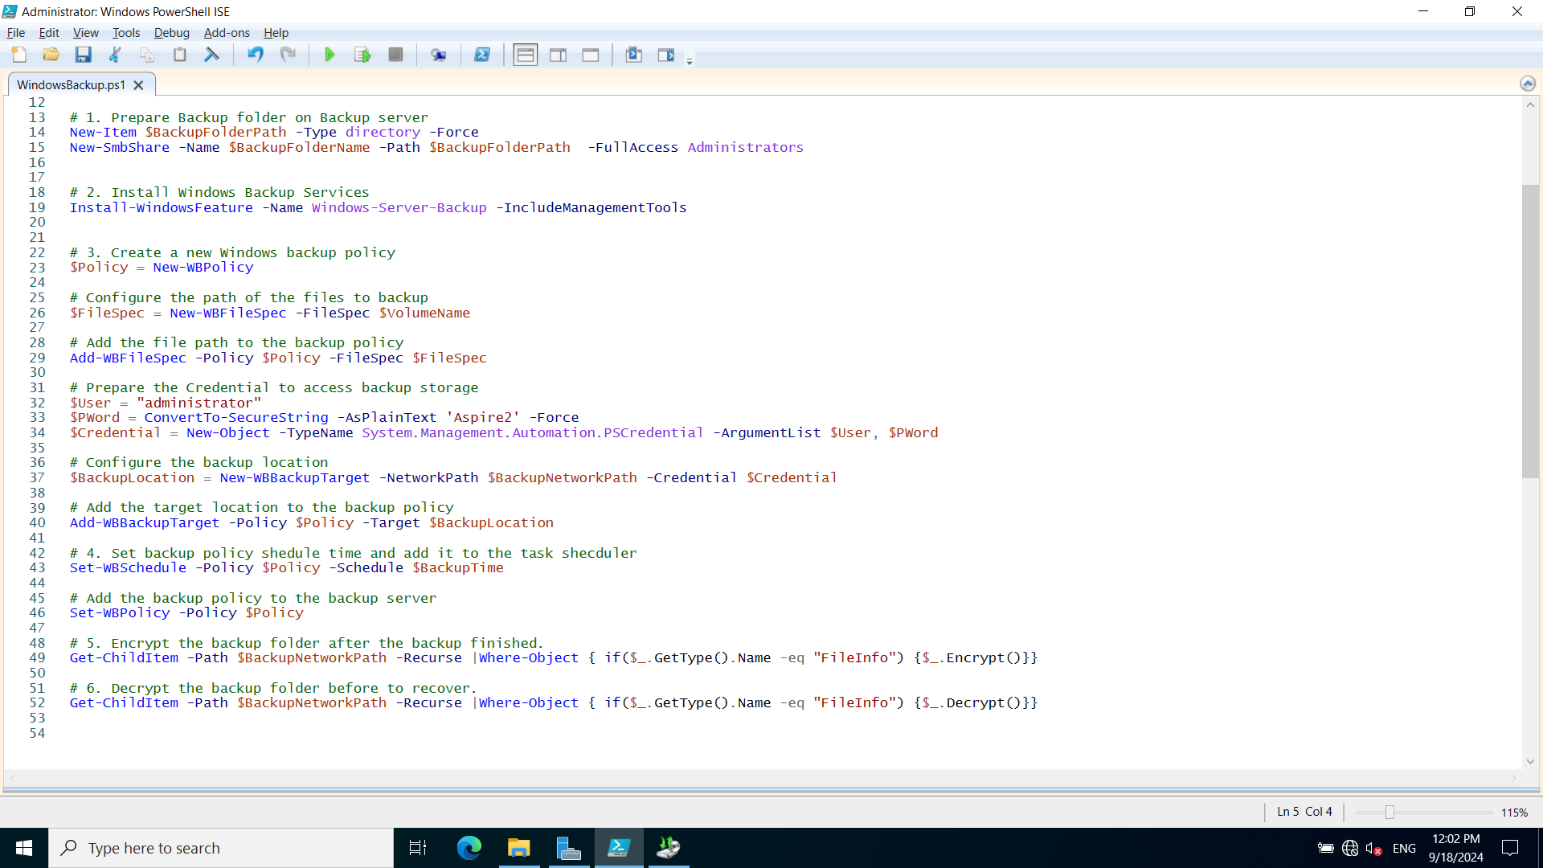

### Task 5.2 Configure Windows backup using the PowerShell Script

**1. Prepare Backup folder on Backup server**

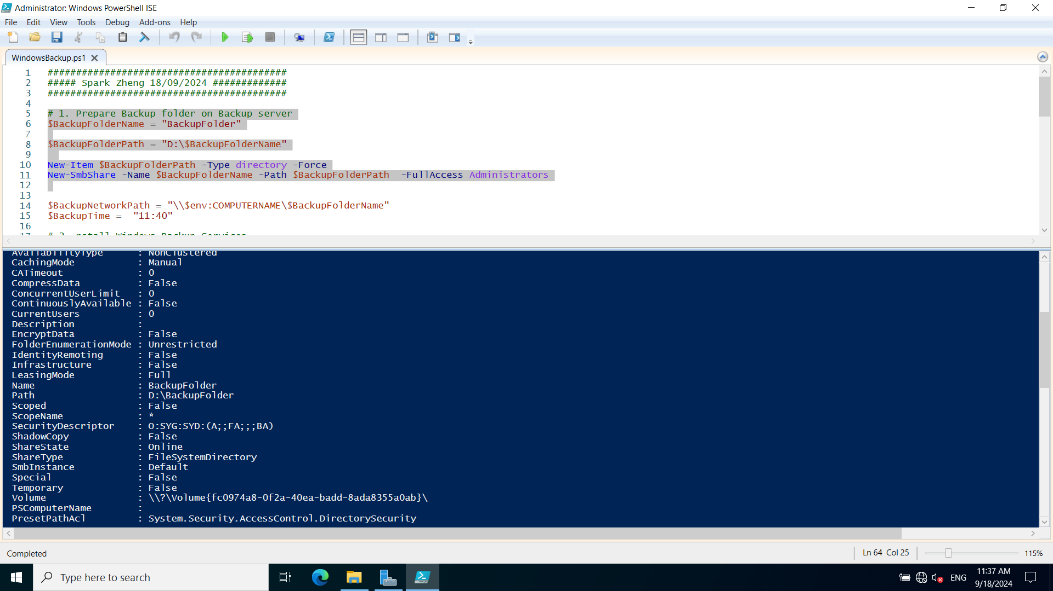

**2. Install Windows Backup Services**

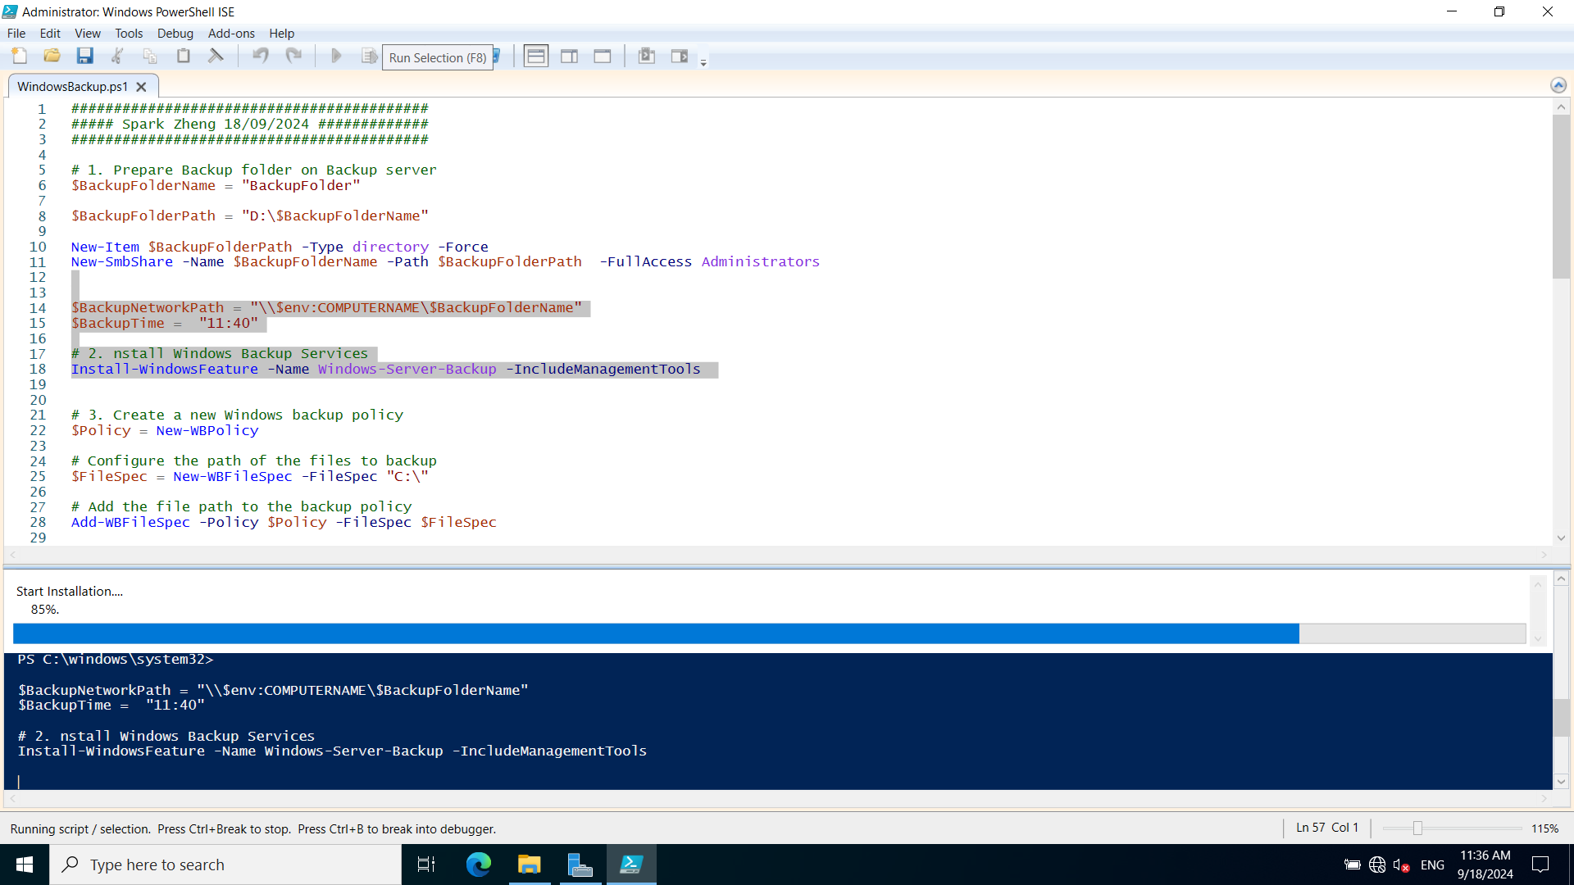

**3. Create a new Windows backup policy**

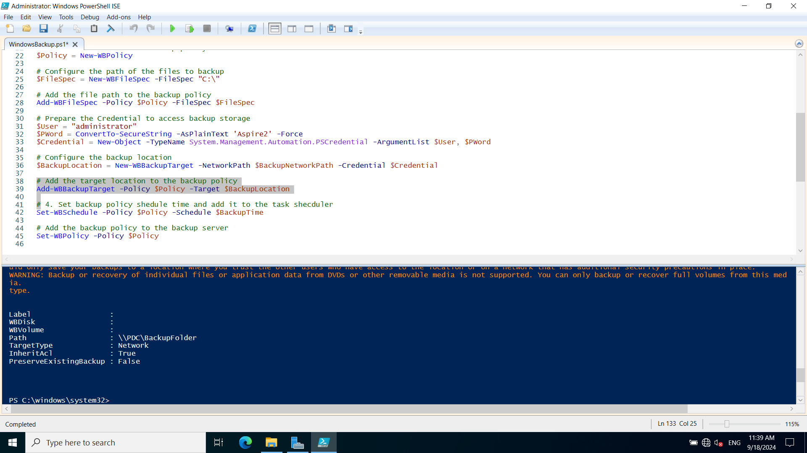

**4. Set backup policy schedule time and add it to the task scheduler**

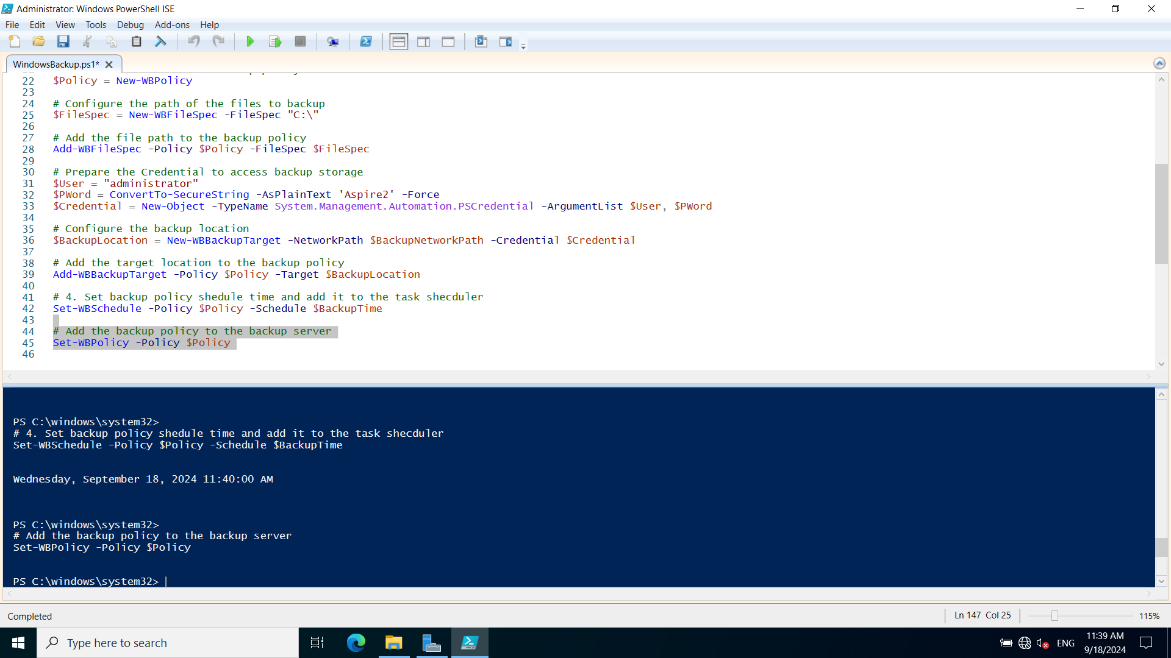

**5. Check Backup status on Windows Server Backup console**

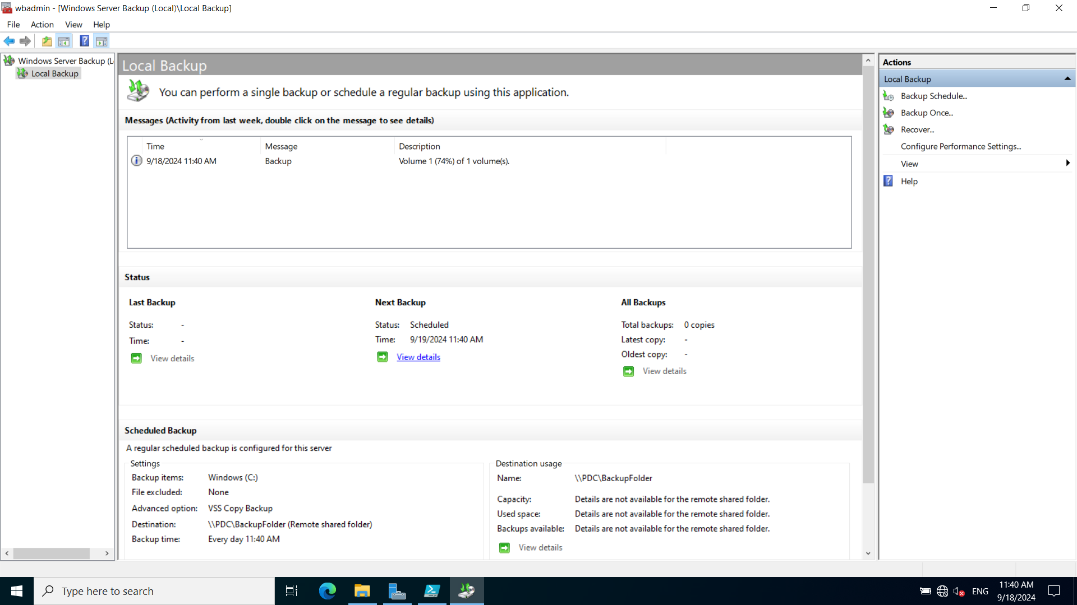

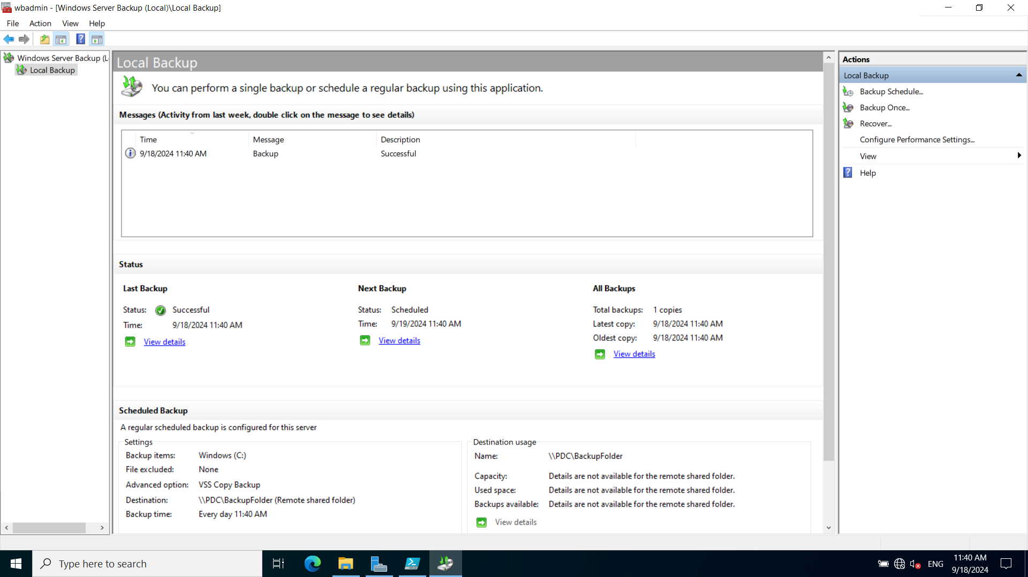

**6. Encrypt the backup folder after the backup finished.**

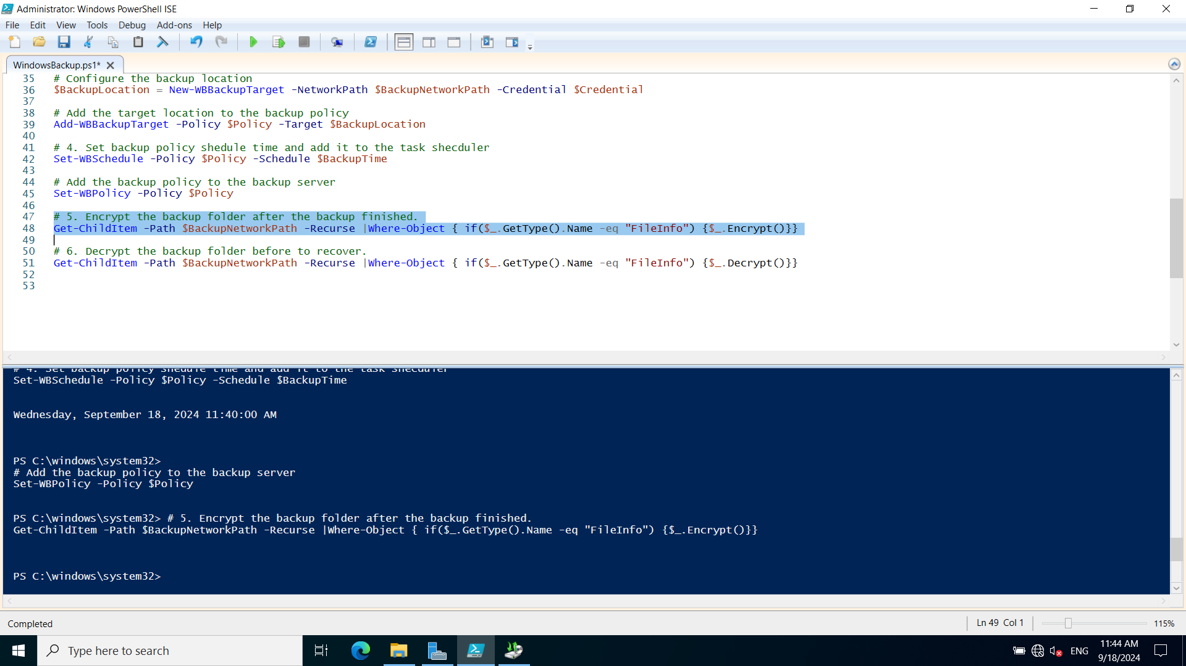

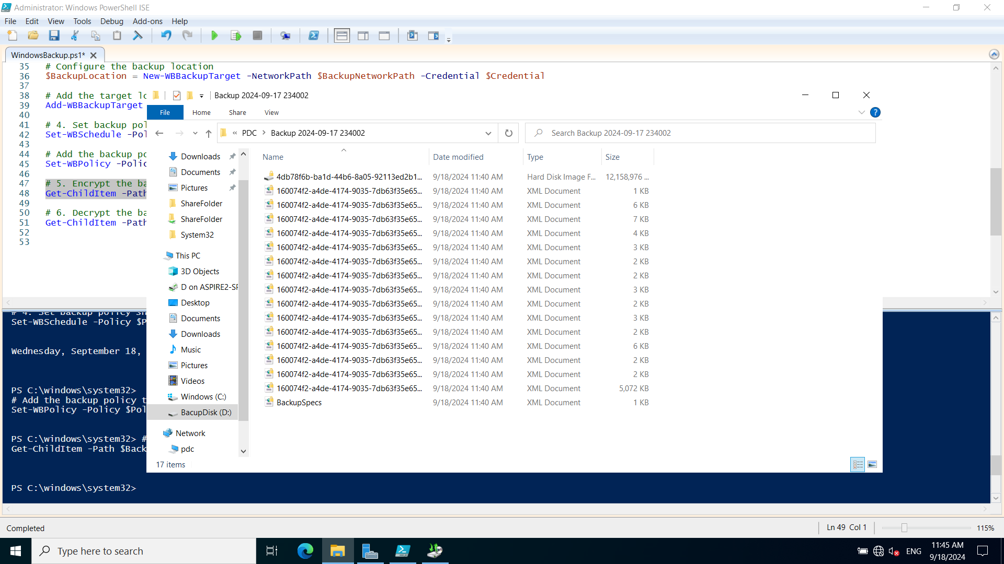

**7. Decrypt the backup folder before to recover.**

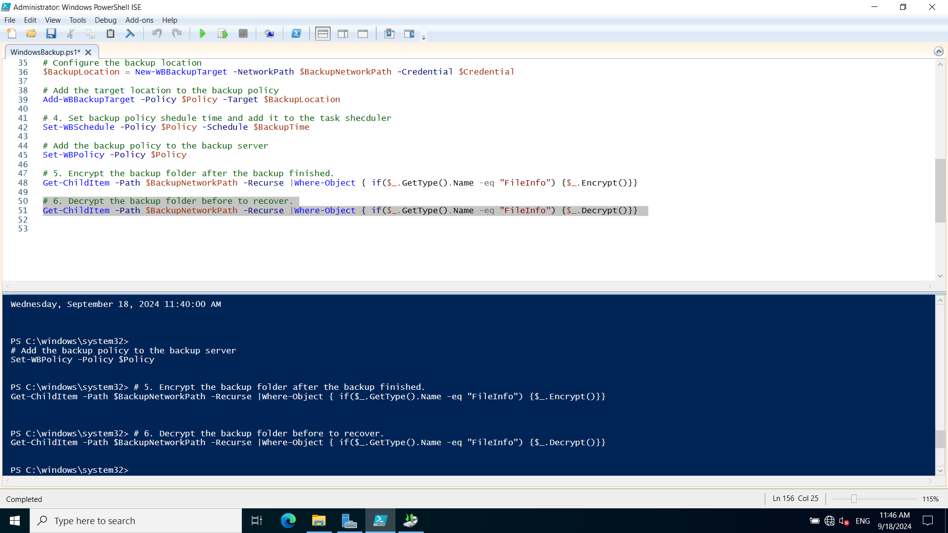

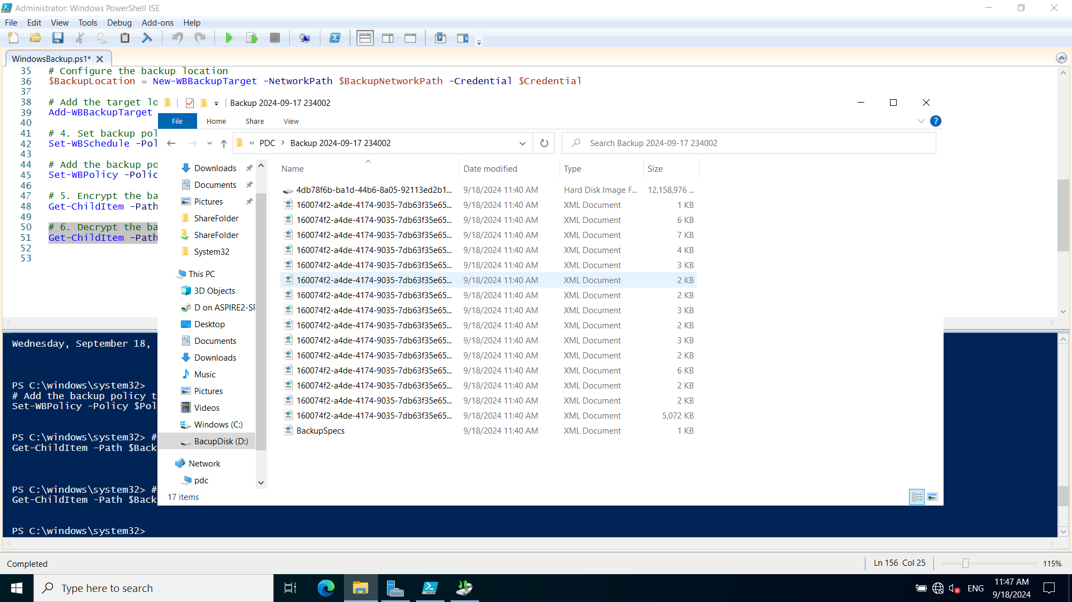

**8. Recover a specified folder from a backup**

There are 5 files in C:\Sharefolder at the beginning of test.

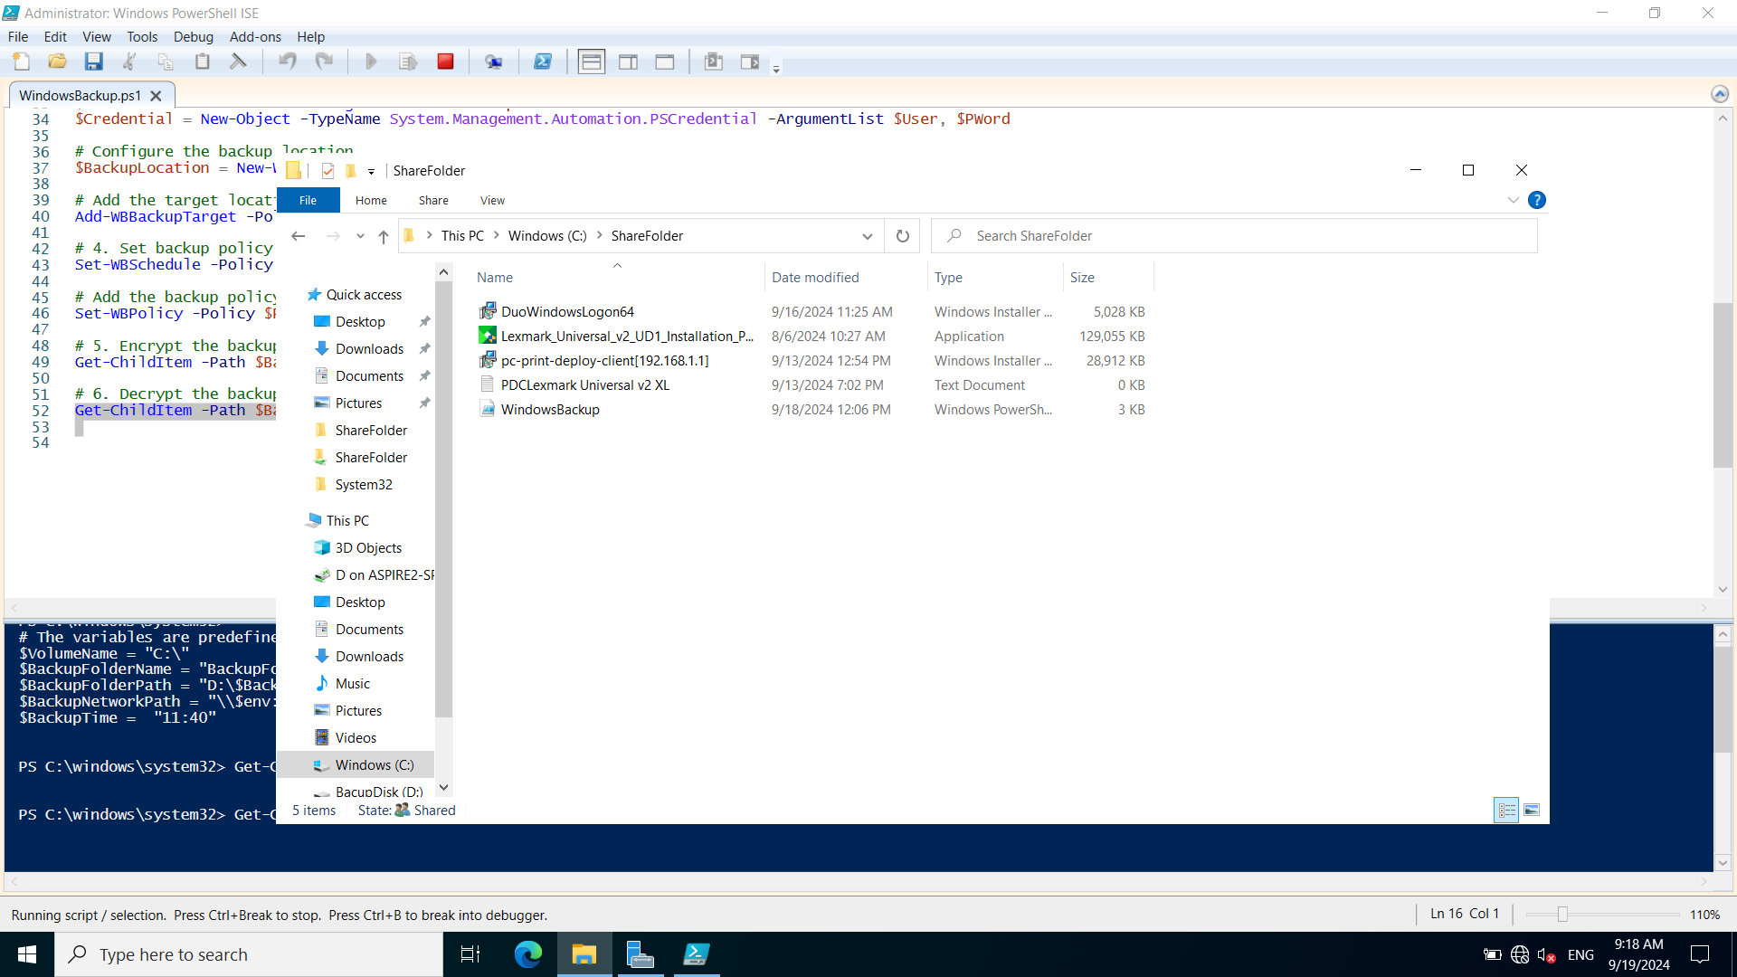

Then 3 files are deleted accidentally:

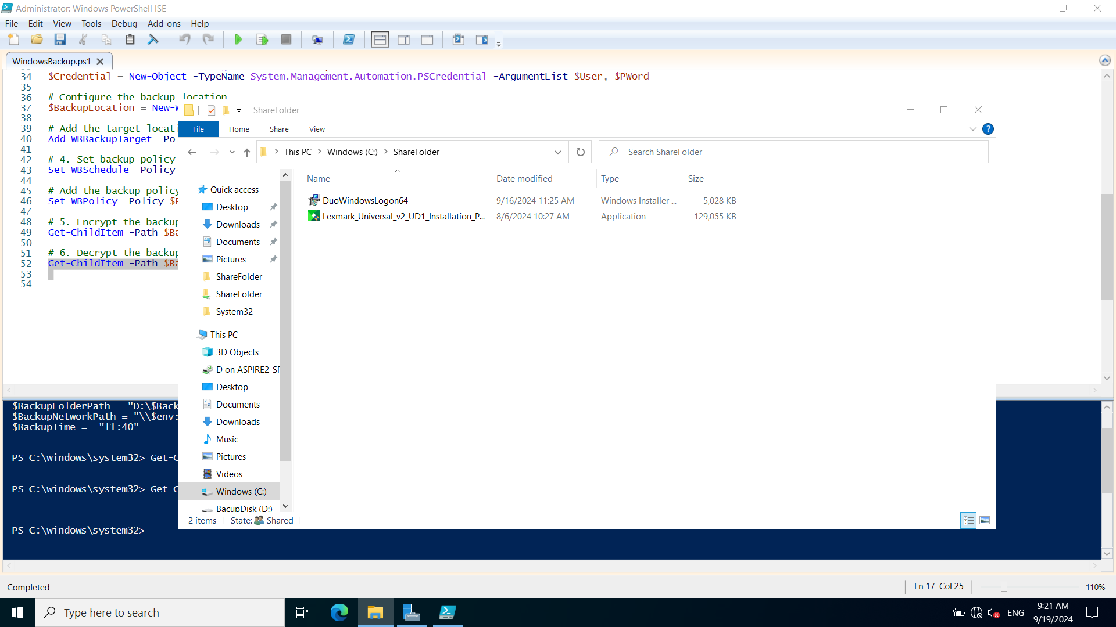

Start a new recover process: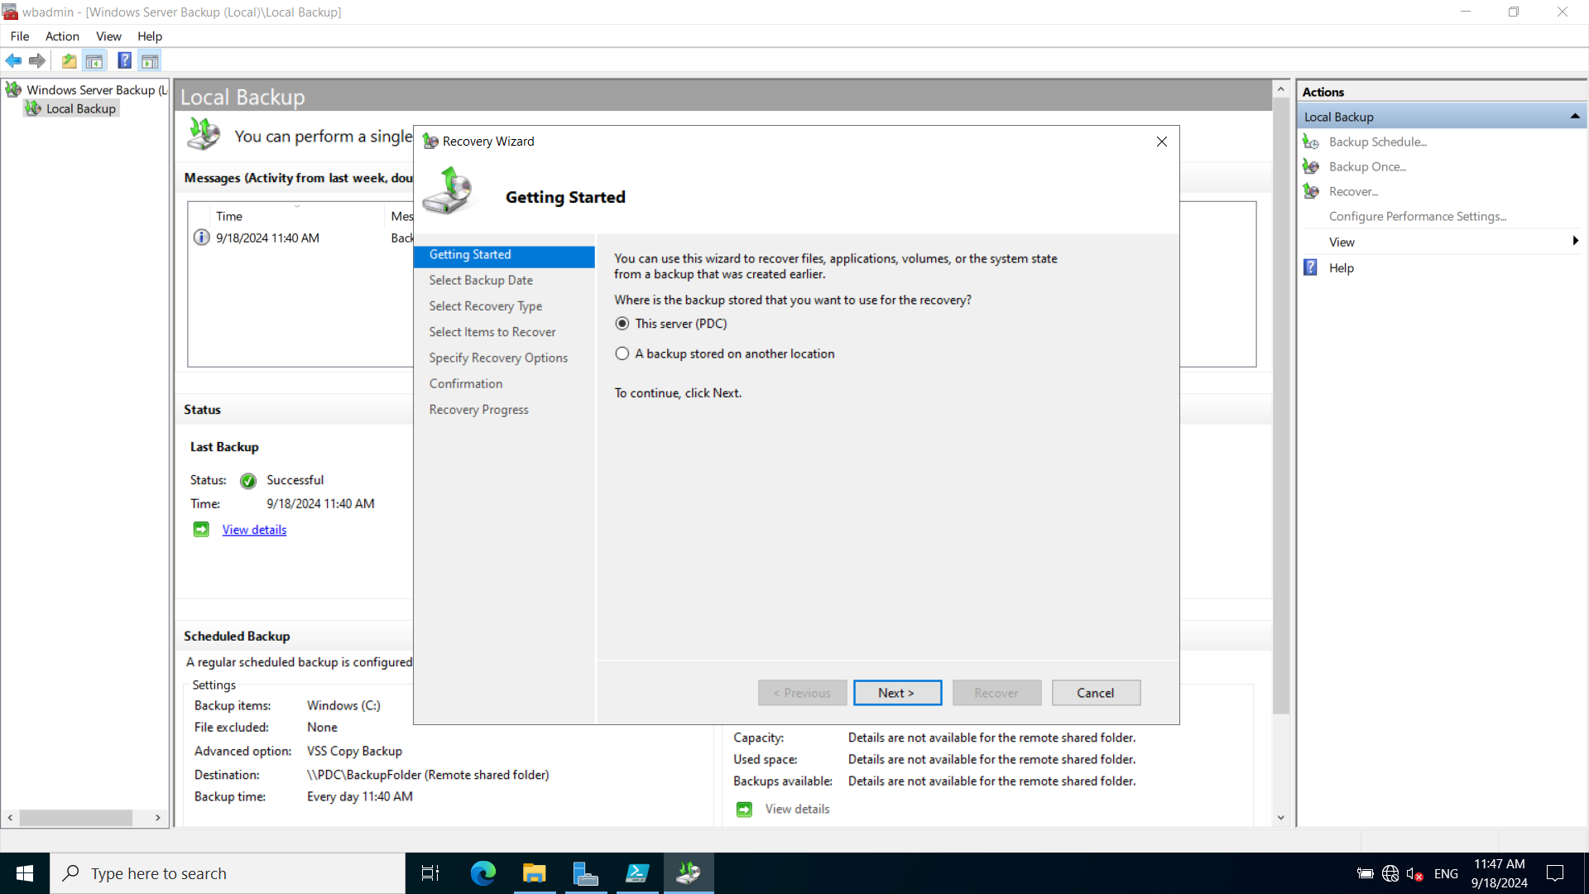

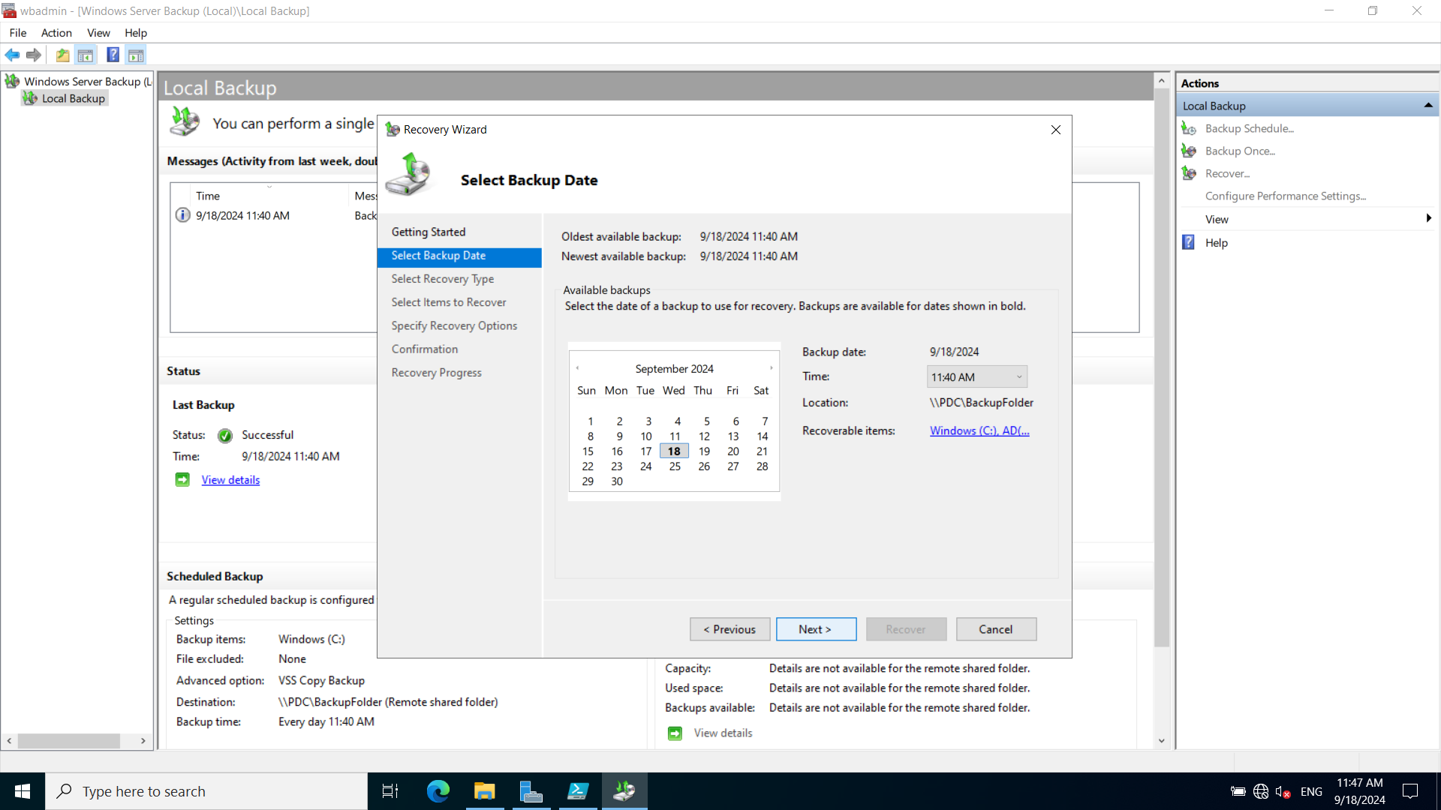

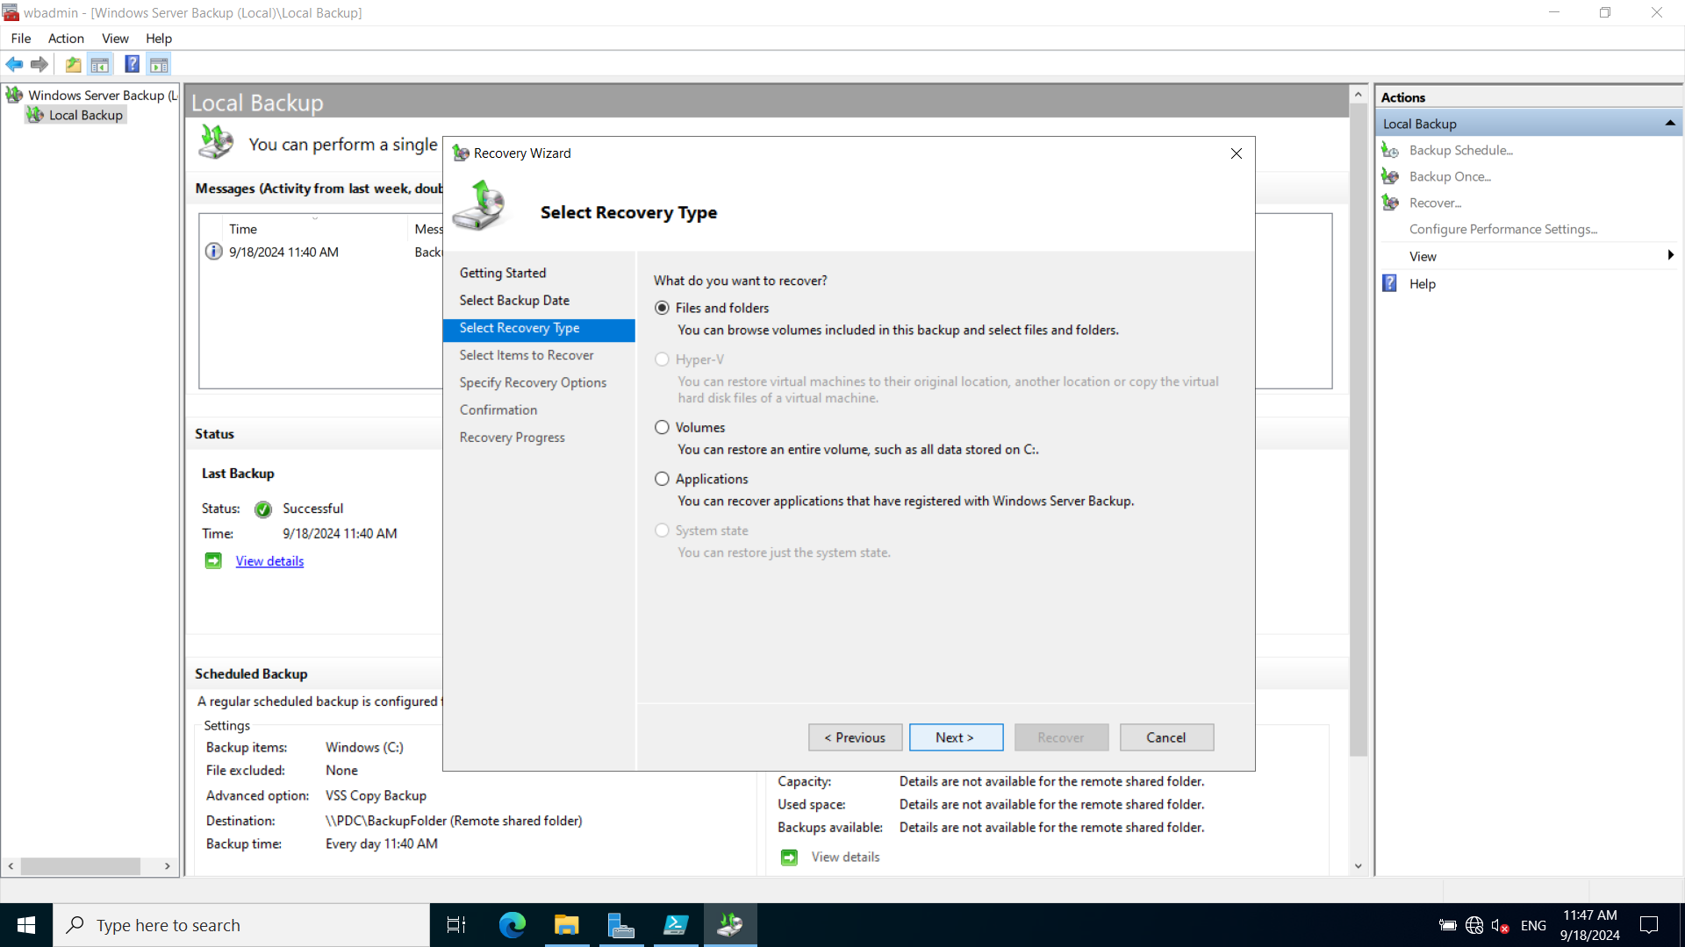

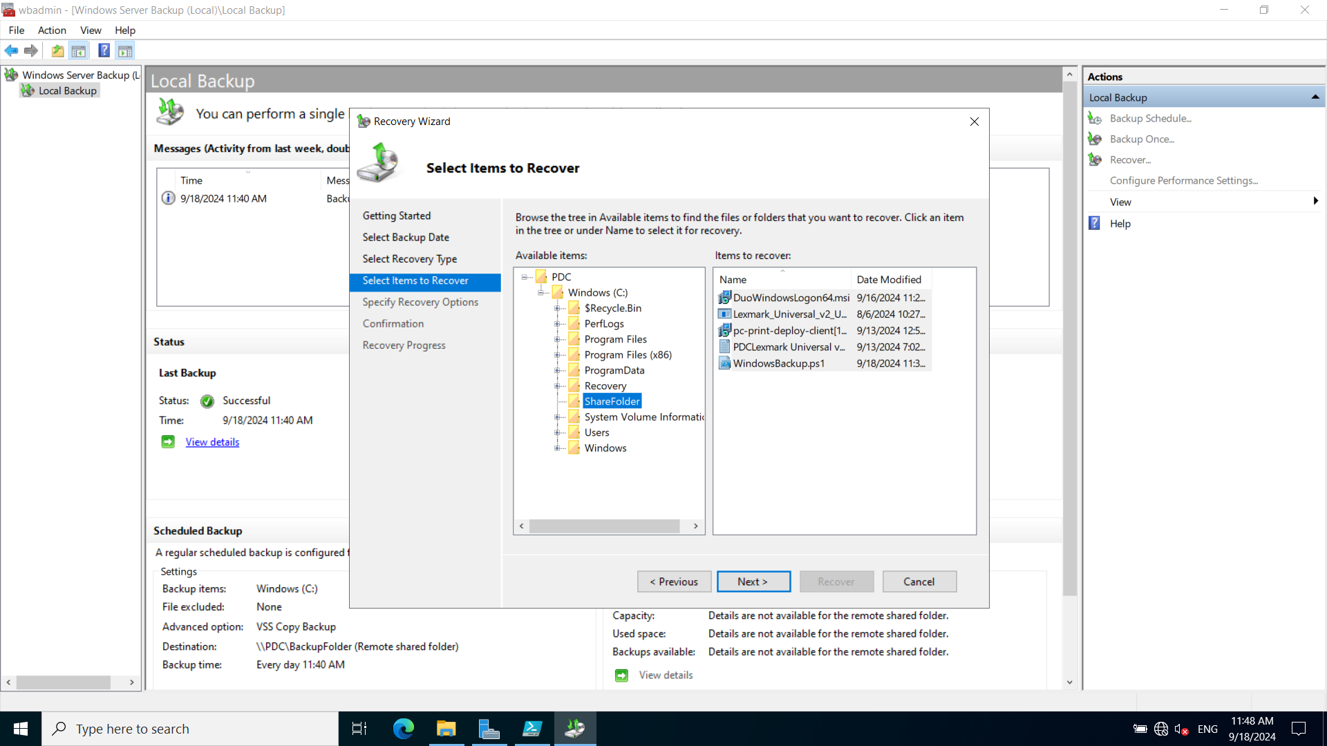

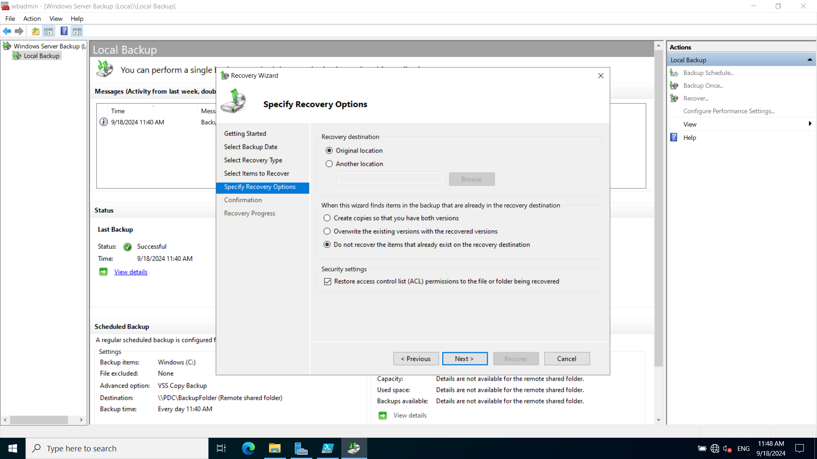

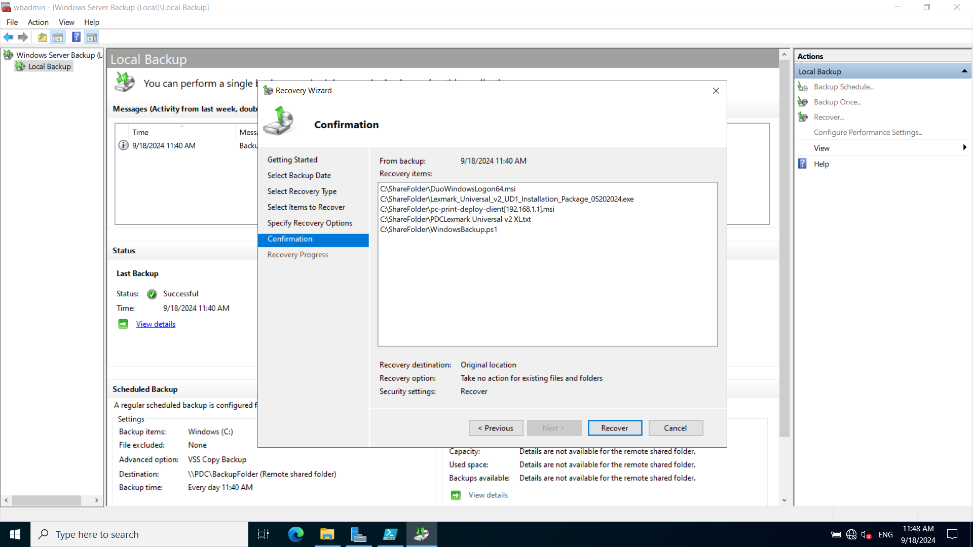

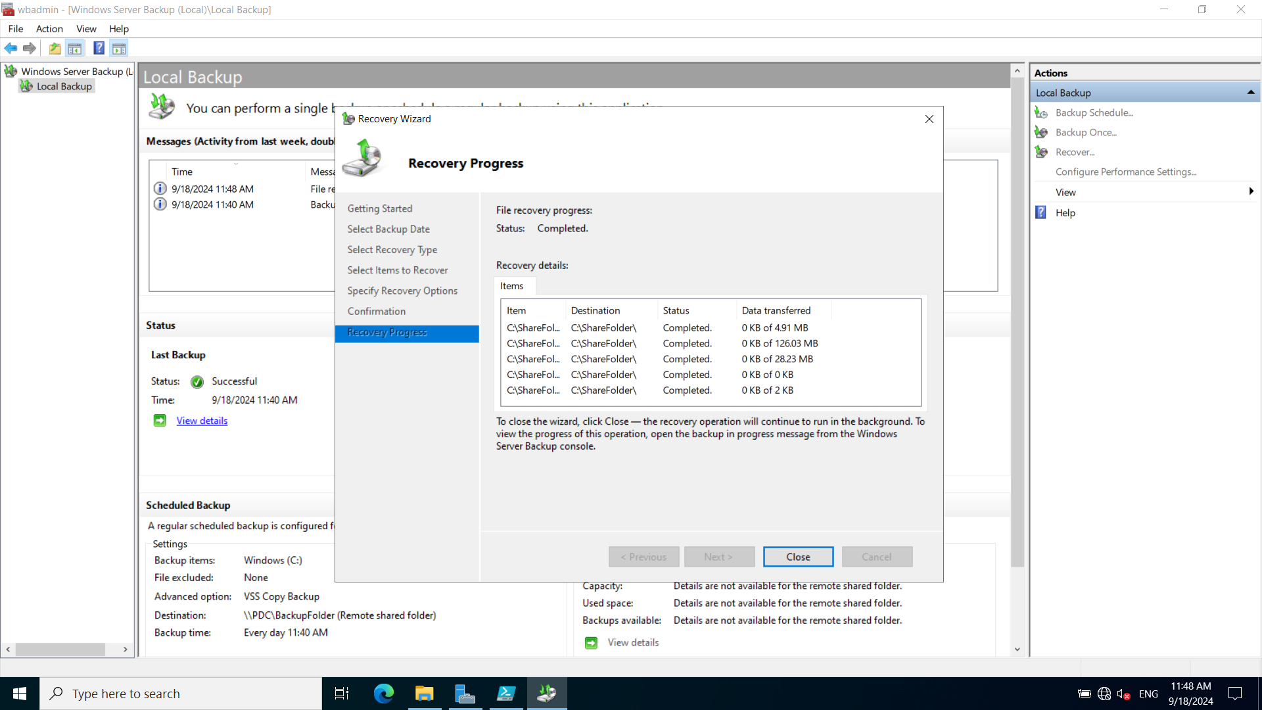

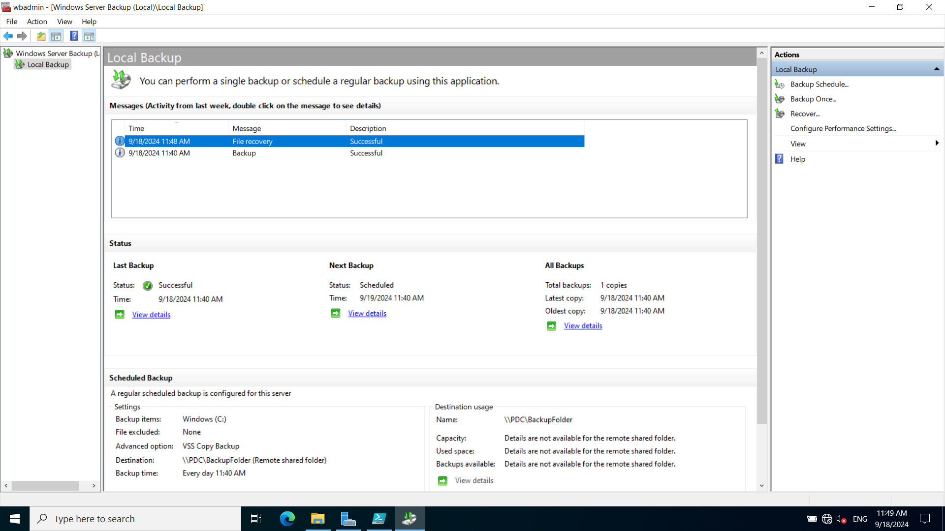

The 3 files deleted accidentally have been recovered to the original place:

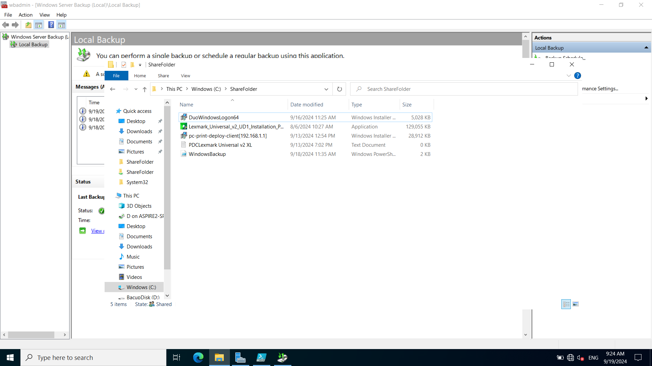

## Task/Mahi 6: Implementing and Managing Intrusion Detection System (IDS)

### Task 6.1: IDS Deployment and Configuration

Snort is chosen as IDS solution for TechCo Solutions because it is cost effective, flexibility and strong community support.

* Low cost. Snort is an open-source software, and it is free and no license fee.
* Ease of use and deployment. Snort has good documentation and strong community support.
* Completed rules sets. Snort provides a lot of detection rules and update rules set regularly.

**1. Install WinPcap**

http://www.winpcap.org/install/bin/WinPcap_4_1_2.exe

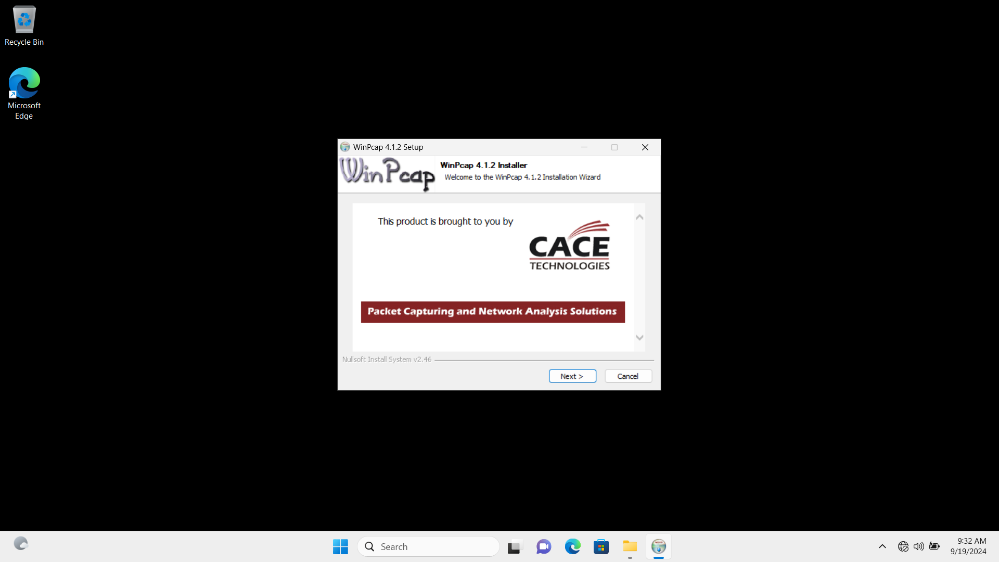

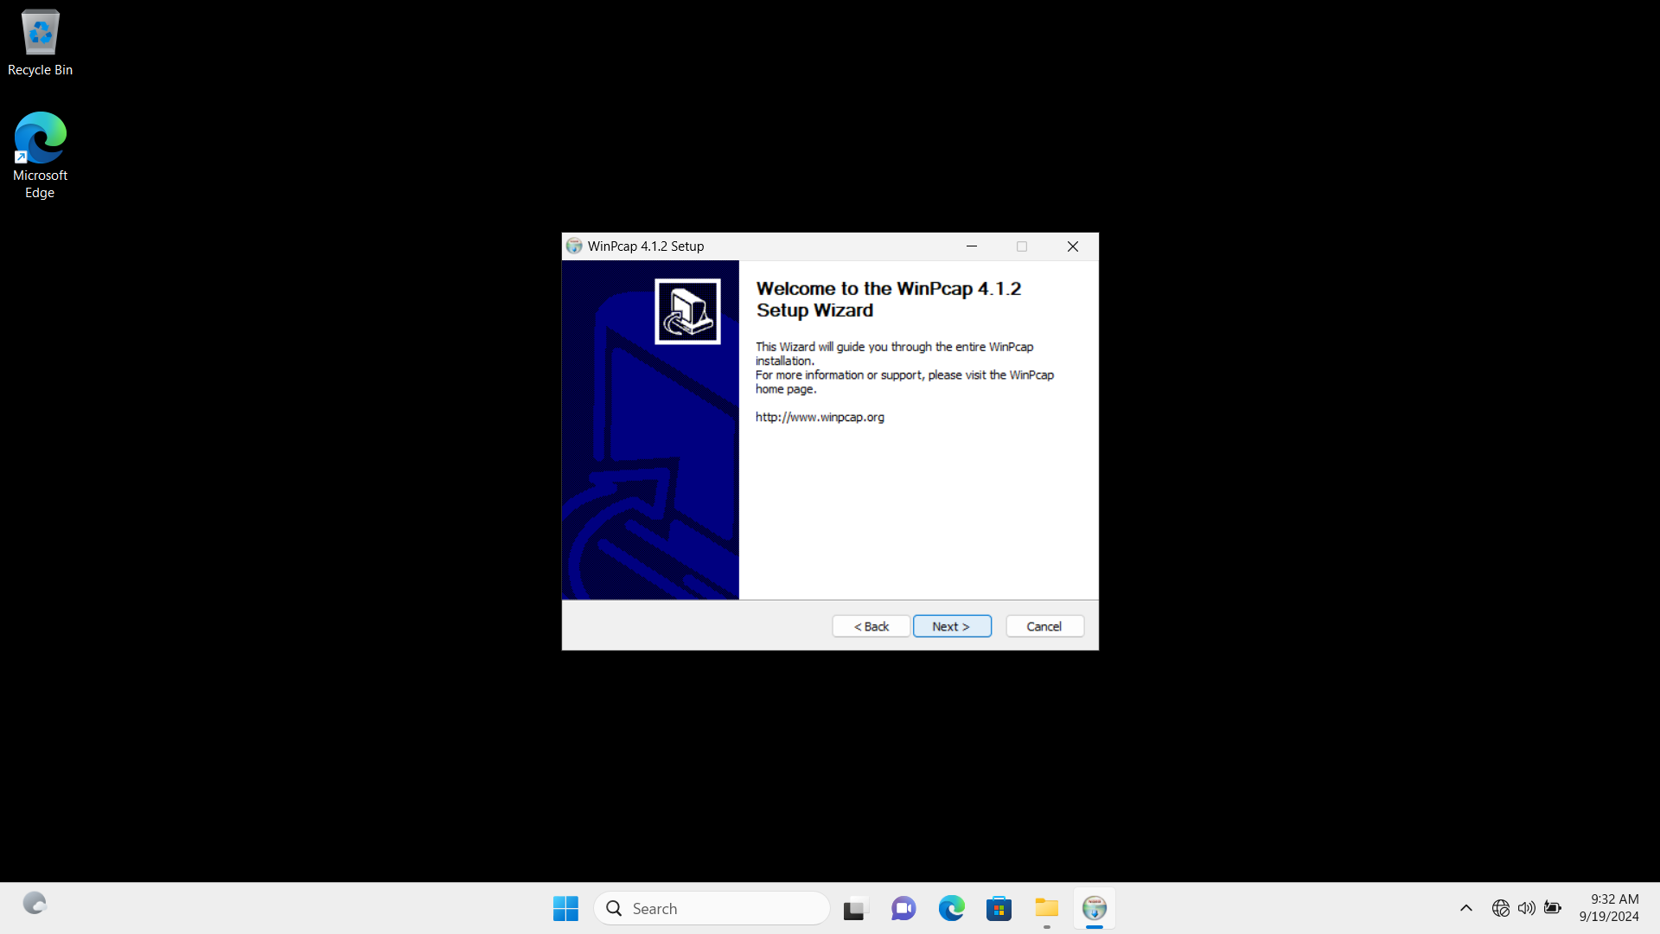

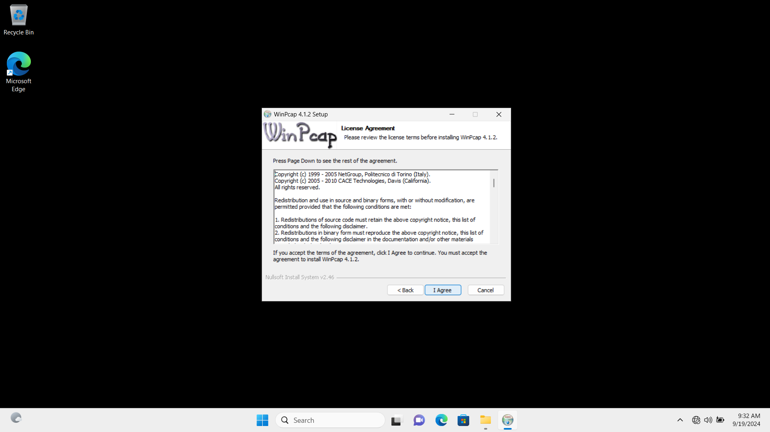

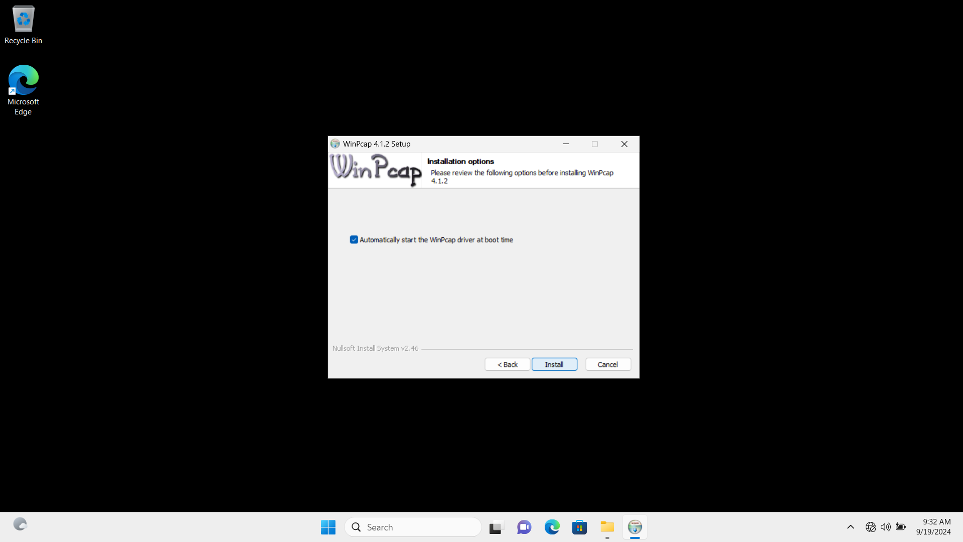

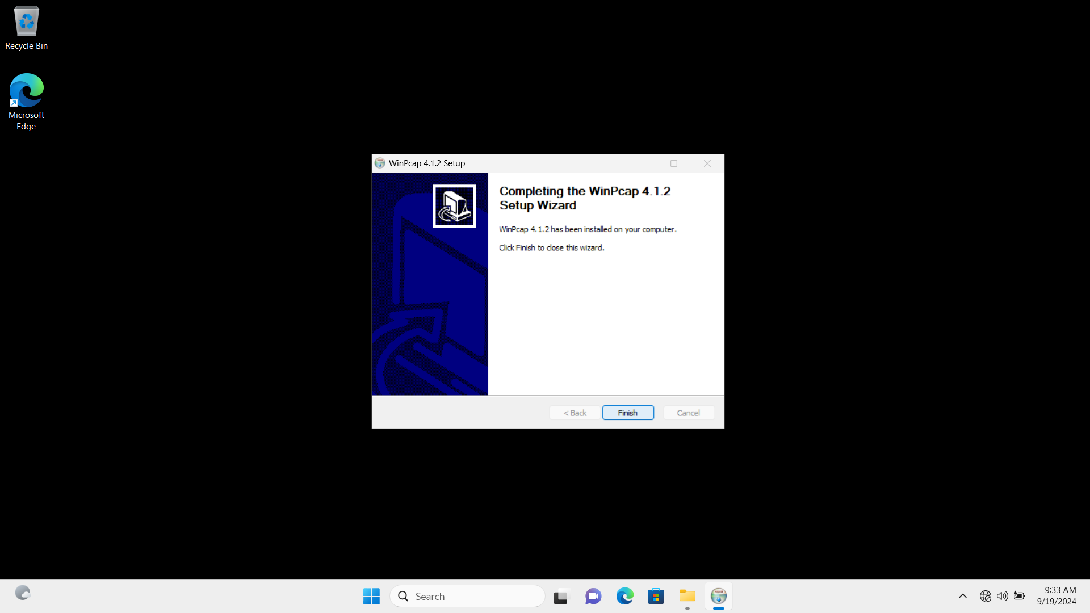

**2. Install Npcap**

https://npcap.com/dist/npcap-1.79.exe

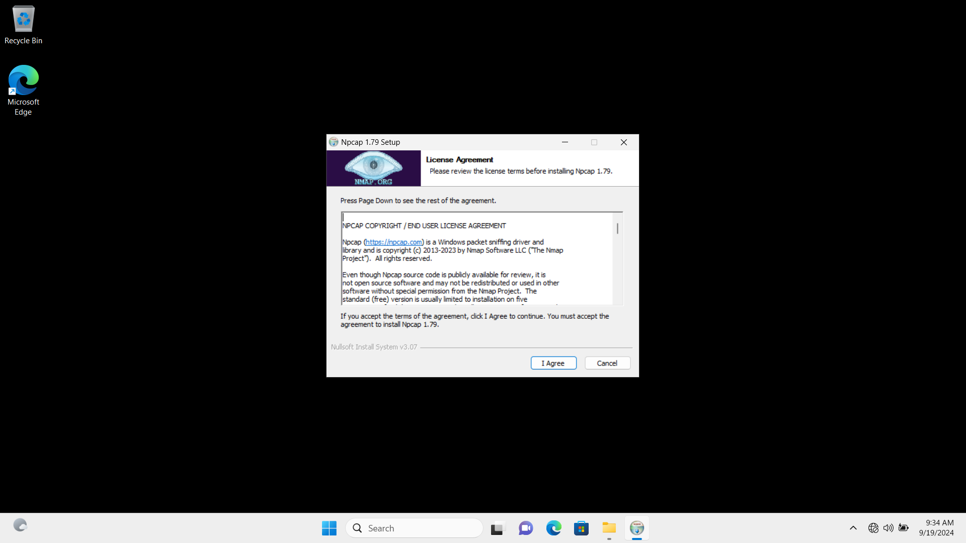

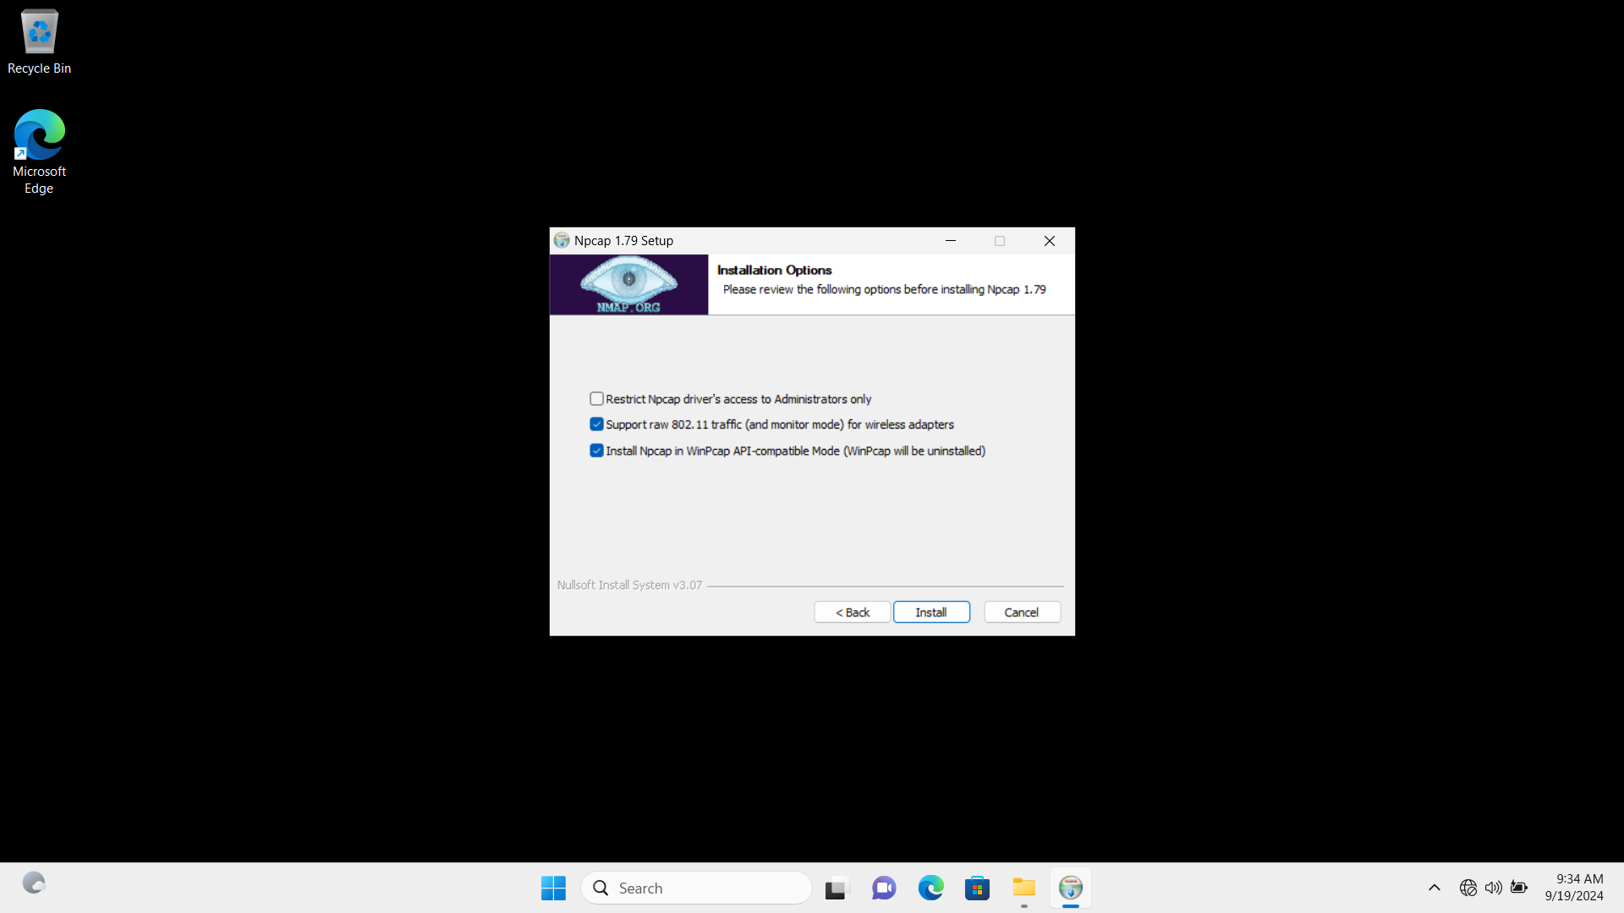

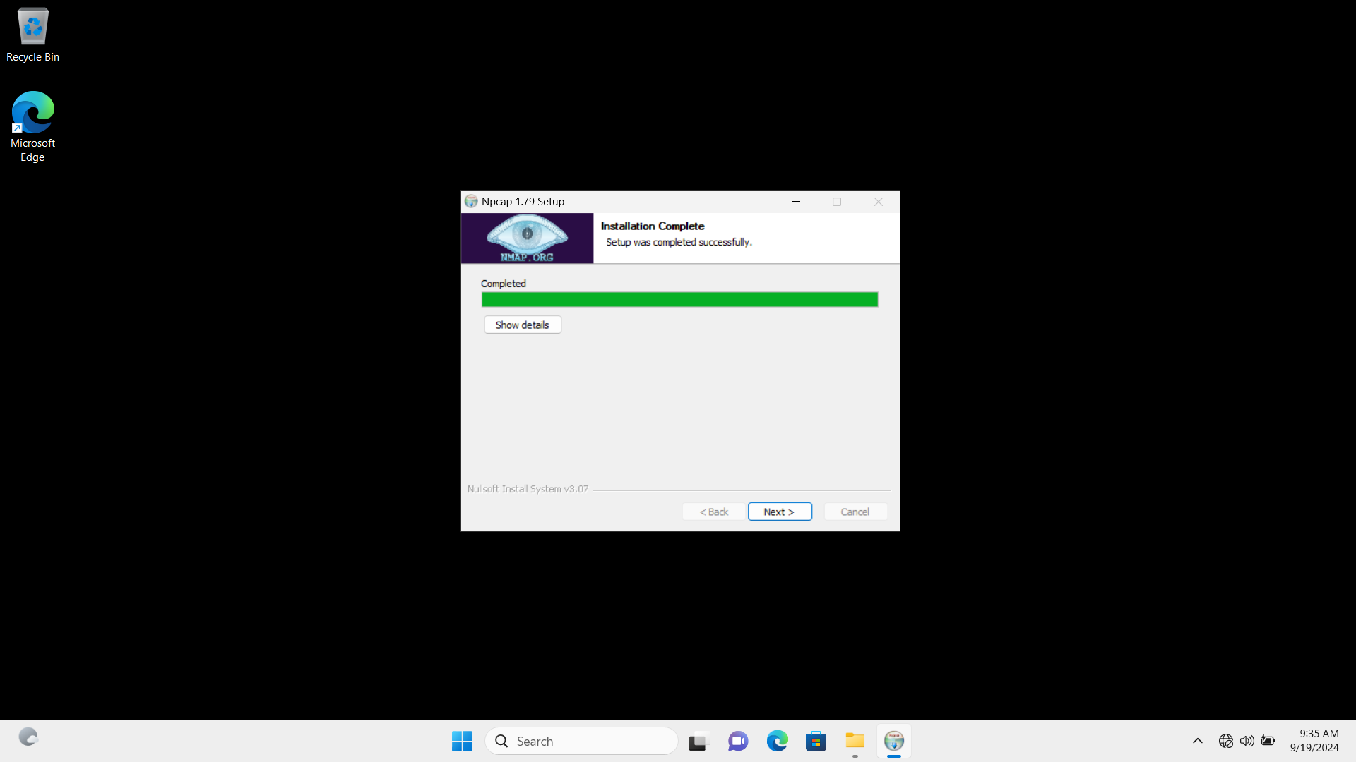

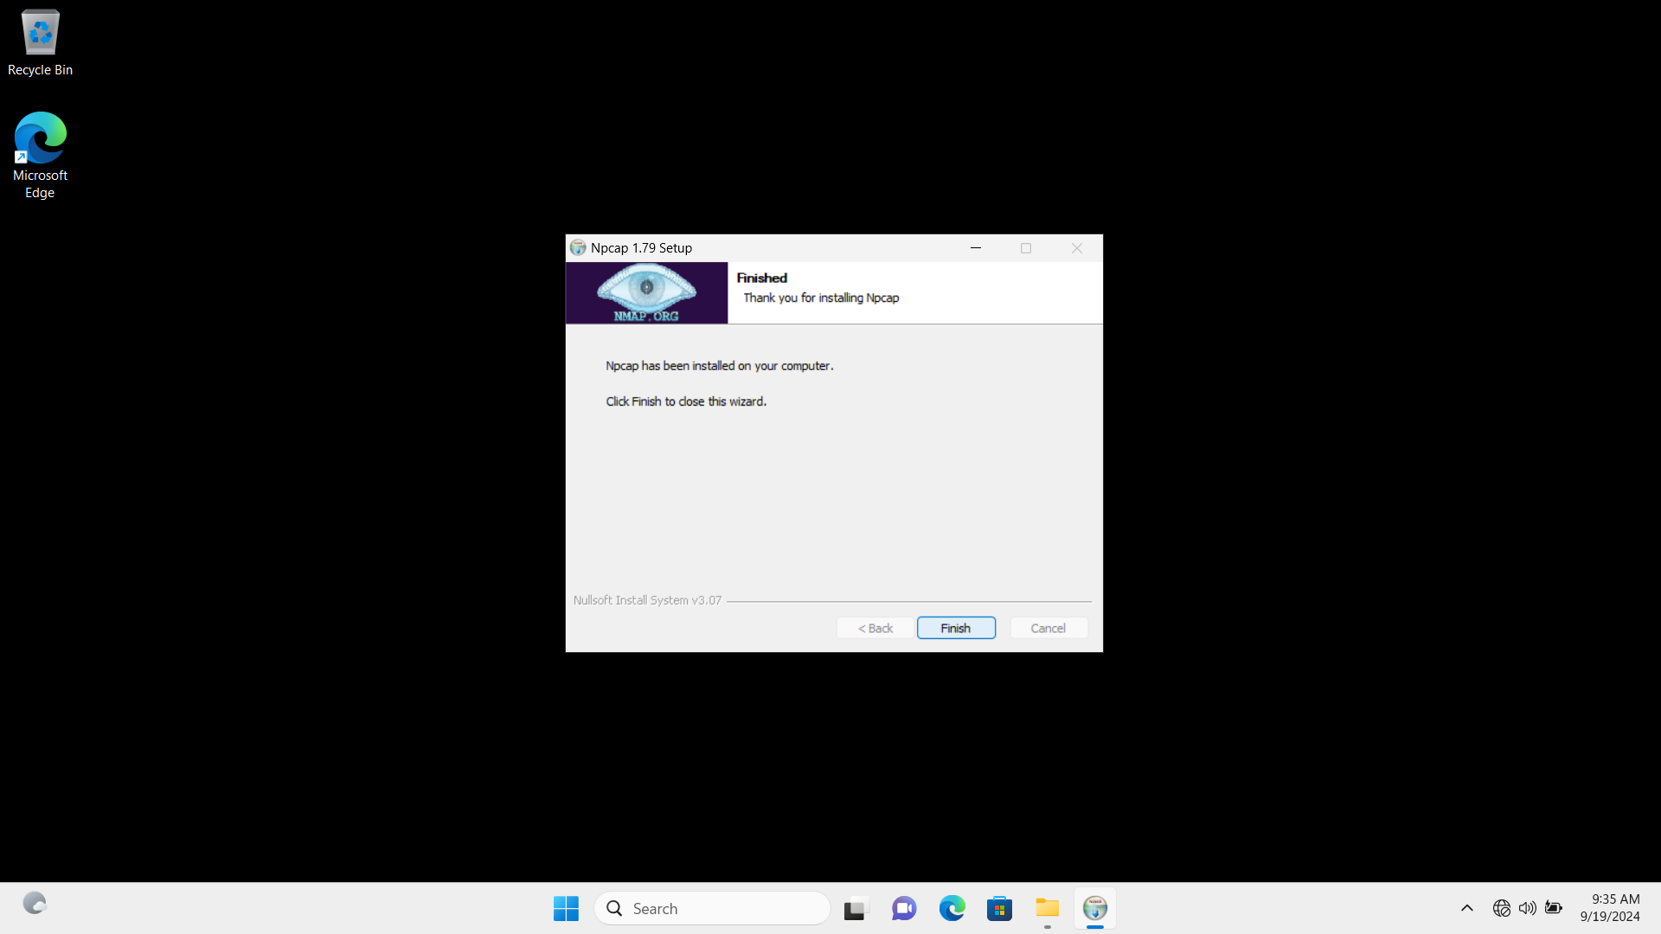

**3. Install Snort**

https://www.snort.org/downloads/snort/Snort_2_9_20_Installer.x64.exe

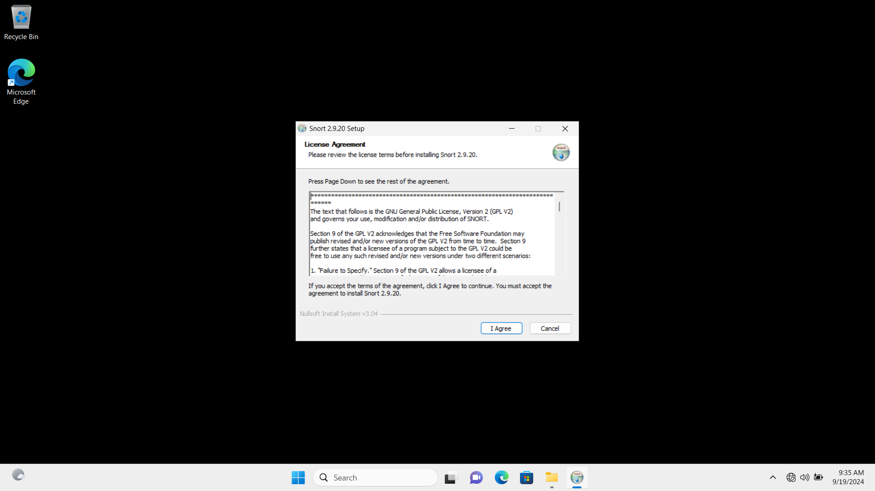

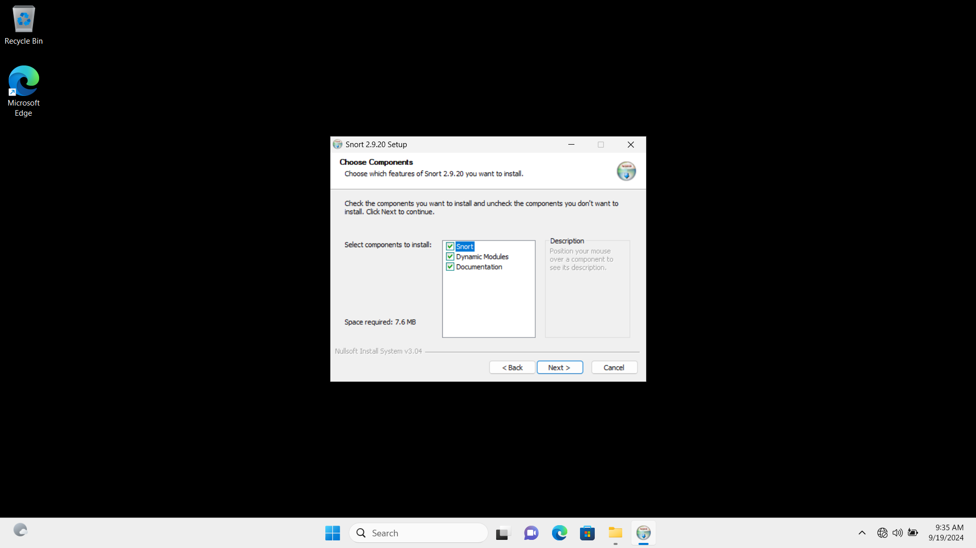

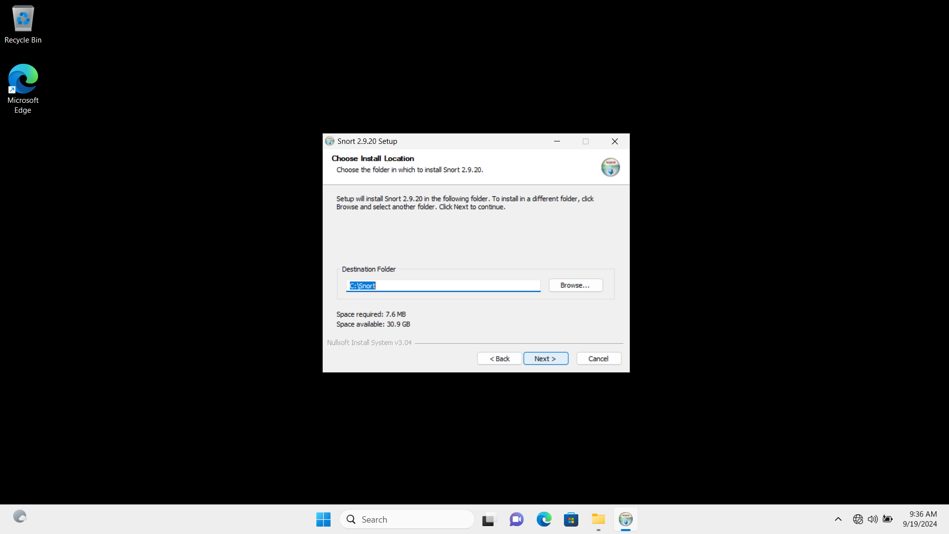

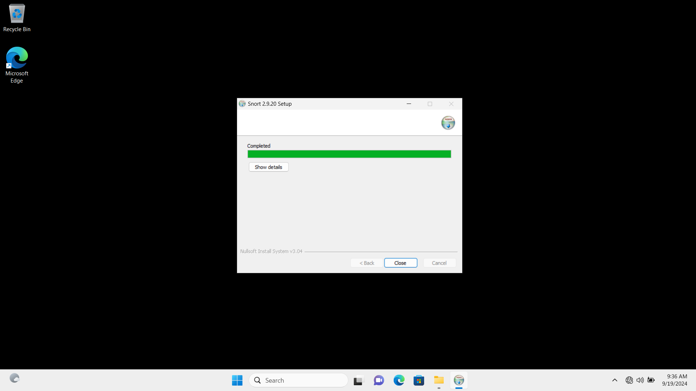

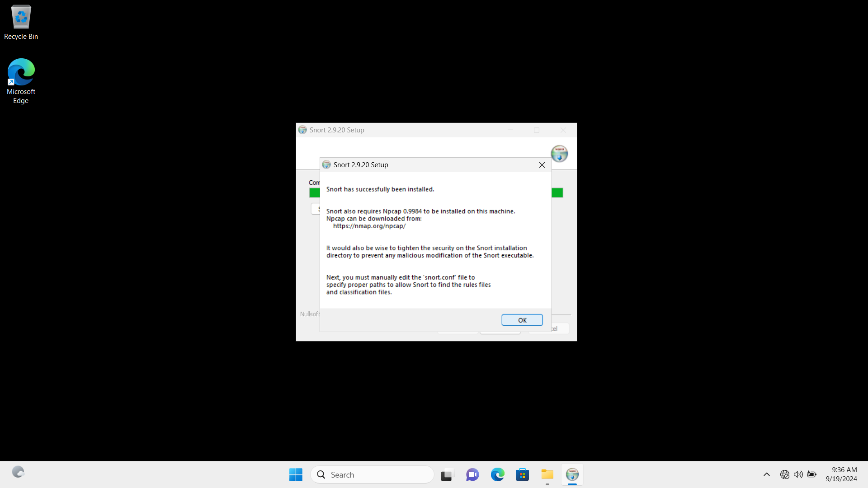

**4. Download Snort Rules to local snort folder**

https://www.snort.org/downloads/registered/snortrules-snapshot-29111.tar.gz

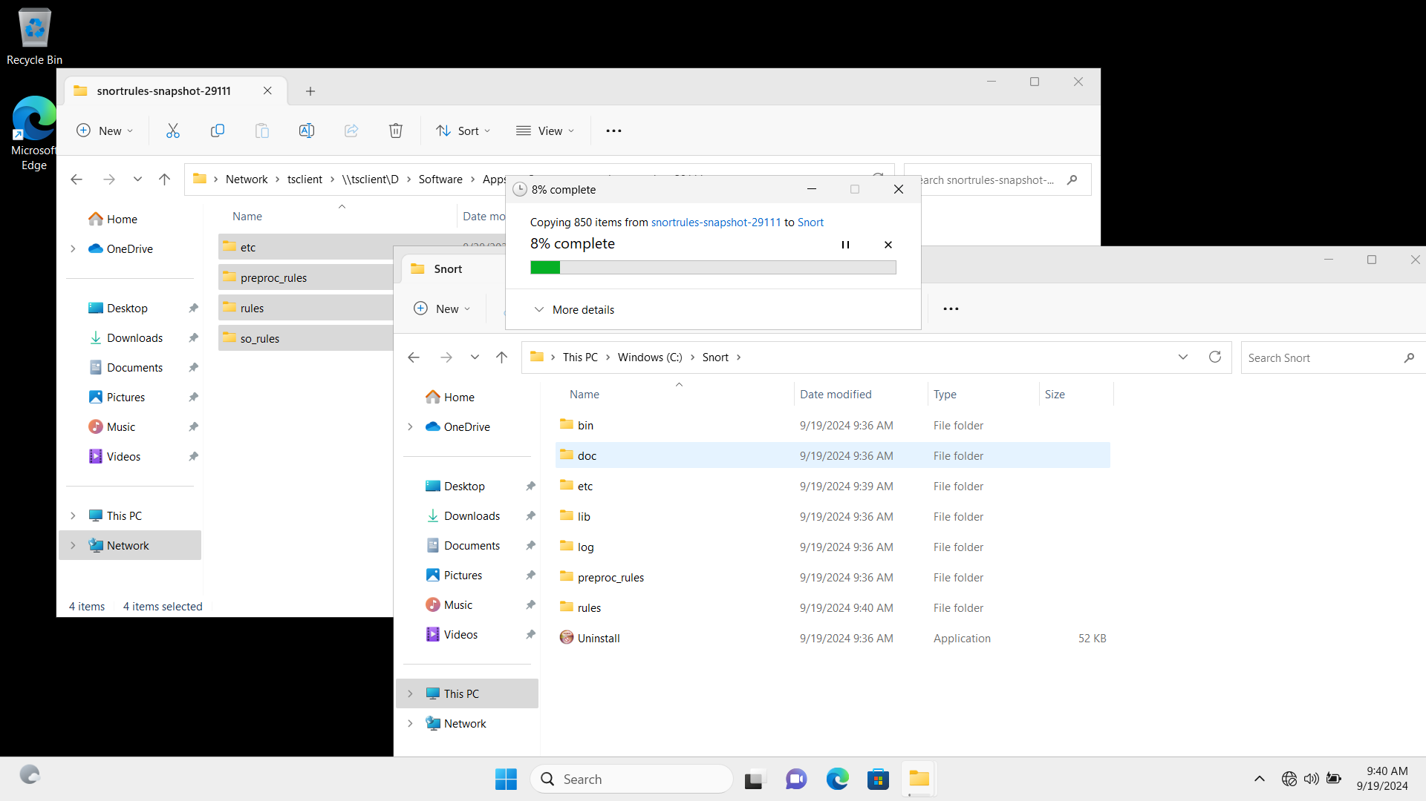

**5. Configure Snort**

* **Set the network variables**

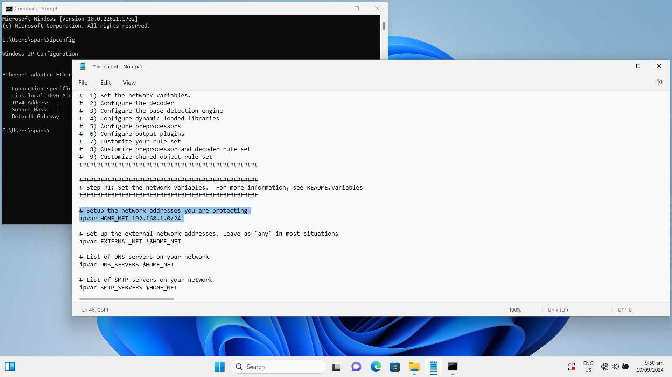

* **Set the path of rules**

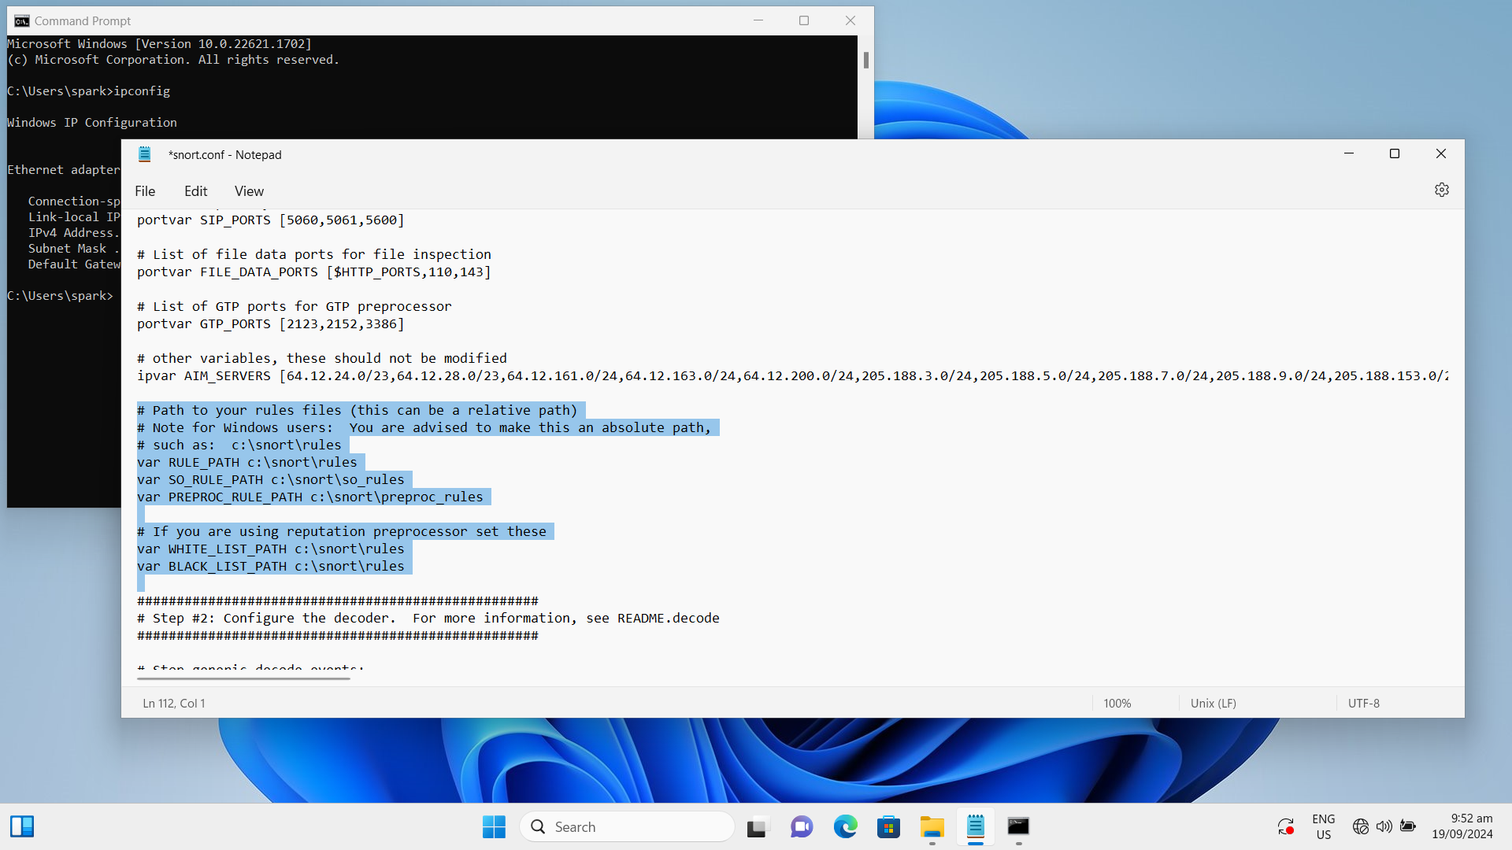

* **Set the path of log file**

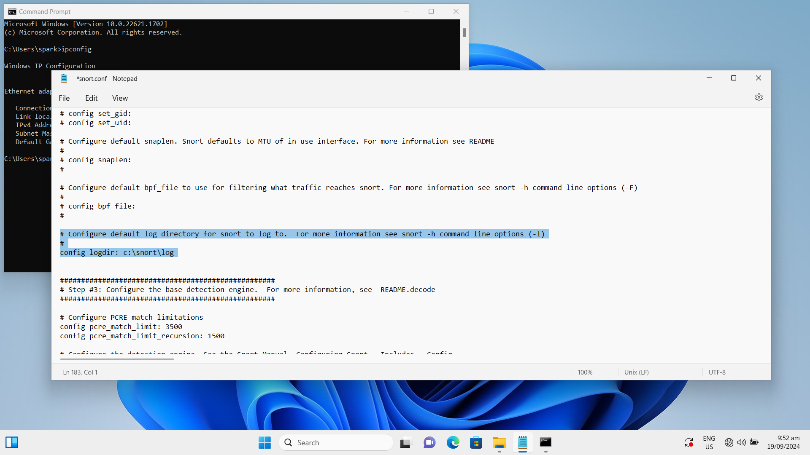

* **Configure dynamic loaded libraries**

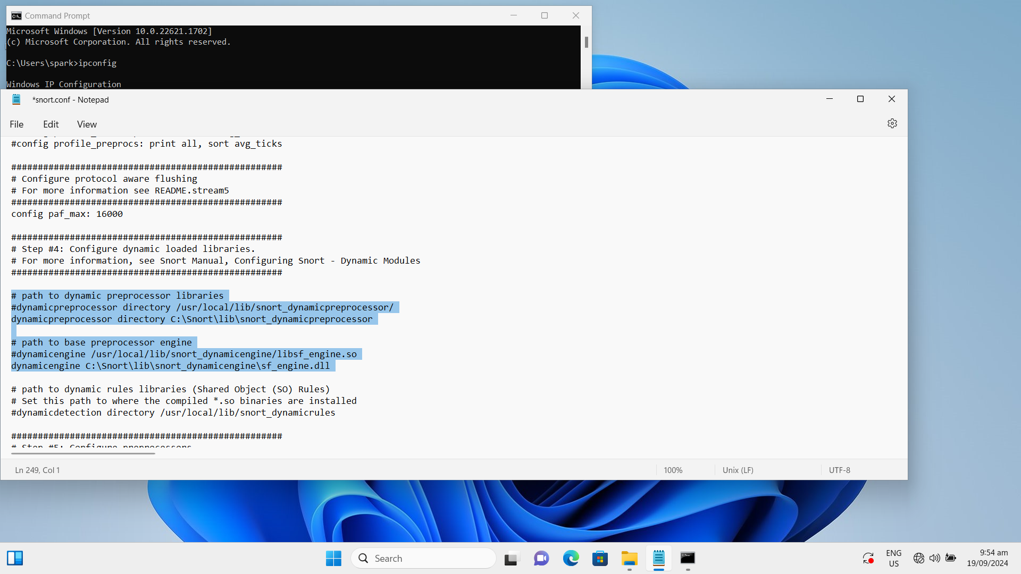

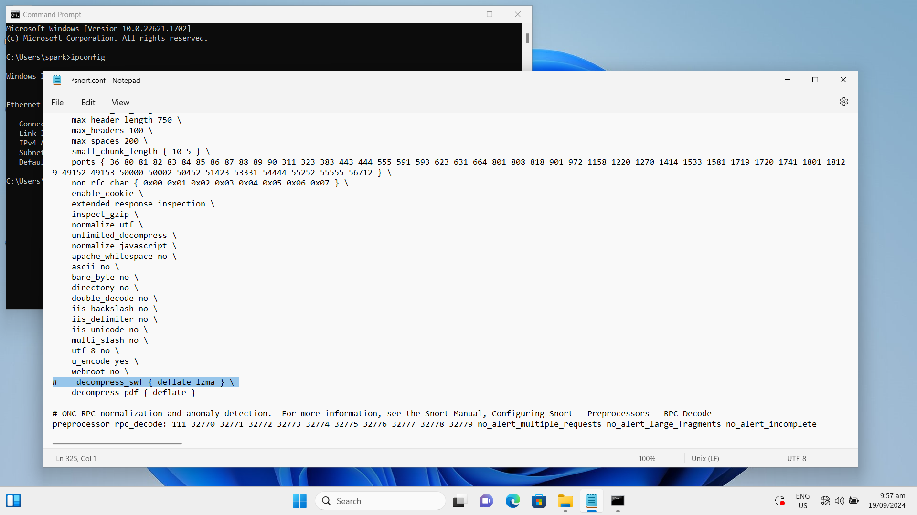

* **Change slash for Windows path**

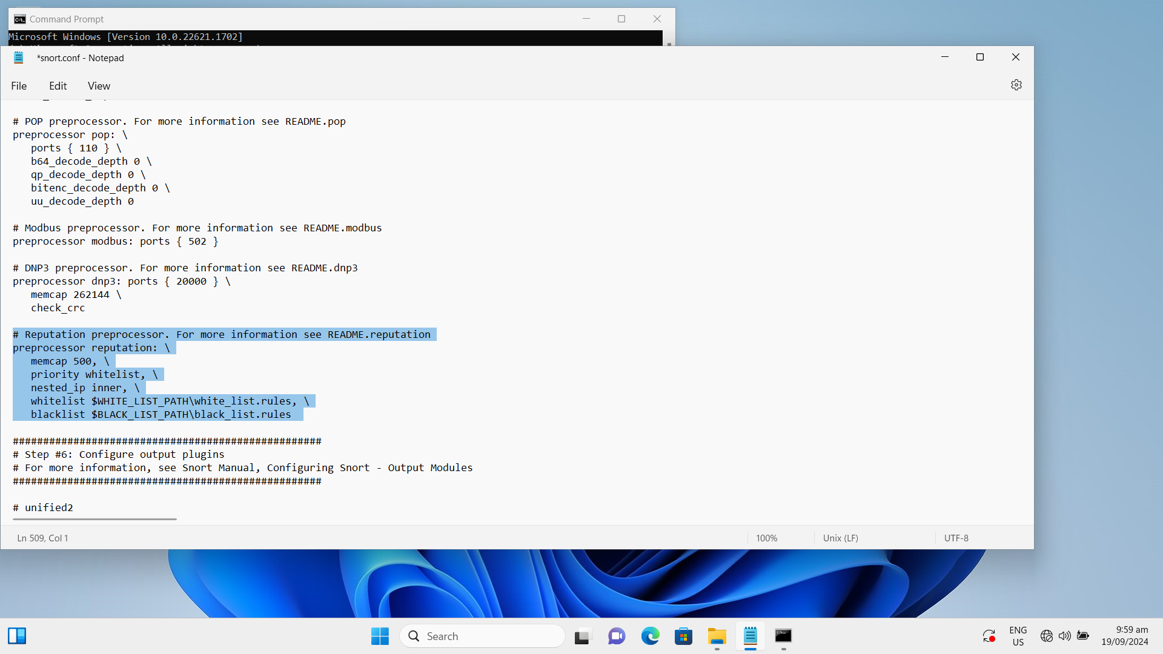

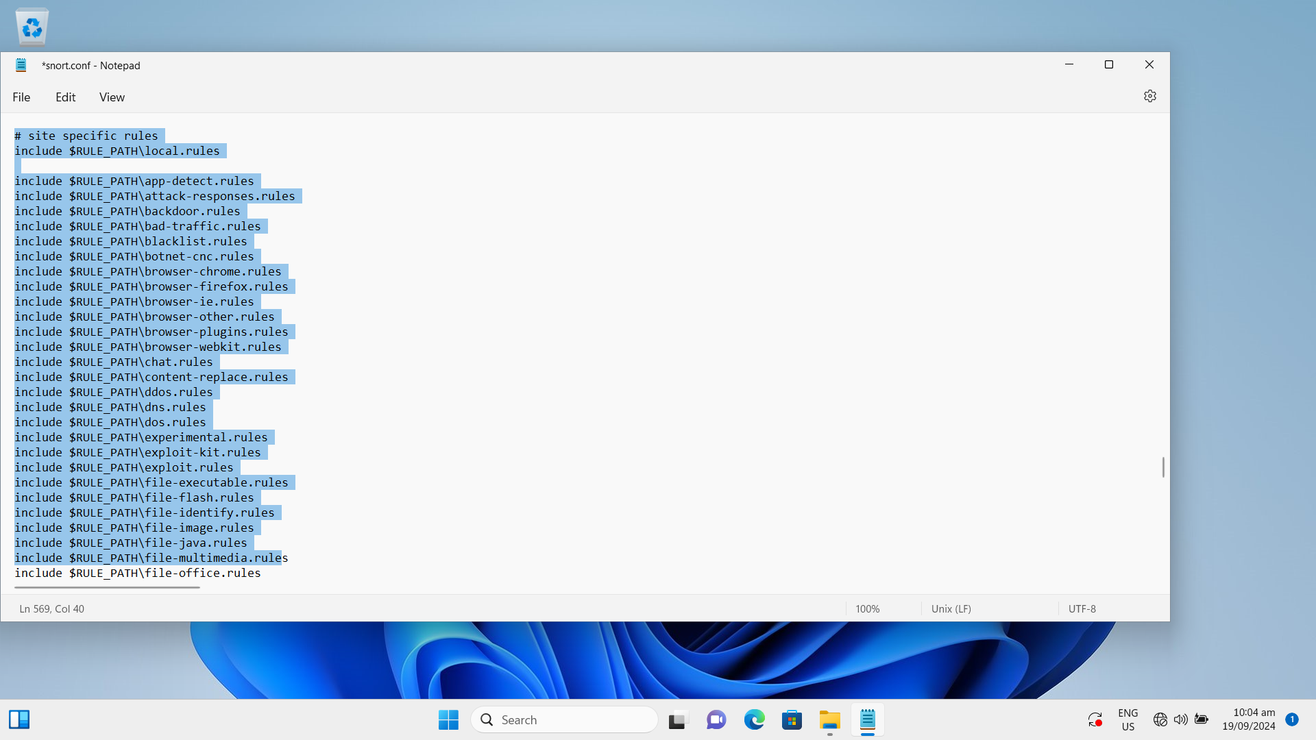

### Task 6.2: Integration, Testing, and Documentation

**1. Add blacklist.rules and whitelist.rules**

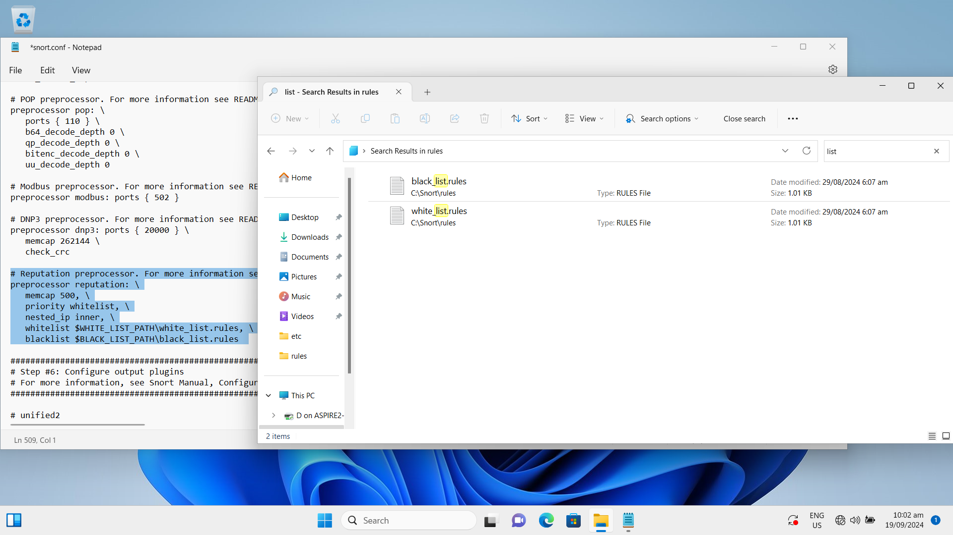

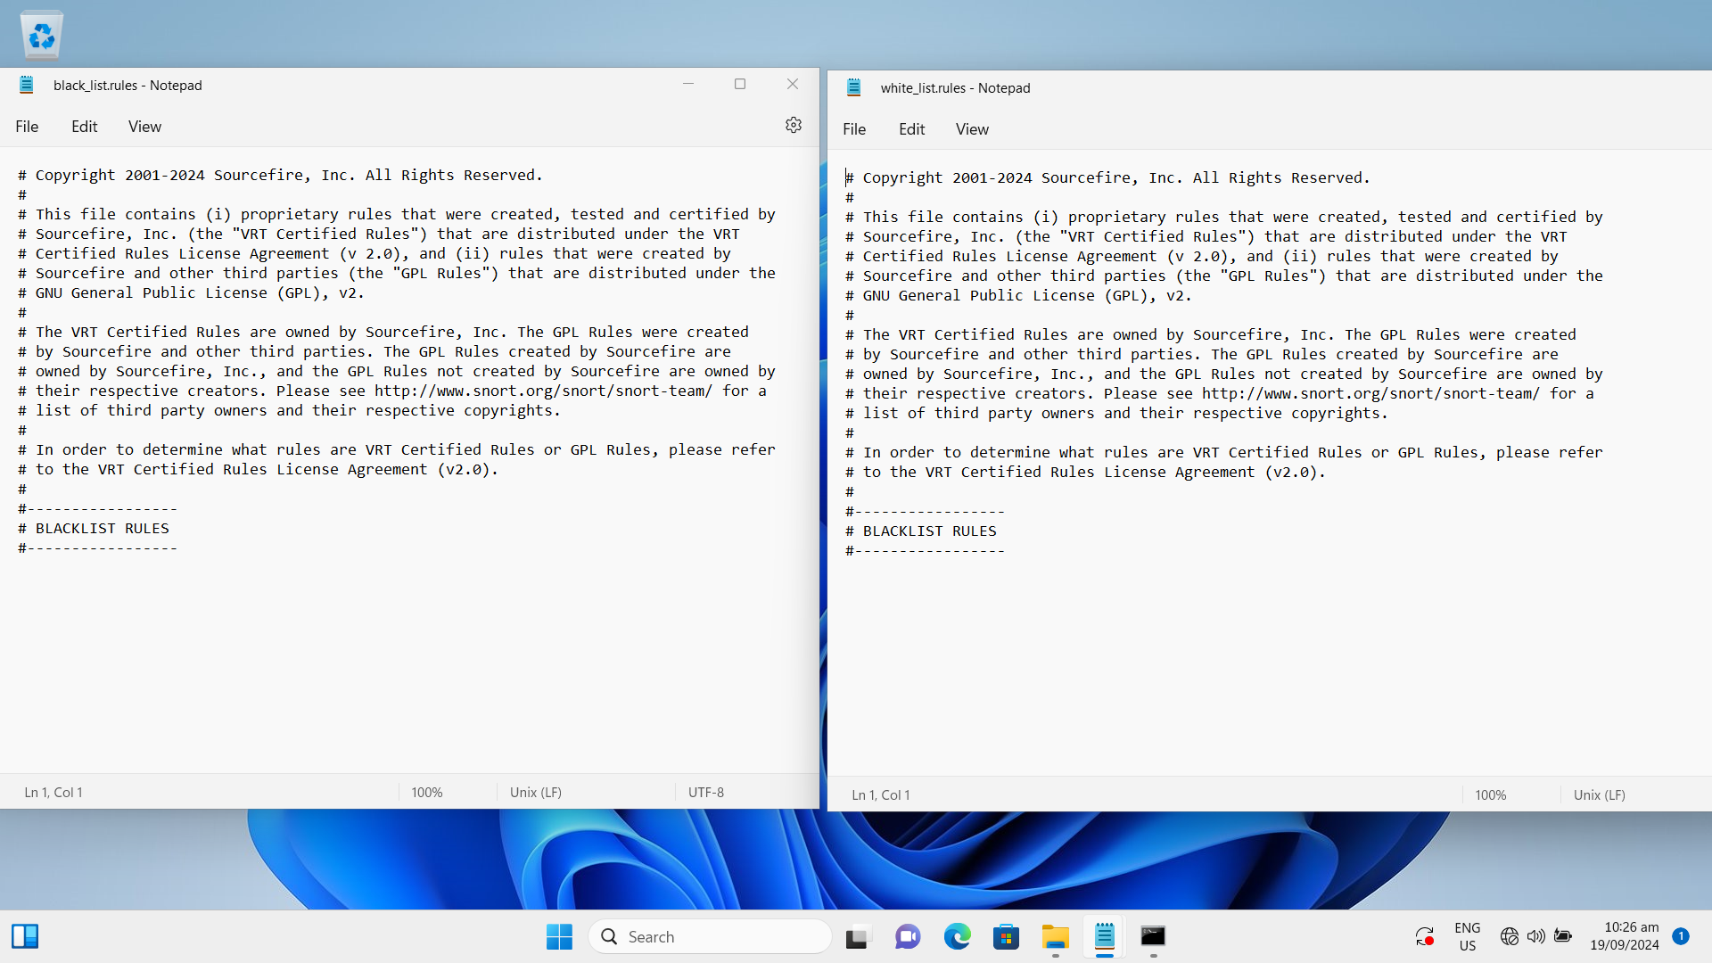

**2. Add local.rules**

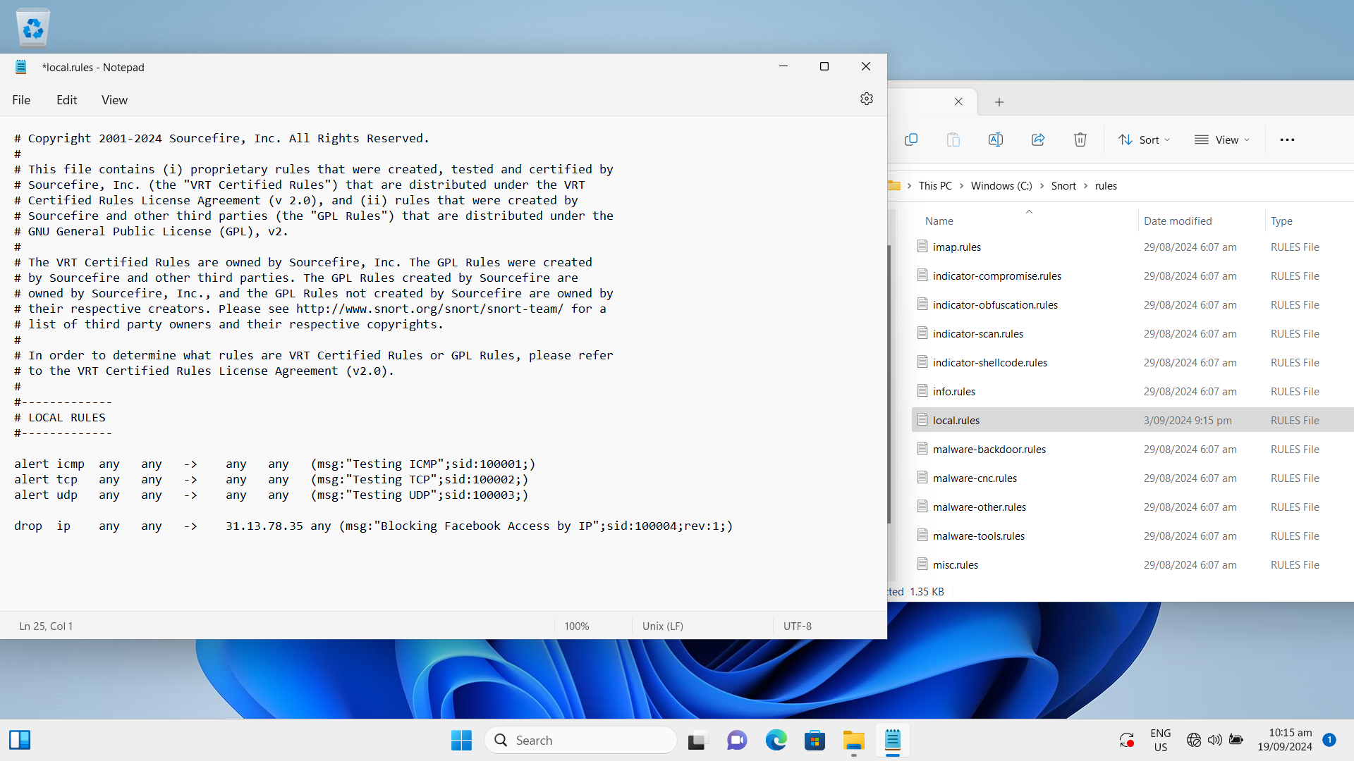

**3. Execute snort**

* Check interface to work on

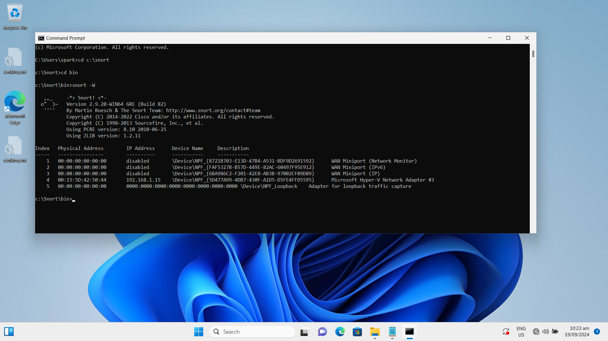

* Start Snort on the right interface

snort -i 4 -c c:\snort\etc\snort.conf -A Console

-W Lists available interfaces. (Win32 only)

-i <if> Listen on interface <if>

-A Set alert mode: fast, full, console, test or none (alert file alerts only)

-c <rules> Use Rules File <rules>

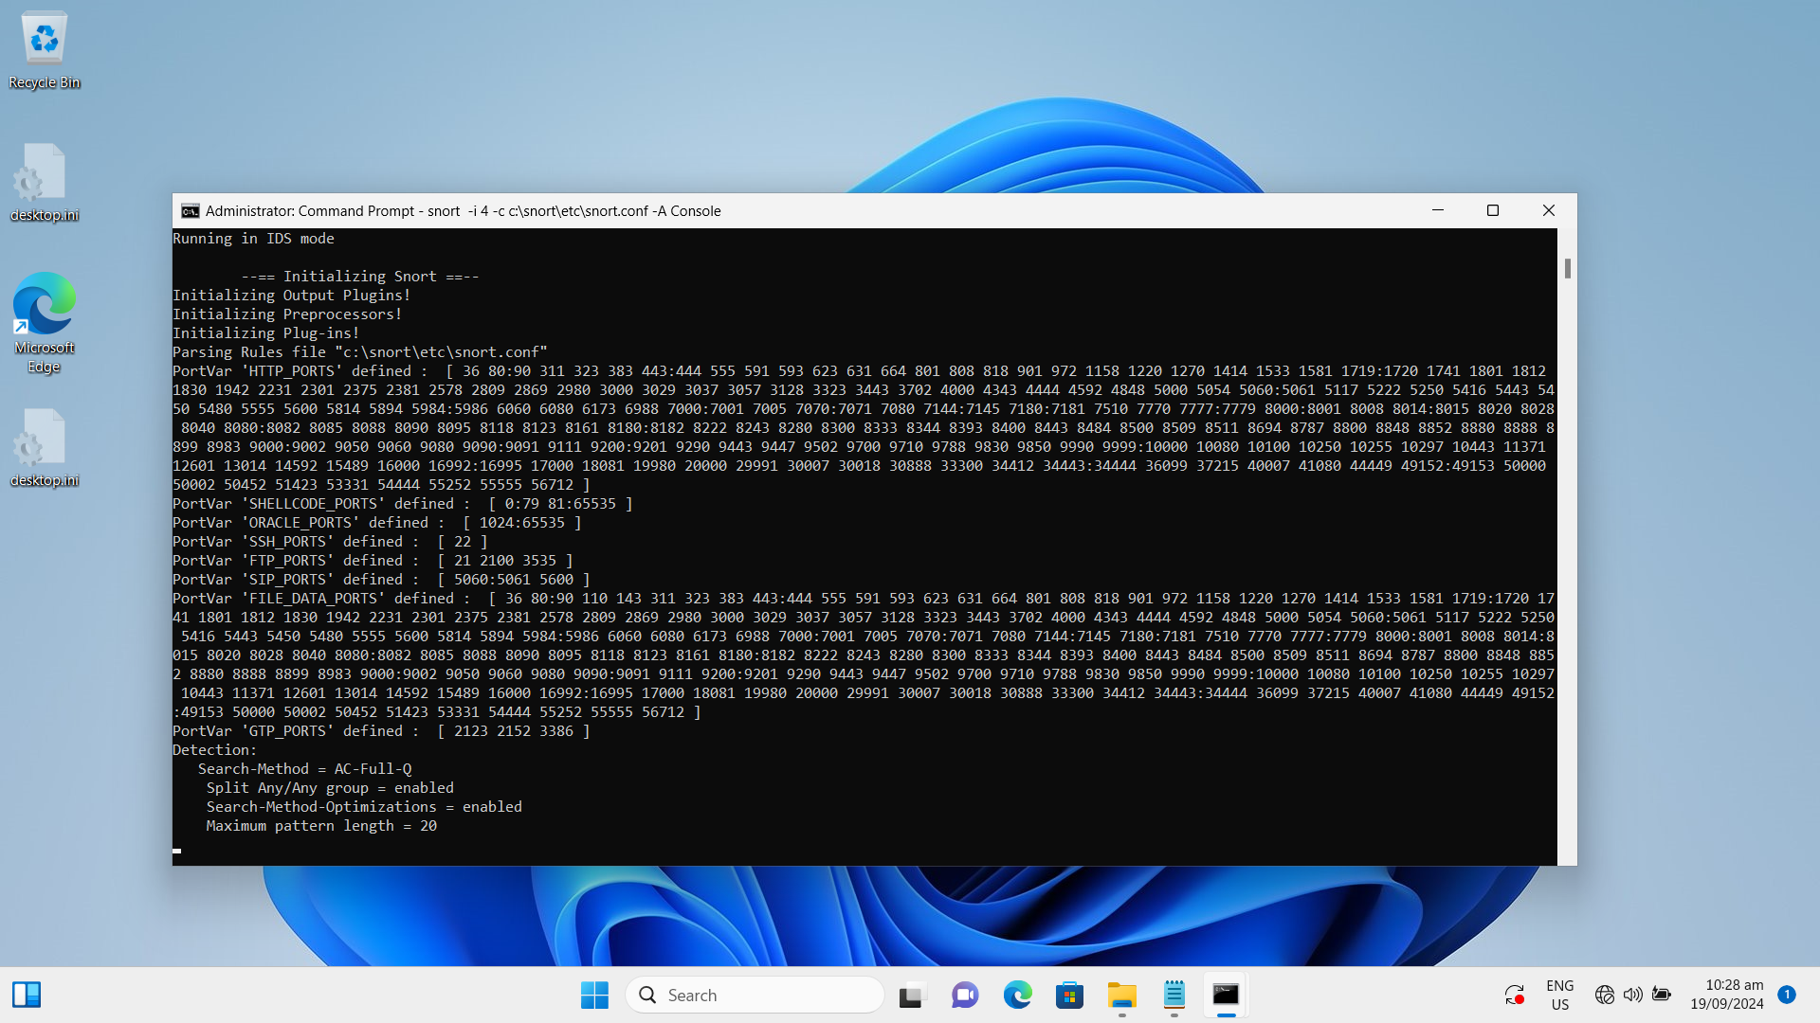

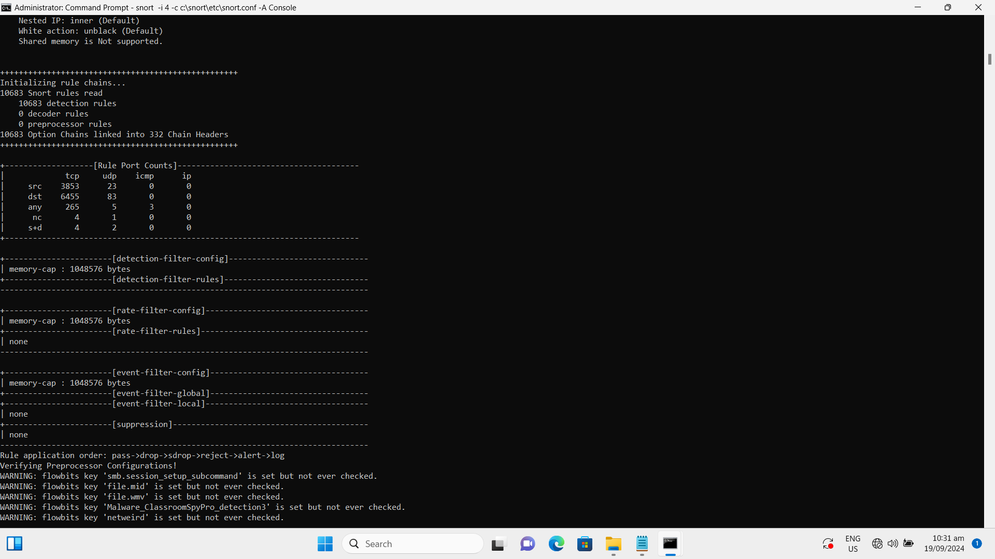

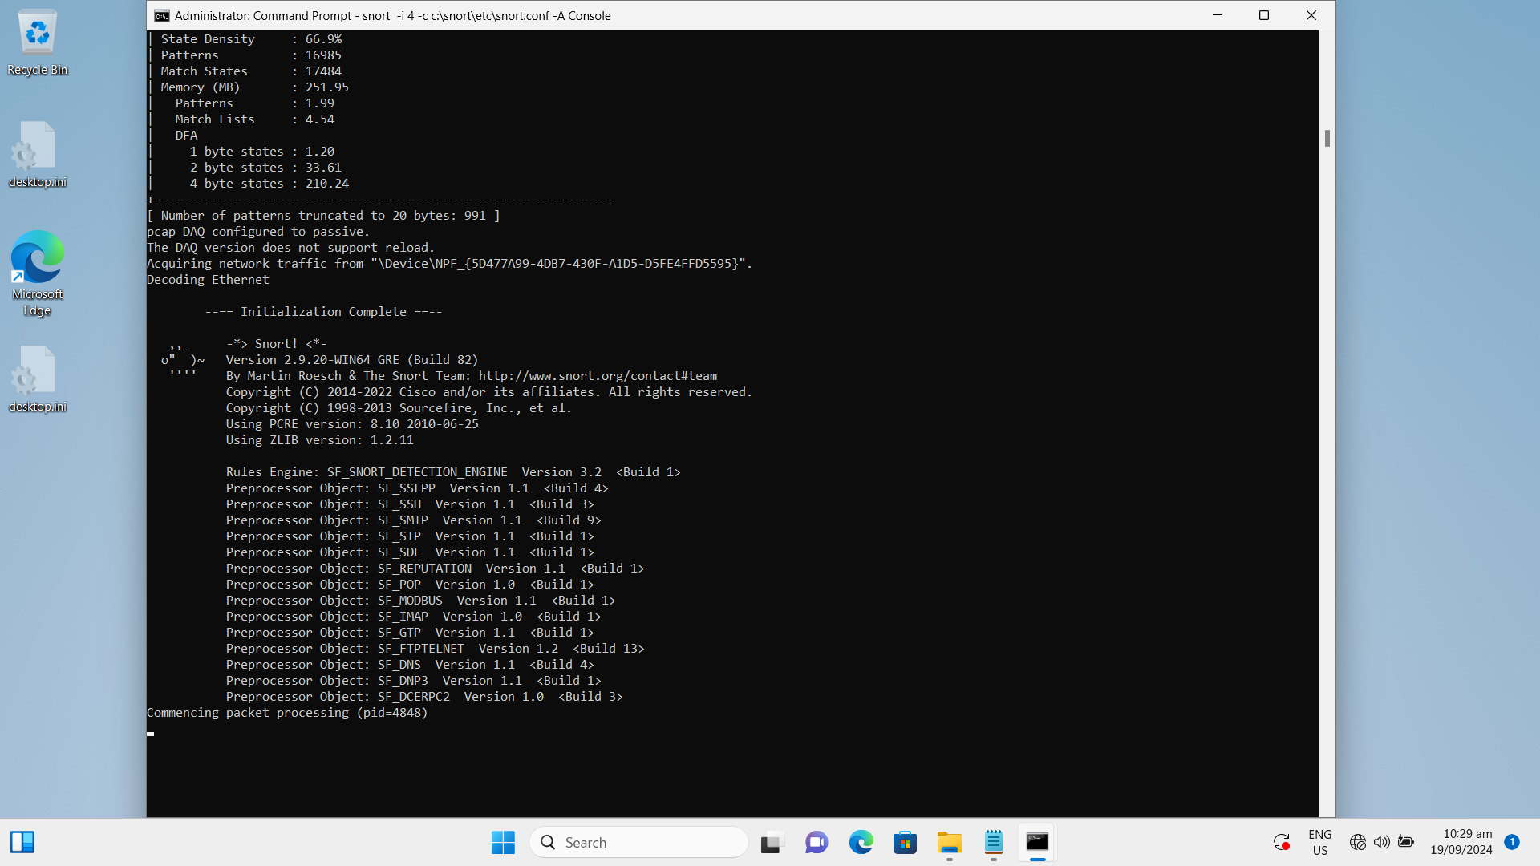

**4. Check logs**

* **ICMP detected.**

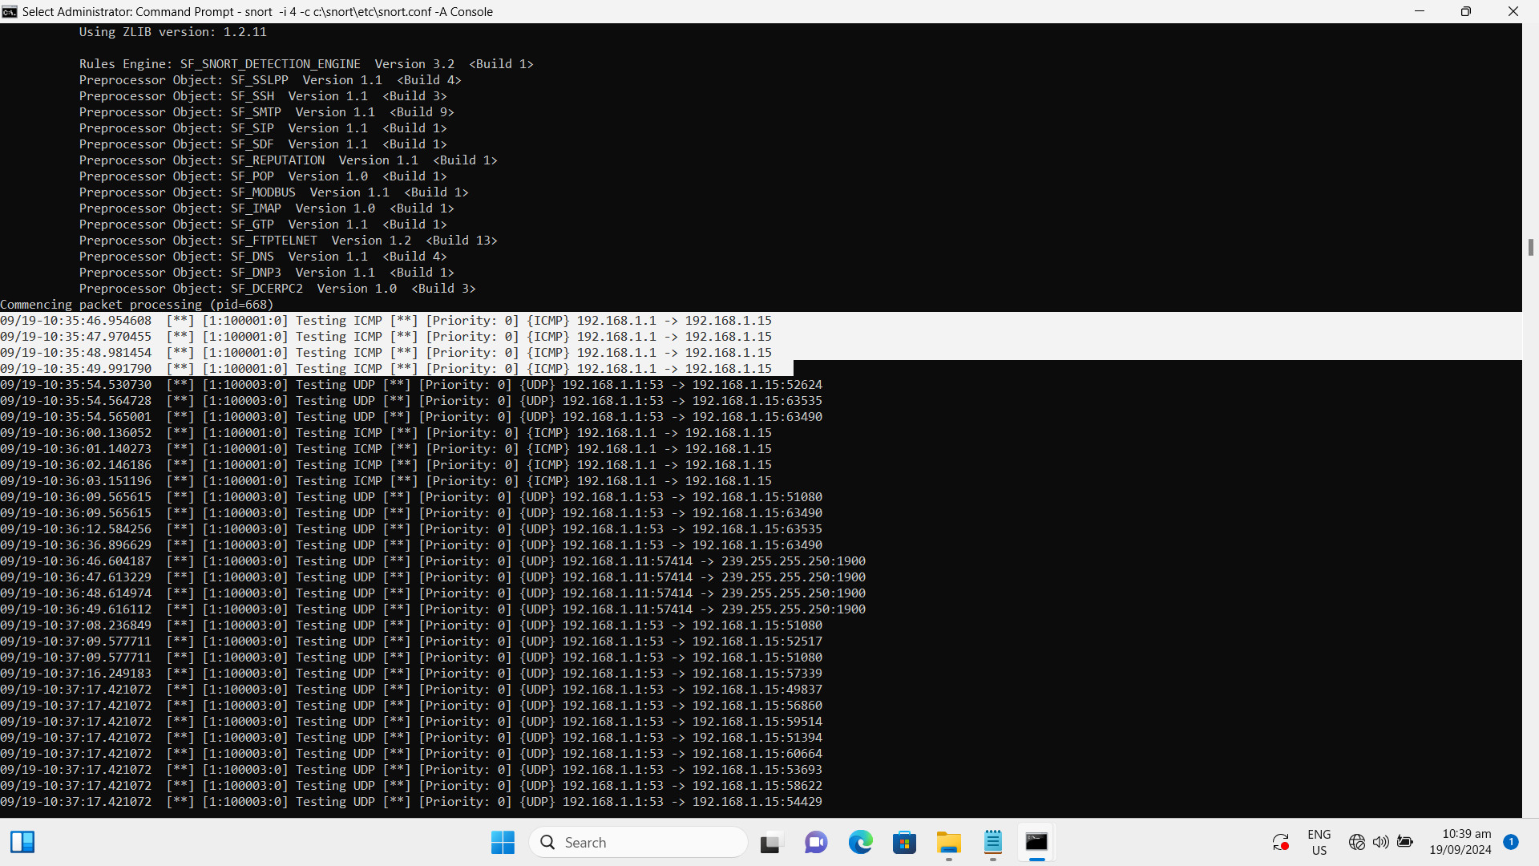

* **UDP detected**

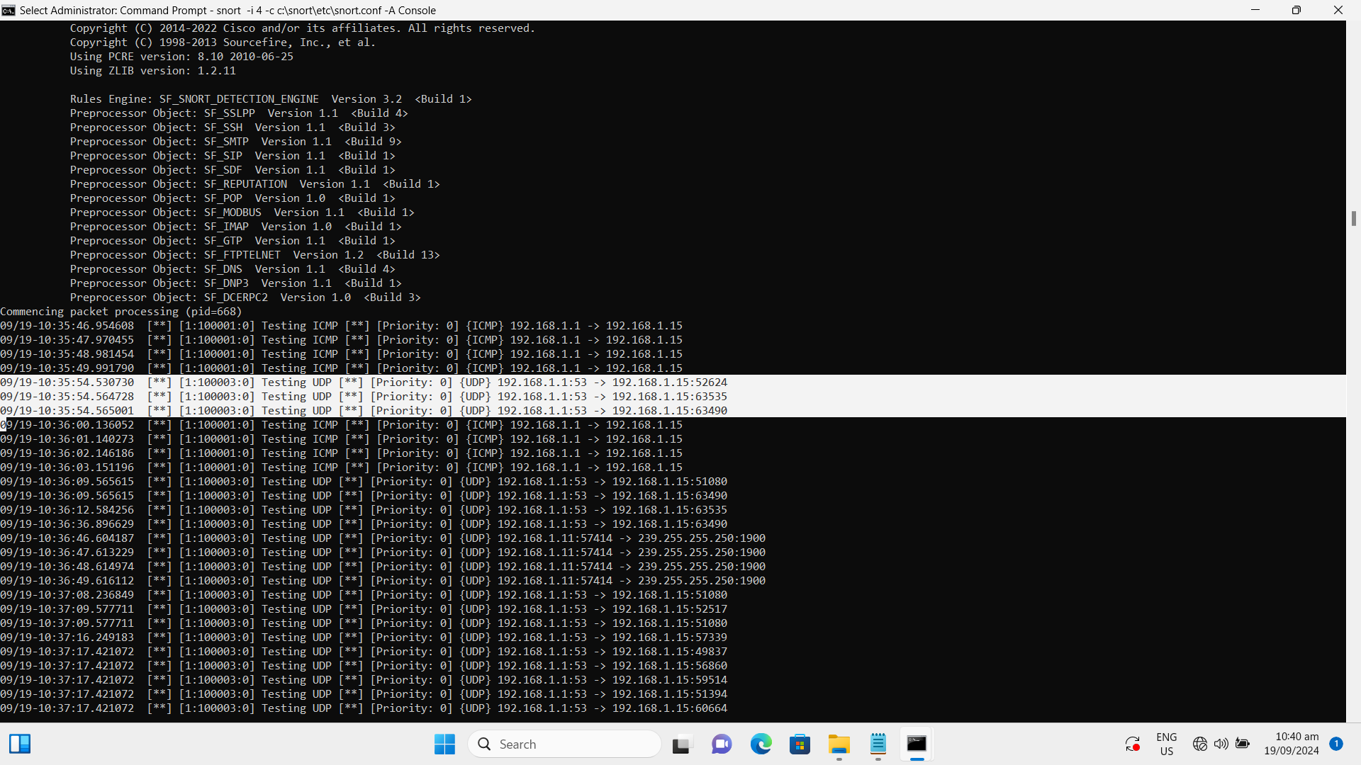

* **TCP detected**

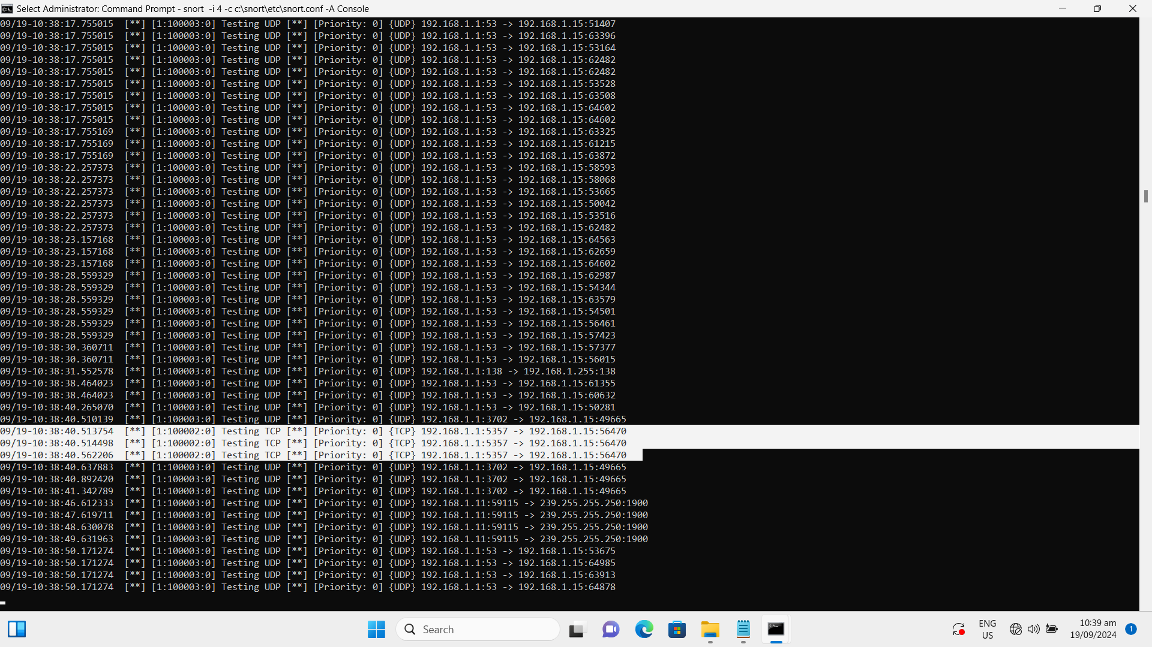

## Task/Mahi 7: Update Existing Network Diagram

The network infrastructure of TechCo Solutions is enhanced with:

* Secondary Domain Controller
* Centralized printing management
* MFA deployed
* VPN server with traffic encryption
* Encrypted Windows Backup
* IDS server

